**Introduction**

We are tried our best to make the complicated process of E-Restaurant System as simple as possible using Structured & Modular technique & Menu oriented interface. We have tried to design the software in such a way that user may not have any difficulty in using this package & further expansion is possible without much effort. Even though, we cannot claim that this work to be entirely exhaustive, the main purpose of my exercise is perform each Employee’s activity in computerized way rather than manually which is time consuming.

Computers have become part of the life for accessing almost any kind of information. Life inthe 21st century is full of technological advancement and in this technological age it is verydifficult for any organization to survive without utilizing technology. The World Wide Webcontributes greatly to the creation of an ever-increasing global information database. It could also be used as a mechanism to share information within an enterprise.

In today’s age of fast food and take

-out, many restaurants have chosen to focus on quick  preparation and speedy delivery of orders rather than offering a rich dining experience. Untilvery recently, all of these delivery orders were placed over the phone, but there are many disadvantages to this system, including the inconvenience of the customer needing to have a physical copy of the menu, lack of a visual confirmation that the order was placed correctly, andthe necessity for the restaurant to have an employee answering the phone and taking orders.What I propose is an online ordering system, which is a technique of ordering foods onlineapplicable in any food delivery industry. The main advantage of my system is that it greatlysimplifies the ordering process for both the customer and the restaurant. When the customer visits the ordering webpage, they are presented with an interactive and up-to-date menu,complete with all available options and dynamically adjusting prices based on the selectedoptions. After making a selection, the item is then added to their order, which the customer canreview the details of at any time before checking out. This provides instant visual confirmationof what was selected and ensures that items in the order are, in fact, what was intended.

This system also greatly lightens the load on the restaurant’

s end, as the entire process of taking orders is automated. Once an order is placed on the webpage, it is entered into thedatabase and then retrieved, in pretty much real-

time, by a desktop application on the restaurant’s

end. Within this application, all items in the order are displayed, along with their correspondingoptions and delivery details, in a concise and easy to read manner. This allows restaurantemployees to quickly go through the orders as they are placed and produce the necessary itemswith minimal delay and confusion.

**1.1) Abstract Of Project:**

The simplicity and ease of access of a menu are the main things that facilitate ordering food in a restaurant. A Tablet menu completely revolutionizes the patron’s dining experience. Existing programs provide an app that restaurants can use to feed their menus into OS based tablets and make it easier for the diners to flip, swipe & tap through the menu. We here aim to provide the restaurants with a tablet menu that would recommend dishes based on a recommendation algorithm which has not been implemented elsewhere.

The main aim of the entire activity is to automate the process of day to day activities of Hotel like Room activities, Admission of a New Customer, Assign a room according to customer’s demand, checkout of a computer and releasing the room and finally compute the bill etc.

**1.1.1) Title Of The Project:**

E-Restaurant System

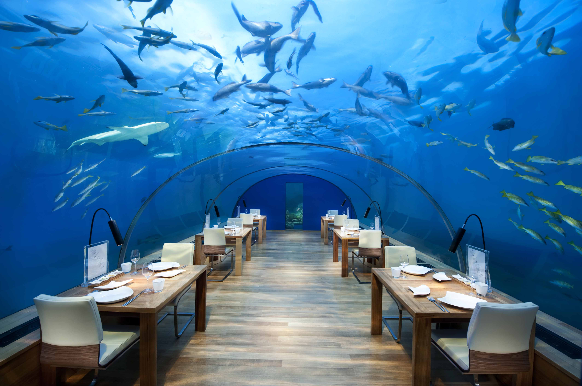

**1.1.2) Objective:**

**General objectives:**

* To increase efficiency and improve services provided to the customers through better application of technology in daily operations.
* To be able to stand out from competitors in the food service industry

**Specific objectives:**

* To enable customers to order custom meals that aren’t in the menu
* To enable customers to have a visual confirmation that the order was placedcorrectly
* To enable customers to know food ingredients before ordering
* To reduce restaurant’s food wastage
* To ensure correct placement of orders through visual confirmation
* Improve efficiency of restaurant’s staff
* Eliminate paper work and increase level of accuracy
* Increase speed of service, sales volume and customer satisfaction

**1.2 ) Problem Specification/Need of Project:**

**CURRENT SYSTEM**

In old system we can’t do reservation online and old system has following problems.

* More time taking.
* Before reservation it is complex to find all information about the hotel.
* Lot of paper work
* Hard to analyze data real time.
* Difficult to process history data
* Difficult communication b/w different branches
* Hard to introduce new processes.

**PROPOSED SYSTEM**

The basic aim of the proposed system was to provide all improvised functionality and flavours of the existing system minus the entire drawbacks or shortcomings analyzed. With a front end like JSP, Java Script, CSS, Jquerry and back end like Oracle most of the major irritants have already vanished. All records of this system are stored in separate databases which are regularly updated, so whenever required these databases are used to respond user queries.

The following points were kept in mind while designing this system.

* The system should be user friendly.
* Data validation whenever necessary to ensure correctness of input data.
* Data security should be taken care of.
* Reduce the redundancy of data.
* Maintaining and updating the database easily.
* This system is based on the very popular Model-ViewController (MVC) architecture. MVC is most commonly used in websites, very popular and tried and tested.

**Feasibility Study**

When a project is started an initial investigation is carried out. During this phase of study users need has recognized and other requirements are determined. Once the problem has been defined a study is carried out to select the best system i.e. a feasible system that meets performance requirements. So Feasibility is the determination of whether or not a project is worth doing and the process followed in making this determination is called a Feasibility Study. In order to conduct the feasibility study we have seven distinct, but inter-related types of feasibility, these are Technical feasibility, Operational feasibility, Economical feasibility, Social feasibility, Management feasibility, Legal feasibility and Time feasibility. Out of these seven three are key feasibilities to consider, those are:

* Technical Feasibility
* Economical Feasibility
* Operational feasibility

**2.1)Technical feasibility:**

This is concerned with specifying equipment (hardware) and software that will successfully satisfy the user requirement. It considers the following facts:

* The facility to produce outputs in a given time
* Response time under certain conditions
* Ability to process a certain volume of transaction at a particular speed
* Facility to communicate data to distant location

While examining technical feasibility, huge importance is given to the configuration of the proposed system. The configuration should give the complete picture about the system’s requirement such that what kind of hardware is required and how these units are interconnected so that they could operate and communicate smoothly.

**2.2)Economical feasibility:**

Since cost plays quite an important role in deciding the new system, it must be identified and estimated properly. So economic analysis is the most frequently used technique for evaluating the effectiveness (economical feasibility) of a proposed system. To determine the economical feasibility of the system a cost/benefit analysis is to make. This procedure is to determine the benefits and savings that are expected from a proposed system and compare them with costs. Four facts that plays an important role in deciding economical feasibility of the proposed system are as follows: Cost-saving benefits, Cost-avoidance benefits, Improved-performance benefits, Improved-information benefits, Hence the proposed system is economically feasible.

**2.3) Operational feasibility:**

It is mainly related to human organizational aspects. The points to be considered are:

What changes will be brought with the system

* What organizational structures are disturbed?
* What new skills will be required?
* Do the existing staff members have these skills if not, can they be trained

**Software Requirement Specifications**

**3.1) Introduction:**

The introduction of the Software Requirements Specification (SRS) provides an overview of the entire SRS with purpose, scope, definitions, acronyms, abbreviations, references and overview of the SRS. The aim of this document is to gather and analyze and give an in-depth insight of the complete **E-Restaurant system** by defining the problem statement in detail. Nevertheless, it also concentrates on the capabilities required by stakeholders and their needs while defining high-level product features. The detailed requirements of the **E_Restaurant System** are provided in this document.

**3.2) Selection of Technology/Specific Requirements:**

**Developer’s End:-**

**Software Required:**

OS : Windows XP/7/8 & 8.1

Tool : Net Beans 8.0.2

Web Server : Tomcat Apache 8.0.15 or Glassfish 4.0

Platform : Java

Scripting : JSP

Backend : Oracle 10 g

**Hardware Required:**

Processor : Intel Dual core and all above

Main Mem : 1 GB DDR3

Hard Disk : Approximate of 10 GB of Disk Space

**User’s End:-**

**Software Required:**

OS : Windows XP/Vista or above

Tool : Net Beans 8.0.2

Server : Tomcat Apache 8.0.15 or Glassfish

**Hardware Required:**

Processor : Intel Pentium Core 2 Duo 1.8 GHz andall above

Main Memory : 1024 MB DDR3

Hard Disk : Approximate of 10 GB of Disk Space

**Design**

Data Flow Diagramming is a means of representing a system at any level of detail with a graphic network of symbols showing data flows, data stores, data processes, and data sources/destination.

The data flow diagram is analogous to a road map. It is a network model of all possibilities with different detail shown on different hierarchical levels. This processes of representing different details level is called “leveling” or “partitioning” by some data flow diagram.

Data Flow Diagram (DFD) uses a number of symbols to represent the systems. Data Flow Diagram also known as Bubble Chart is used to clarify system requirements and identifying the major transformations that will become programs in system design.

**DFD Symbols:**

1. A square defines a source (originator) or destination of system data.
2. An arrow identifies data flow-data in motion. It is a pipeline through which data flows.
3. A circle or “bubble” represents a process that transforms incoming data flow into outgoing data flow.

1. An open rectangle is a temporary repository of data.

**4.1) ER Diagram:**

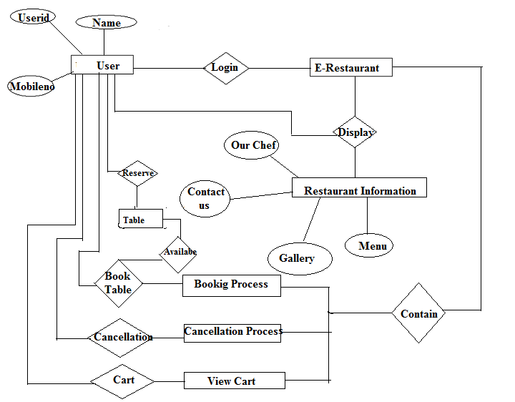

**4.2) Data Flow Diagram (0 & 1 Level):**

**ZERO LEVEL D.F.D**

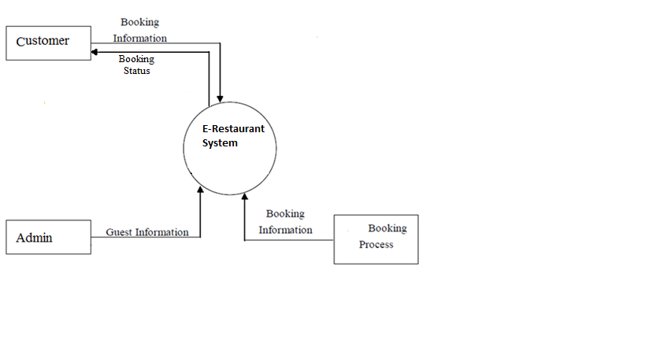

**LEVEL ONE D.F.D.**

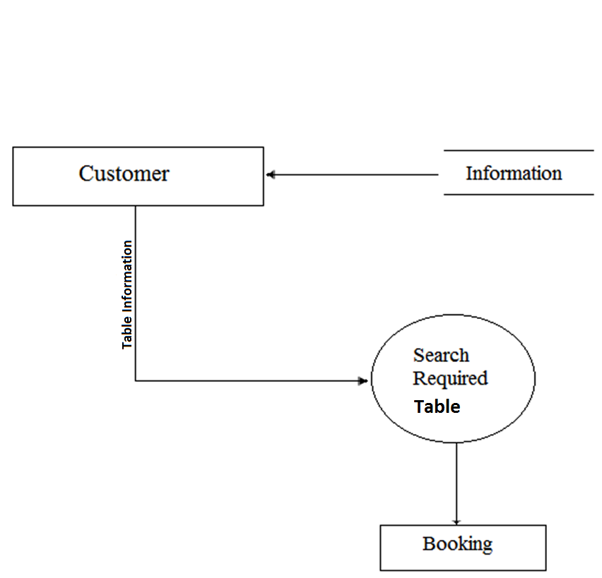

**4.3) Modules:**

We Design following modules in our Project**.**

**1. Information:** In this module we are try to give inforformation about our hotel, to the customer .in this we also tell the facelities available in hotel.

**2.** **Custumer Details**: In this Module we take the basic Information of coustomer like Name, Mobile Number, E-Mail ID ,Address ect., and store them in our Database.

**3.** **Login:** In this module we take the use Administrator and check that whether it an authenticated admin or not.and then give the information about customer those reseve room in our hotel.

**4. Book Table:** In This module we book table.

**5.** **Order:** In this Module we Place the order of seleted item.

**6. Cart:** In this module we view the order item. .

**7.Cancellation:** In The module we cancel the table and order.

**8.** **Avalability:** In the module we check the avalaiblity of Table.

**9. Contact Us:** In this module customer communicate the Restaurant Staff and give Own view and suggestion .

**4.4) Database:**

**Register User Table:**

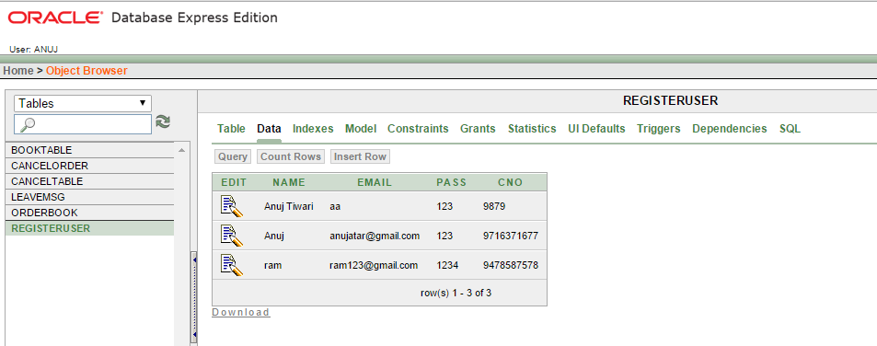

**Book Table:**

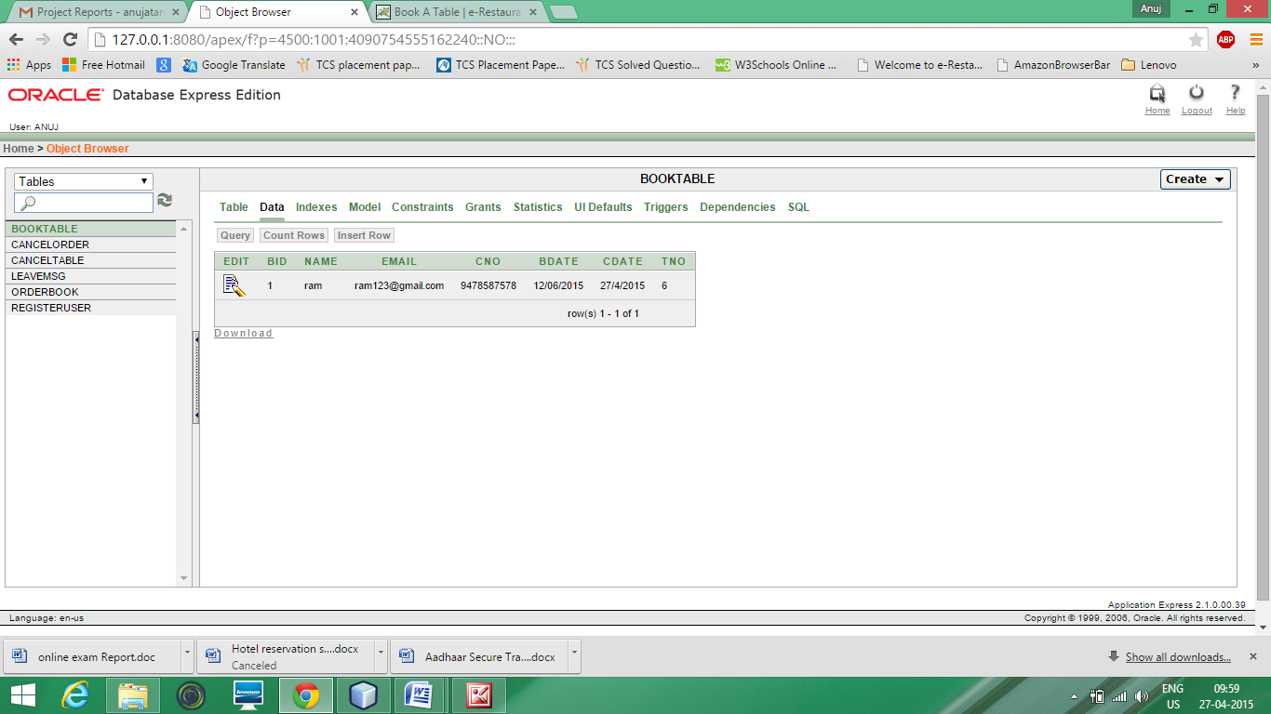

**OrderBook Table:**

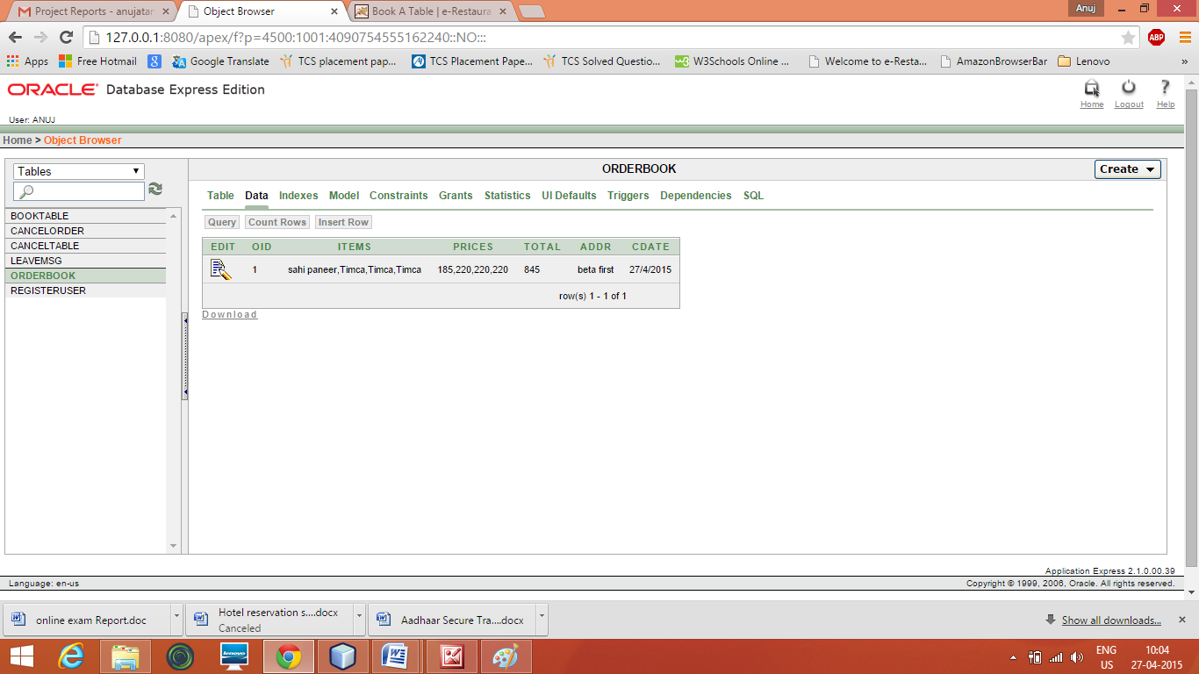

**Leavemsg Table:**

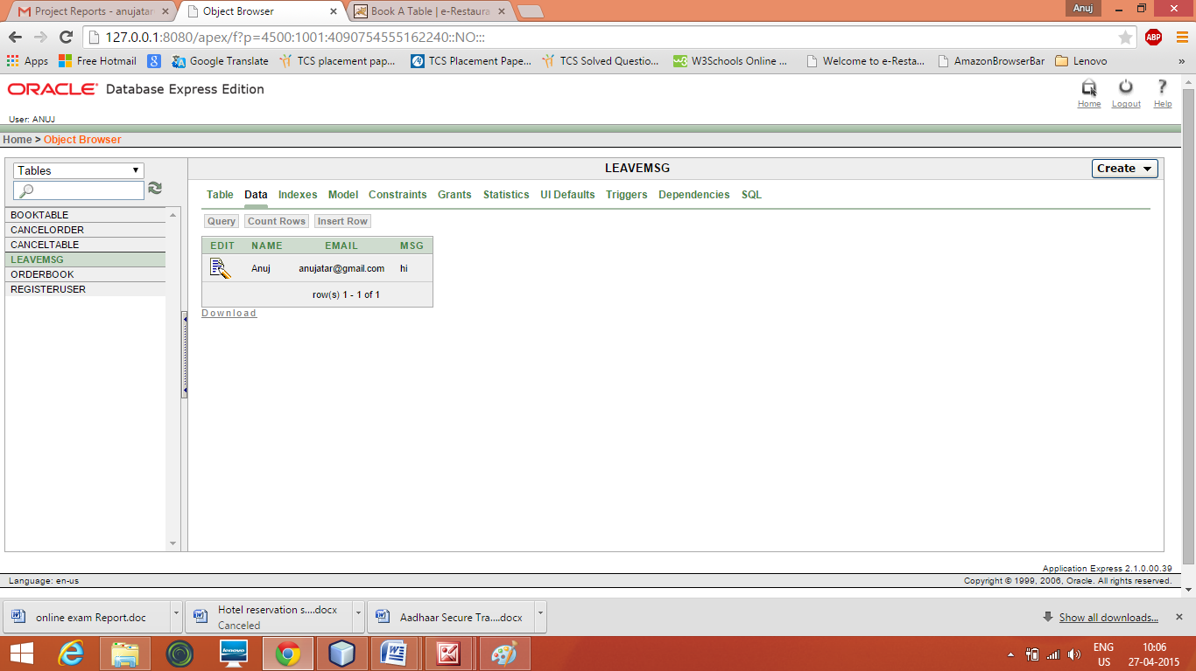

**Cancel Table:**

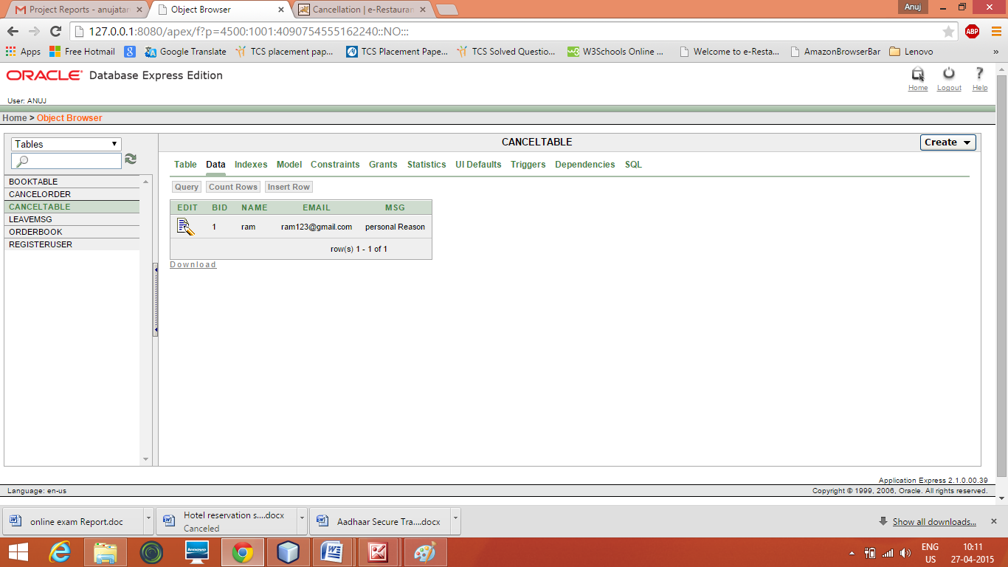

**Cancel Order Table:**

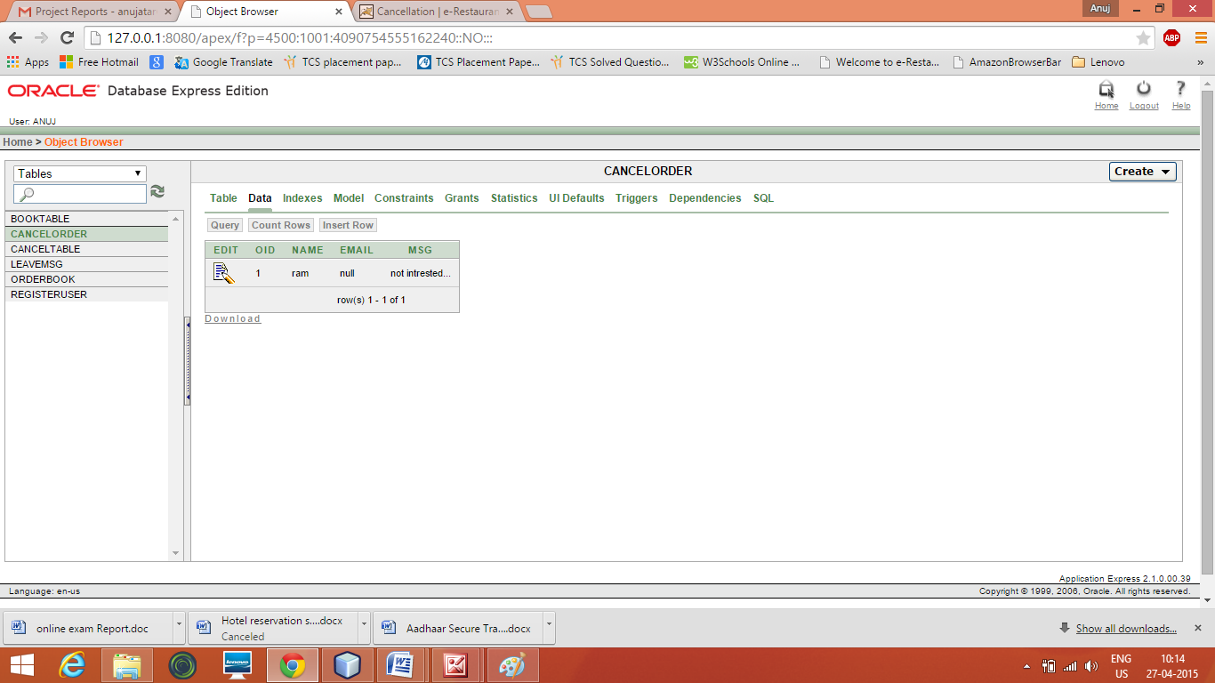

**4.5) Input-Output form (Screen Layout)**

**Home Page:**

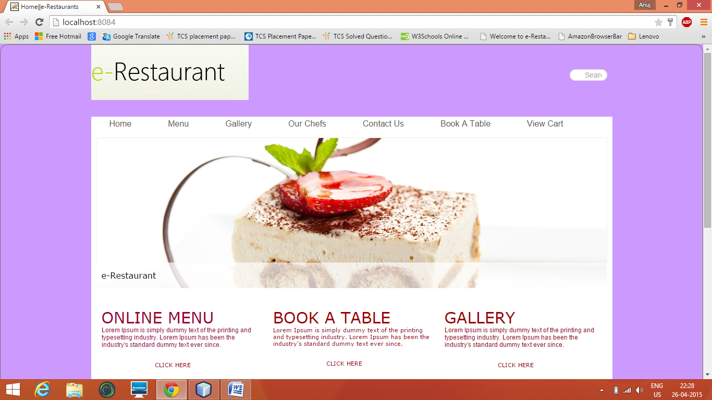

**Login Page:**

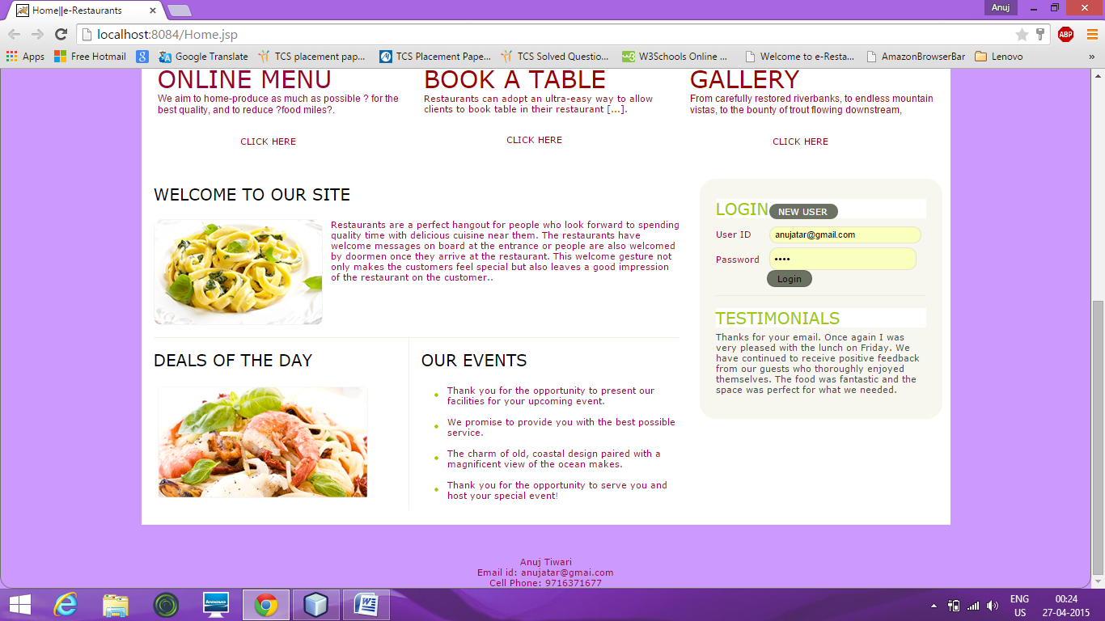

**Registration Page:**

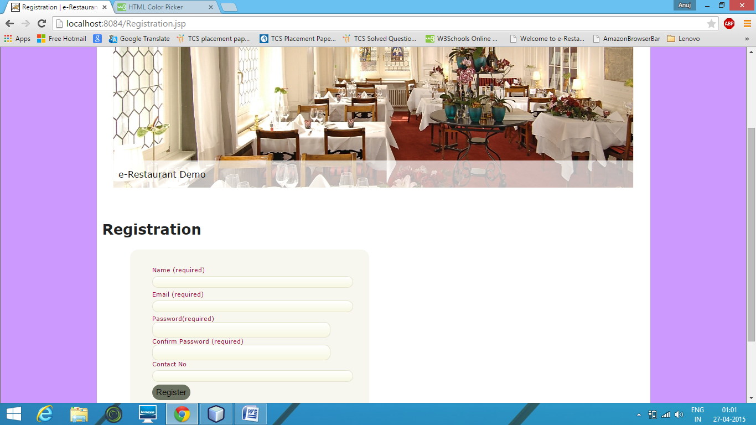

**Book Table Page:**

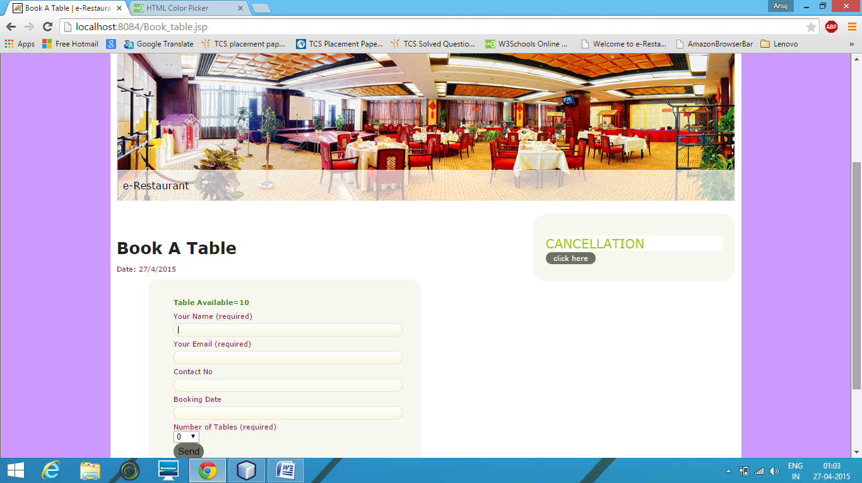

**Contact Us Page:**

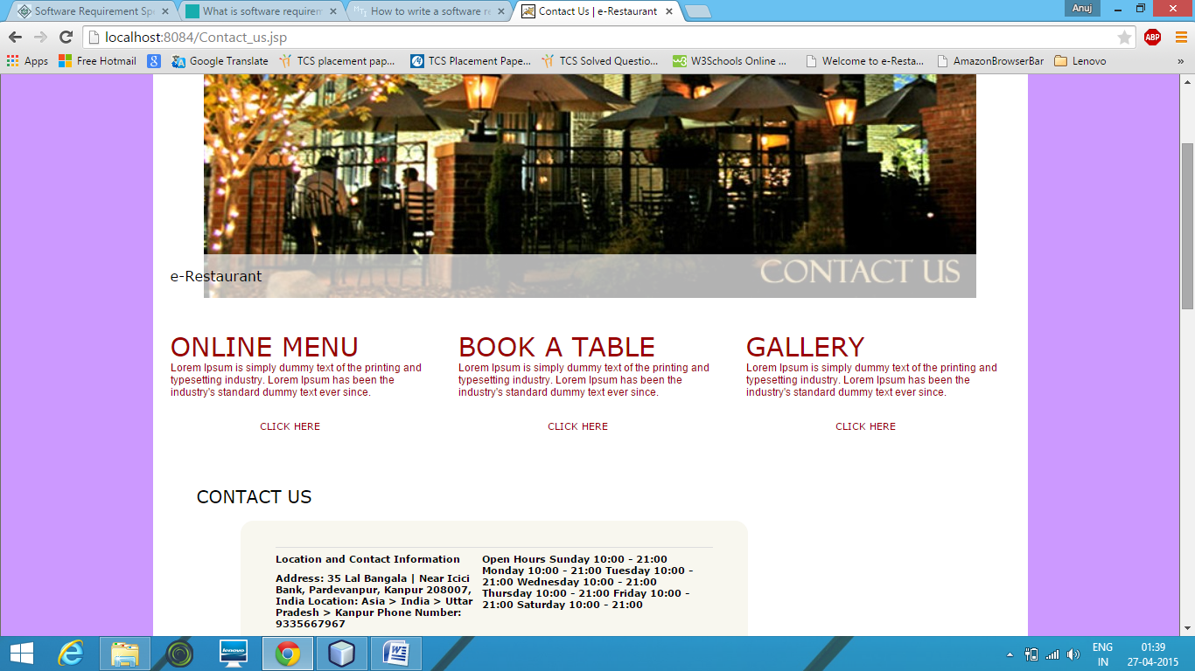

**On Map:**

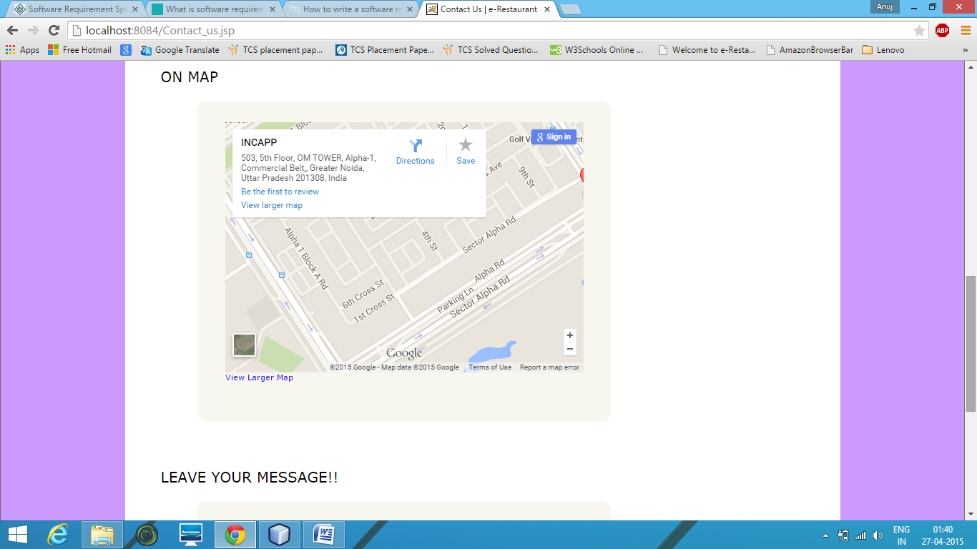

**Leave Message:**

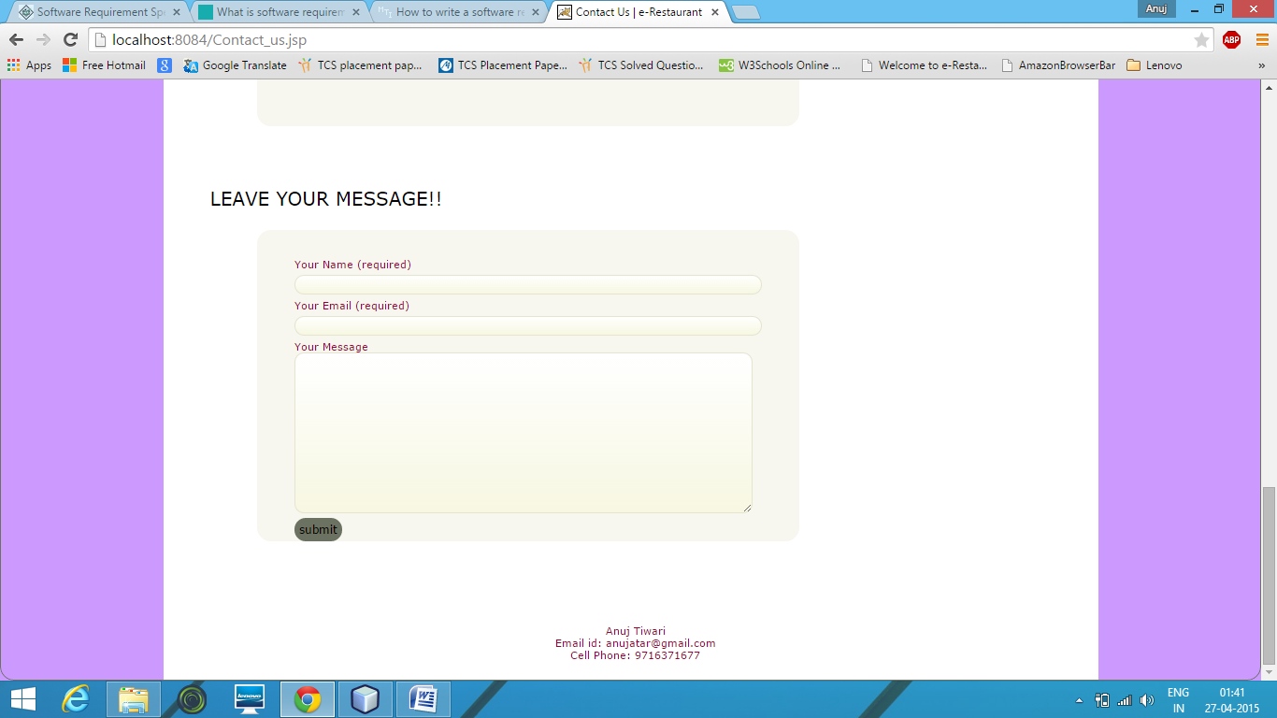

**Our Chef Page:**

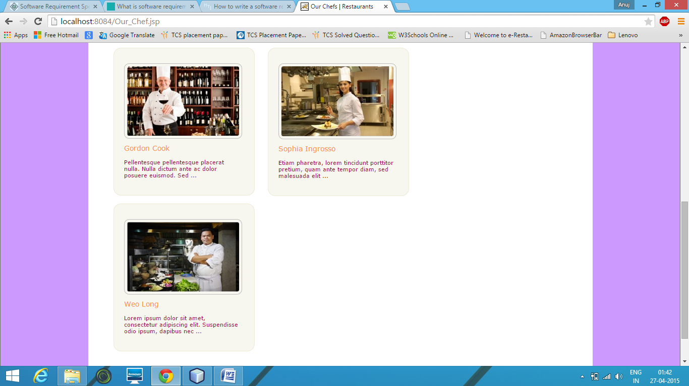

**Gallery Page:**

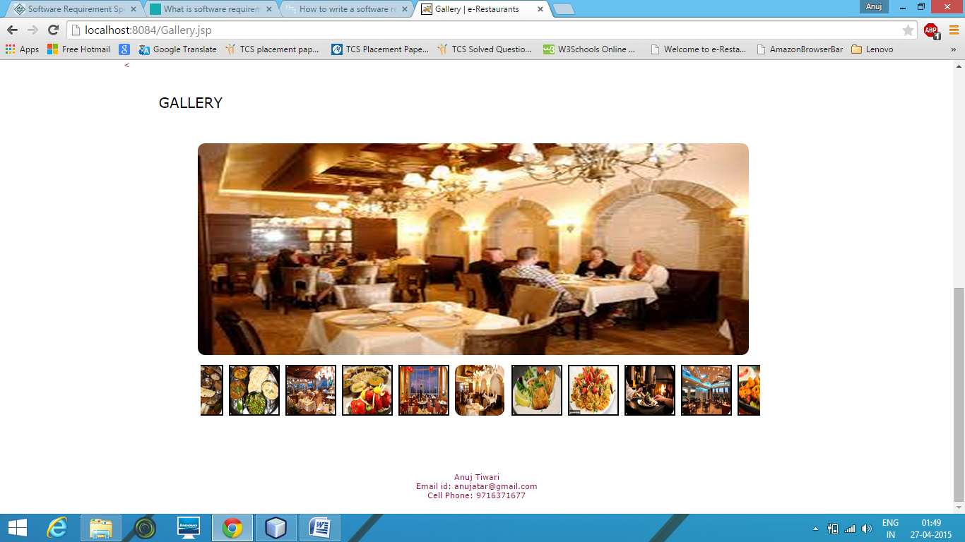

**Menu Page:**

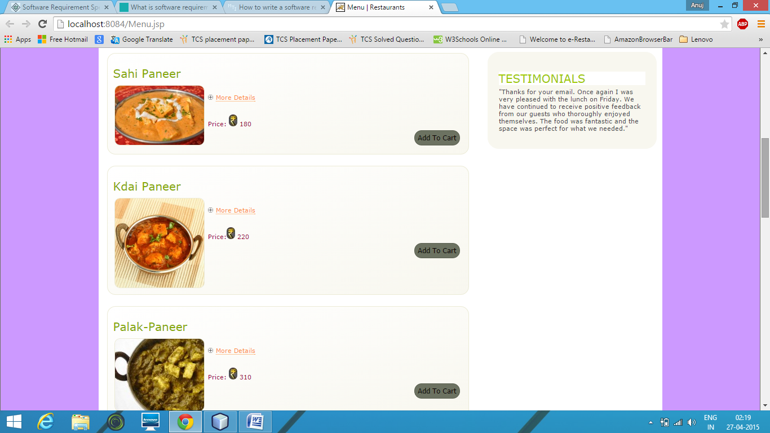

**Cart Page:**

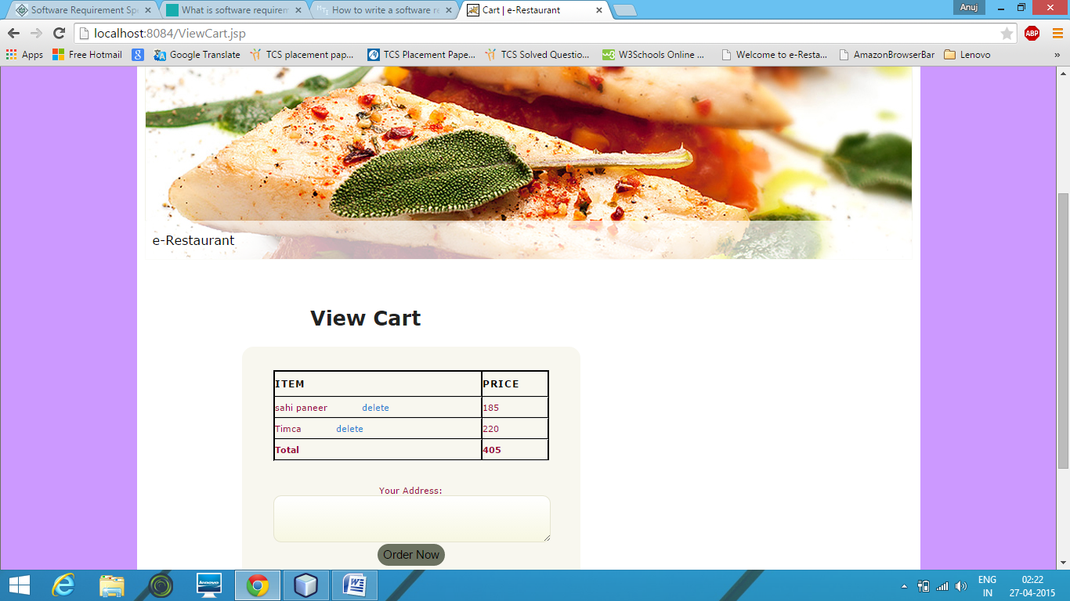

**Cancellation Page:**

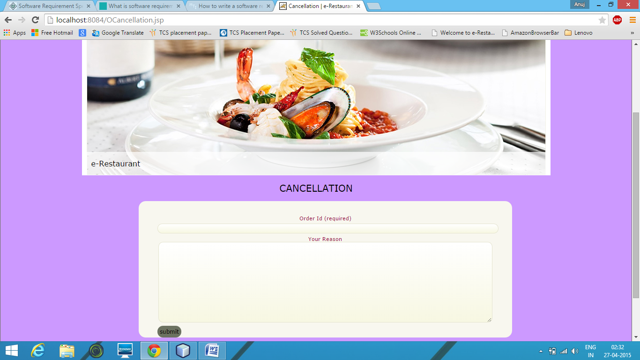

**Coding**

**Home Page:**

<!DOCTYPE html

<html lang="en-US">

<!--<![endif]-->

<head>

<meta charset="UTF-8" />

<meta name="viewport" content="width=device-width" />

<title>Home||e-Restaurants</title>

<link rel="profile" href="http://gmpg.org/xfn/11" />

<link rel="stylesheet" type="text/css" media="all" href="wp-content/themes/twentyelevencutom/style.css" />

<link rel="alternate" type="application/rss+xml" title="e-Restaurants &raquo; Feed" href="http://e-restaurant.com/Home/?feed=rss2" />

<link rel="alternate" type="application/rss+xml" title="e-Restaurant &raquo; Comments Feed" href="http://e-restaurant.com/Home/?feed=comments-rss2" />

<link rel="alternate" type="application/rss+xml" title="e-Restaurant &raquo; Home Comments Feed" href="Home.xml" />

<link rel='stylesheet' id='slider-ui-css' href='wp-content/plugins/thethe-image-slider/style/css/thethe-image-slider.css' type='text/css' media='screen' />

<link rel='stylesheet' id='wpsc-thickbox-css' href='wp-content/plugins/wp-e-commerce/wpsc-core/js/thickbox.css' type='text/css' media='all' />

<link rel='stylesheet' id='wpsc-theme-css-css' href='wp-content/themes/twentyelevencutom/wpsc-default.css' type='text/css' media='all' />

<style type='text/css'>

/*

* Default View Styling

*/

div.default_product_display div.textcol{

margin-left: 158px !important;

min-height: 148px;

_height: 148px;

}

div.default_product_display div.textcol div.imagecol{

position:absolute;

top:0px;

left: 0px;

margin-left: -158px !important;

}

div.default_product_display div.textcol div.imagecol a img {

width: 148px;

height: 148px;

}

.wpsc_category_grid_item {

display:block;

float:left;

width: 148px;

height: 148px;

}

.wpsc_category_grid_item span{

position:relative;

top:16.2222222222px;

}

div.default_product_display div.item_no_image a {

width: 146px;

}

div.default_product_display .imagecol img.no-image, #content div.default_product_display .imagecol img.no-image {

width: 148px;

height: 148px;

}

/*

* Single View Styling*/

div.single_product_display div.item_no_image {

width: 146px;

height: 146px;

}

div.single_product_display div.item_no_image a {

width: 146px;

}

div.single_product_display div.textcol{

margin-left: 158px !important;

min-height: 148px;

_height: 148px;

}

div.single_product_display div.textcol div.imagecol{

position:absolute;

margin-left: -158px !important;

}

div.single_product_display div.textcol div.imagecol a img {

width: 148px;

height: 148px;

}

div#categorydisplay{

display: block;

}

div#branddisplay{

display: none;

}

</style>

<link rel='stylesheet' id='wpsc-theme-css-compatibility-css' href='wp-content/plugins/wp-e-commerce/wpsc-theme/compatibility.css' type='text/css' media='all' />

<link rel='stylesheet' id='cptchStylesheet-css' href='wp-content/plugins/captcha/css/style.css' type='text/css' media='all' />

<link rel='stylesheet' id='contact-form-7-css' href='wp-content/plugins/contact-form-7/includes/css/styles.css' type='text/css' media='all' />

<link rel='stylesheet' id='gllrStylesheet-css' href='wp-content/plugins/gallery-plugin/css/stylesheet.css' type='text/css' media='all' />

<link rel='stylesheet' id='gllrFancyboxStylesheet-css' href='wp-content/plugins/gallery-plugin/fancybox/jquery.fancybox-1.3.4.css' type='text/css' media='all' />

<script type='text/javascript' src='https://ajax.googleapis.com/ajax/libs/jquery/1.6.4/jquery.min.js?ver=1.6.4'></script>

<script type='text/javascript' src='wp-content/plugins/wp-e-commerce/wpsc-core/js/wp-e-commerce.js'></script>

<script type='text/javascript' src='wp-content/plugins/wp-e-commerce/wpsc-core/js/jquery.infieldlabel.min.js'></script>

<script type='text/javascript' src='wp-content/plugins/wp-e-commerce/wpsc-core/js/ajax.js'></script>

<script type='text/javascript'>

/* <![CDATA[ */

var wpsc_ajax = {"ajaxurl":"http:\/\/e-restaurant.com\/Home\/wp-admin\/admin-ajax.php","spinner":"http:\/\/e-restaurant.com\/Home\/wp-admin\/images\/wpspin_light.gif","no_quotes":"It appears that there are no shipping quotes for the shipping information provided. Please check the information and try again."};

/* ]]> */

</script>

<script type='text/javascript' src='index.JS'></script>

<script type='text/javascript' src='wp-content/plugins/wp-e-commerce/wpsc-admin/js/jquery.livequery.js'></script>

<script type='text/javascript' src='wp-content/plugins/wp-e-commerce/wpsc-core/js/user.js'></script>

<script type='text/javascript' src='wp-content/plugins/wp-e-commerce/wpsc-core/js/thickbox.js'></script>

<script type='text/javascript' src='wp-content/themes/twentyelevencutom/js/showcase.js'></script>

<script type='text/javascript' src='wp-includes/js/comment-reply.min.js'></script>

<script type='text/javascript' src='wp-content/plugins/g

allery-plugin/fancybox/jquery.mousewheel-3.0.4.pack.js'></script>

<script type='text/javascript' src='wp-content/plugins/gallery-plugin/fancybox/jquery.fancybox-1.3.4.pack.js'></script>

<script type='text/javascript' src='wp-content/plugins/thethe-image-slider/style/js/thethe-image-slider.js'></script>

<link rel="EditURI" type="application/rsd+xml" title="RSD" href="xmlrpc.xml" />

<link rel="wlwmanifest" type="application/wlwmanifest+xml" href="wp-includes/wlwmanifest.xml" />

<link rel='prev' title='Contact Us' href='Contact us.jsp' />

<link rel='next' title='Book A Table' href='Book table.jsp' />

<meta name="generator" content="WordPress 3.5.2" />

<link rel='canonical' href='Home.jsp' />

<script type='text/javascript' src='wp-includes/js/tw-sack.min.js'></script>

<script type="text/javascript">

//<![CDATA[

function validateform(){

var name=document.myform.name.value;

var password=document.myform.password.value;

if (name==null || name==""){

alert("Name can't be blank");

return false;

}else if(password.length<6){

alert("Password must be at least 6 characters long.");

return false;

}

}

</script> <link rel='alternate' type='application/rss+xml' title='Restaurants Demo Sample Product List RSS' href='http://e-restaurant.com/Home?wpsc_action=rss'/><style type="text/css" id="custom-background-css">

body.custom-background { background-color: #CC99FF; }

.style4 {font-weight: 500; text-transform: uppercase; font-size: 30px;}

.style5 {font-weight:normal; font: 12px normal Verdana, Geneva, sans-serif;}

.style6 {color: #990000}

</style>

</head>

<body class="home page page-id-38 page-template page-template-showcase-php custom-background single-author two-column right-sidebar">

<div id="page" class="hfeed">

<header id="branding" role="banner">

<hgroup>

<h1 id="site-title"><a href="Home.jsp"><img src="wp-content/themes/twentyelevencutom/images/logo_04.gif"></a></h1>

</hgroup>

<div class="body-top">&nbsp;</div>

<%

String s=(String)session.getAttribute("naam");

if(s!=null)

{

%>

<p><span style="color:#000000; font:14px Verdana, Geneva, sans-serif; float: right;">Welcome <%=s%>,</span></p>

<h1 ><a href="logout.jsp" style="color:#ff3333; font:16px Verdana, Geneva, sans-serif; float: right;">Logout</a></h1>

<br/><br/>

<%

}

%>

<nav id="access" role="navigation">

<h3 class="assistive-text">Main menu</h3>

<div class="skip-link"><a class="assistive-text" href="Home.jsp#content" title="Skip to primary content">Skip to primary content</a></div>

<div class="skip-link"><a class="assistive-text" href="Home.jsp#secondary" title="Skip to secondary content">Skip to secondary content</a></div>

<div class="menu-menubar-container"><ul id="menu-menubar" class="menu">

<li id="menu-item-77" class="menu-item menu-item-type-post_type menu-item-object-page menu-item-77"><a href="Home.jsp">Home</a></li>

<li id="menu-item-82" class="menu-item menu-item-type-post_type menu-item-object-page menu-item-82"><a href="Menu.jsp">Menu</a></li>

<li id="menu-item-80" class="menu-item menu-item-type-post_type menu-item-object-page menu-item-80"><a href="Gallery.jsp">Gallery</a></li>

<li id="menu-item-79" class="menu-item menu-item-type-post_type menu-item-object-page menu-item-79"><a href="Our_Chef.jsp">Our Chefs</a></li>

<li id="menu-item-78" class="menu-item menu-item-type-post_type menu-item-object-page menu-item-78"><a href="Contact_us.jsp">Contact Us</a></li>

<li id="menu-item-293" class="menu-item menu-item-type-post_type menu-item-object-page menu-item-293"><a href="Book_table.jsp">Book A Table</a></li>

<li id="menu-item-81" class="menu-item menu-item-type-post_type menu-item-object-page menu-item-81"><a href="ViewCart.jsp">View Cart</a></li>

</ul></div> </nav>

<div class="thethe_image_slider frame-white" id="thethe_image_slider142" style="width:980px;"><div class="thethe_image_slider_inner" style="width:980px; height:290px;"><div class="thethe-image-slider-settings"><span class="width">980</span><span class="loop">true</span>

<span class="pagginator_type">dots</span>

<span class="pagginator_position">bottomright</span>

<span class="height">290</span><span class="autoplay">true</span>

<span class="autoresize">false</span>

<span class="trans-time">800</span><span class="skin">http://e-restaurant.com/Home/wp-content/plugins/thethe-image-slider/style/skins/frame-white</span>

</div>

<div class="thethe-image-slider-loader"><div class="thethe-image-slider-progress"></div></div><ul class="thethe-image-slider-slides"><li> <div class="thethe-image-slider-slide-settings">

<span class="time">5000</span>

<span class="transition">random</span>

<span class="slide_caption">true</span>

<span class="caption-size">50</span>

<span class="caption-position">bottom</span>

<span class="caption_opacity">30</span>

<span class="link"></span>

</div><img src="wp-content/uploads/slide.jpg" alt="Slide1" class="thethe-image-slider-image"/>

<div class="thethe-image-slider-caption thethe-image-slider-caption-bottom thethe-image-slider-caption-bg thethe-image-slider-caption-white" ></div>

<div class="thethe-image-slider-caption front thethe-image-slider-caption-bottom thethe-image-slider-caption-white">

<div class="thethe-image-slider-caption-inner" >

<div class="thethe-image-slider-caption-text">e-Restaurant </div>

</div>

</div></li><li> <div class="thethe-image-slider-slide-settings">

<span class="time">5000</span>

<span class="transition">random</span>

<span class="slide_caption">true</span>

<span class="caption-size">50</span>

<span class="caption-position">bottom</span>

<span class="caption_opacity">30</span>

<span class="link"></span>

</div><img src="wp-content/uploads/slide1.jpg" alt="Slide2" class="thethe-image-slider-image"/>

<div class="thethe-image-slider-caption thethe-image-slider-caption-bottom thethe-image-slider-caption-bg thethe-image-slider-caption-white" ></div>

<div class="thethe-image-slider-caption front thethe-image-slider-caption-bottom thethe-image-slider-caption-white">

<div class="thethe-image-slider-caption-inner" >

<div class="thethe-image-slider-caption-text">e-Restaurant</div>

</div>

</div></li><li> <div class="thethe-image-slider-slide-settings">

<span class="time">5000</span>

<span class="transition">random</span>

<span class="slide_caption">true</span>

<span class="caption-size">50</span>

<span class="caption-position">bottom</span>

<span class="caption_opacity">30</span>

<span class="link"></span>

</div><img src="wp-content/uploads/slide2.jpg" alt="Slide3" class="thethe-image-slider-image"/>

<div class="thethe-image-slider-caption thethe-image-slider-caption-bottom thethe-image-slider-caption-bg thethe-image-slider-caption-white" ></div>

<div class="thethe-image-slider-caption front thethe-image-slider-caption-bottom thethe-image-slider-caption-white">

<div class="thethe-image-slider-caption-inner" >

<div class="thethe-image-slider-caption-text"> e-Restaurant </div>

</div>

</div></li><li> <div class="thethe-image-slider-slide-settings">

<span class="time">5000</span>

<span class="transition">random</span>

<span class="slide_caption">true</span>

<span class="caption-size">50</span>

<span class="caption-position">bottom</span>

<span class="caption_opacity">30</span>

<span class="link"></span>

</div><img src="wp-content/uploads/slide3.jpg" alt="Slide4" class="thethe-image-slider-image"/>

<div class="thethe-image-slider-caption thethe-image-slider-caption-bottom thethe-image-slider-caption-bg thethe-image-slider-caption-white" ></div>

<div class="thethe-image-slider-caption front thethe-image-slider-caption-bottom thethe-image-slider-caption-white">

<div class="thethe-image-slider-caption-inner" >

<div class="thethe-image-slider-caption-text"> e-Restaurant </div>

</div>

</div></li><li> <div class="thethe-image-slider-slide-settings">

<span class="time">5000</span>

<span class="transition">random</span>

<span class="slide_caption">true</span>

<span class="caption-size">50</span>

<span class="caption-position">bottom</span>

<span class="caption_opacity">30</span>

<span class="link"></span>

</div><img src="wp-content/uploads/slide4.jpg" alt="Slide5" class="thethe-image-slider-image"/>

<div class="thethe-image-slider-caption thethe-image-slider-caption-bottom thethe-image-slider-caption-bg thethe-image-slider-caption-white" ></div>

<div class="thethe-image-slider-caption front thethe-image-slider-caption-bottom thethe-image-slider-caption-white">

<div class="thethe-image-slider-caption-inner" >

<div class="thethe-image-slider-caption-text"> e-Restaurant </div>

</div>

</div></li><li> <div class="thethe-image-slider-slide-settings">

<span class="time">5000</span>

<span class="transition">random</span>

<span class="slide_caption">true</span>

<span class="caption-size">50</span>

<span class="caption-position">bottom</span>

<span class="caption_opacity">30</span>

<span class="link"></span>

</div><img src="wp-content/uploads/slide5.jpg" alt="Slide6" class="thethe-image-slider-image"/>

<div class="thethe-image-slider-caption thethe-image-slider-caption-bottom thethe-image-slider-caption-bg thethe-image-slider-caption-white" ></div>

<div class="thethe-image-slider-caption front thethe-image-slider-caption-bottom thethe-image-slider-caption-white">

<div class="thethe-image-slider-caption-inner" >

<div class="thethe-image-slider-caption-text"> e-Restaurant</div>

</div>

</div></li></ul></div><div class="thethe-image-slider-thumbnails thethe-image-slider-thumbnails-dots thethe-image-slider-thumbnailsbottomright"><div class="thethe-image-slider-thumbnails-thumb"></div><div class="thethe-image-slider-thumbnails-thumb"></div><div class="thethe-image-slider-thumbnails-thumb"></div><div class="thethe-image-slider-thumbnails-thumb"></div><div class="thethe-image-slider-thumbnails-thumb"></div><div class="thethe-image-slider-thumbnails-thumb"></div></div></div> <a href="Home.jsp">

<!--<img src="http://e-restaurant.com/Home/wp-content/themes/twentyelevencutom/images/headers/lanterns.jpg" width="1000" height="288" alt="" />-->

</a>

<form method="get" id="searchform" action="Home.jsp">

<label for="s" class="assistive-text">Search</label>

<input type="text" class="field" name="s" id="s" placeholder="Search" />

<input type="submit" class="submit" name="submit" id="searchsubmit" value="Search" />

</form>

<!-- #access -->

</header><!-- #branding -->

<div id="main">

<aside id="text-8" class="widget widget_text style3"><body background="#FFCC00"><h3 class="style4">ONLINE MENU</h3><div class="style5">We aim to home-produce as much as possible ? for the best quality, and to reduce ?food miles?.

<div id="widget"><a href="Menu.jsp" class="style6">Click here</a></div></div>

</aside>

<aside id="text-9" class="widget widget_text"><h3 class="widget-title style6">BOOK A TABLE</h3><div class="textwidget"><span class="style6">Restaurants can adopt an ultra-easy way to allow clients to book table in their restaurant [...].

</span>

<div class="thethe-image-slider-caption-bg" id="widget"><a href="Book_table.jsp" class="style6">Click here</a></div>

</div>

</aside>

<aside id="text-10" class="widget widget_text"><h3 class="widget-title">GALLERY</h3><div class="textwidget">From carefully restored riverbanks, to endless mountain vistas, to the bounty of trout flowing downstream,

<div id="widget"><a href="Gallery.jsp" class="thethe-image-slider-caption-bg style6">Click here</a></div>

</div>

</aside> <!-- .widget-area -->

<div id="primary" class="showcase">

<div id="content" role="main">

<article id="post-38" class="post-38 page type-page status-publish hentry intro">

<!-- .entry-header -->

<div class="entry-content">

<div class="body-left">

<div class="welcome">

<p><span class="headings">WELCOME TO OUR SITE</span></p>

<p>&nbsp;<br />

<img src="wp-content/themes/twentyelevencutom/images/welcome.jpg" /></p>

<p>Restaurants are a perfect hangout for people who look forward to spending quality time with delicious cuisine near them. The restaurants have welcome messages on board at the entrance or people are also welcomed by doormen once they arrive at the restaurant. This welcome gesture not only makes the customers feel special but also leaves a good impression of the restaurant on the customer..</p>

</div>

<div class="dealsoftheday"><span class="headings">DEALS OF THE DAY</span><br />

<img src="wp-content/themes/twentyelevencutom/images/dealsoftheday.gif" alt="" /></div>

<div class="ourevents">

<p><span class="headings">OUR EVENTS</span><br />

<br />

<img src="wp-content/themes/twentyelevencutom/images/smallgreendot.png" alt="" /></p>

<p>Thank you for the opportunity to present our facilities for your upcoming event.<br />

<br />

<img src="wp-content/themes/twentyelevencutom/images/smallgreendot.png" alt="" /></p>

<p>We promise to provide you with the best possible service.<br />

<br />

<img src="wp-content/themes/twentyelevencutom/images/smallgreendot.png" alt="" /></p>

<p>The charm of old, coastal design paired with a magnificent view of the ocean makes.<br />

<br />

<img src="wp-content/themes/twentyelevencutom/images/smallgreendot.png" alt="" /></p>

<p>Thank you for the opportunity to serve you and host your special event!</p>

</div>

</div>

</div><!-- .entry-content -->

</article><!-- #post-38 -->

<section class="recent-posts">

<h1 class="showcase-heading"></h1>

</section><!-- .recent-posts -->

</div><!-- #content -->

</div><!-- #primary -->

<div id="secondary" class="widget-areatwo" role="complementary">

<aside id="alo-easymail-widget-2" class="widget alo_easymail_widget"><h3 class="widget-title">Login<a href="Registration.jsp">New User</a></h3><div id='alo_em_widget_loading' class='alo_em_widget_loading' style='display:none;'><img src='wp-content/plugins/alo-easymail/images/wpspin_light.gif' alt='' style='vertical-align:middle' /> sending...</div>

<div id='alo_easymail_widget_feedback'></div>

<form name='myform' id='' class='alo_easymail_widget_form alo_easymail_widget_form_public' method='post' action="LoginProcess.jsp" onsubmit="return validateform()">

<%

String s1=request.getParameter("msg2");

if(s1!=null)

{

%>

<h1 style="color:#398f14"><%=s1%></h1>

<%

}

%>

<table class='alo_easymail_form_table'><tbody>

<tr>

<td><label for='opt_name'>User ID</label></td><td><input type='text' name='uid' value='' id='opt_name' maxlength='50' class='input-text' /></td>

</tr>

<tr>

<td><label for='opt_email'>Password</label></td>

<td><input type='Password' name='pass' value='' id='opt_email' maxlength='50' class='input-text' /></td>

</tr>

</tbody></table>

<input type='submit' name='submit' value='Login' class='input-submit' />

</form>

</aside><aside id="text-11" class="widget widget_text"><h3 class="widget-title">TESTIMONIALS</h3><div class="textwidget">Thanks for your email. Once again I was very pleased with the lunch on Friday. We have continued to receive positive feedback from our guests who thoroughly enjoyed themselves. The food was fantastic and the space was perfect for what we needed. </div>

</aside> </div><!-- #secondary .widget-area -->

</div><!-- #main -->

<p><br/></p>

<p style="text-align: center;">&nbsp;</p>

<p style="text-align: center;">&nbsp;</p>

<p style="text-align: center;">Tushar Shukla<br />

Email id: anujatar@gmai.com </p>

<p style="text-align: center;">Cell Phone: 9971361254</p>

</div><!-- .entry-content -->

<footer class="entry-meta">

</footer><!-- .entry-meta -->

</article><!-- #post-27 -->

<footer id="colophon" role="contentinfo">

</body>

</html>

**Registration Page:**

<%--

Document : Registration

Created on : 27 Mar, 2015, 5:03:23 PM

Author : Tushar Shukla

--%>

<%@page contentType="text/html" pageEncoding="UTF-8"%>

<!DOCTYPE html>

<html lang="en-US">

<!--<![endif]-->

<head>

<meta charset="UTF-8" />

<meta name="viewport" content="width=device-width" />

<title>Registration | e-Restaurant</title>

<link rel="profile" href="http://gmpg.org/xfn/11" />

<link rel="stylesheet" type="text/css" media="all" href="wp-content/themes/twentyelevencutom/style.css" />

<link rel="pingback" href="xmlrpc.php" />

<!--[if lt IE 9]>

<script src="http://e-restaurant.com/Home/wp-content/themes/twentyelevencutom/js/html5.js" type="text/javascript"></script>

<![endif]-->

<link rel="alternate" type="application/rss+xml" title="Restaurants Demo Sample &raquo; Feed" href="http://e-restaurant.com/Home/?feed=rss2" />

<link rel="alternate" type="application/rss+xml" title="Restaurants Demo Sample &raquo; Comments Feed" href="http://e-restaurant.com/Home/?feed=comments-rss2" />

<link rel='stylesheet' id='slider-ui-css' href='wp-content/plugins/thethe-image-slider/style/css/thethe-image-slider.css' type='text/css' media='screen' />

<link rel='stylesheet' id='wpsc-thickbox-css' href='wp-content/plugins/wp-e-commerce/wpsc-core/js/thickbox.css' type='text/css' media='all' />

<link rel='stylesheet' id='wpsc-theme-css-css' href='wp-content/themes/twentyelevencutom/wpsc-default.css' type='text/css' media='all' />

<style type='text/css'>

/*

* Default View Styling

*/

div.default_product_display div.textcol{

margin-left: 158px !important;

min-height: 148px;

_height: 148px;

}

div.default_product_display div.textcol div.imagecol{

position:absolute;

top:0px;

left: 0px;

margin-left: -158px !important;

}

div.default_product_display div.textcol div.imagecol a img {

width: 148px;

height: 148px;

}

.wpsc_category_grid_item {

display:block;

float:left;

width: 148px;

height: 148px;

}

.wpsc_category_grid_item span{

position:relative;

top:16.2222222222px;

}

div.default_product_display div.item_no_image a {

width: 146px;

}

div.default_product_display .imagecol img.no-image, #content div.default_product_display .imagecol img.no-image {

width: 148px;

height: 148px;

}

/*

* Single View Styling

*/

div.single_product_display div.item_no_image {

width: 146px;

height: 146px;

}

div.single_product_display div.item_no_image a {

width: 146px;

}

div.single_product_display div.textcol{

margin-left: 158px !important;

min-height: 148px;

_height: 148px;

}

div.single_product_display div.textcol div.imagecol{

position:absolute;

margin-left: -158px !important;

}

div.single_product_display div.textcol div.imagecol a img {

width: 148px;

height: 148px;

}

div#categorydisplay{

display: block;

}

div#branddisplay{

display: none;

}

</style>

<link rel='stylesheet' id='wpsc-theme-css-compatibility-css' href='wp-content/plugins/wp-e-commerce/wpsc-theme/compatibility.css' type='text/css' media='all' />

<link rel='stylesheet' id='cptchStylesheet-css' href='wp-content/plugins/captcha/css/style.css' type='text/css' media='all' />

<link rel='stylesheet' id='contact-form-7-css' href='wp-content/plugins/contact-form-7/includes/css/styles.css' type='text/css' media='all' />

<link rel='stylesheet' id='gllrStylesheet-css' href='wp-content/plugins/gallery-plugin/css/stylesheet.css' type='text/css' media='all' />

<link rel='stylesheet' id='gllrFancyboxStylesheet-css' href='wp-content/plugins/gallery-plugin/fancybox/jquery.fancybox-1.3.4.css' type='text/css' media='all' />

<script type='text/javascript' src='https://ajax.googleapis.com/ajax/libs/jquery/1.6.4/jquery.min.js?ver=1.6.4'></script>

<script type='text/javascript' src='wp-content/plugins/wp-e-commerce/wpsc-core/js/wp-e-commerce.js'></script>

<script type='text/javascript' src='wp-content/plugins/wp-e-commerce/wpsc-core/js/jquery.infieldlabel.min.js'></script>

<script type='text/javascript' src='wp-content/plugins/wp-e-commerce/wpsc-core/js/ajax.js'></script>

<script type='text/javascript'>

/* <![CDATA[ */

var wpsc_ajax = {"ajaxurl":"http:\/\/e-restaurant.com\/Home\/wp-admin\/admin-ajax.php","spinner":"http:\/\/e-restaurant.com\/Home\/wp-admin\/images\/wpspin_light.gif","no_quotes":"It appears that there are no shipping quotes for the shipping information provided. Please check the information and try again."};

/* ]]> */

</script>

<script type='text/javascript' src='index.JS'></script>

<script type='text/javascript' src='wp-content/plugins/wp-e-commerce/wpsc-admin/js/jquery.livequery.js'></script>

<script type='text/javascript' src='wp-content/plugins/wp-e-commerce/wpsc-core/js/user.js'></script>

<script type='text/javascript' src='wp-content/plugins/wp-e-commerce/wpsc-core/js/thickbox.js'></script>

<script type='text/javascript' src='wp-includes/js/comment-reply.min.js'></script>

<script type='text/javascript' src='wp-content/plugins/gallery-plugin/fancybox/jquery.mousewheel-3.0.4.pack.js'></script>

<script type='text/javascript' src='wp-content/plugins/gallery-plugin/fancybox/jquery.fancybox-1.3.4.pack.js'></script>

<script type='text/javascript' src='wp-content/plugins/thethe-image-slider/style/js/thethe-image-slider.js'></script>

<link rel="EditURI" type="application/rsd+xml" title="RSD" href="xmlrpc<div>.xml</div>" />

<link rel="wlwmanifest" type="application/wlwmanifest+xml" href="wp-includes/wlwmanifest.xml" />

<link rel='prev' title='Home' href='../Home.jsp' />

<link rel='next' title='Checkout' href='check out.jsp' />

<meta name="generator" content="WordPress 3.5.2" />

<link rel='canonical' href='Book_table.jsp' />

<script type='text/javascript' src='wp-includes/js/tw-sack.min.js'></script>

<link rel='alternate' type='application/rss+xml' title='Restaurants Demo Sample Product List RSS' href='http://e-restaurant.com/Home?wpsc_action=rss'/><style type="text/css" id="custom-background-css">

body.custom-background { background-color: #CC99FF; }

</style>

</head>

<body class="page page-id-138 page-child parent-pageid-16 page-template page-template-sidebar-page-php custom-background single-author two-column right-sidebar">

<div id="page" class="hfeed">

<header id="branding" role="banner">

<hgroup>

<h1 id="site-title"><a href="Home.jsp"><img src="wp-content/themes/twentyelevencutom/images/logo_04.gif"></a></h1>

</hgroup>

<div class="body-top">&nbsp;</div>

<%

String s=(String)session.getAttribute("naam");

if(s!=null)

{

%>

<p><span style="color:#000000; font:14px Verdana, Geneva, sans-serif; float: right;">Welcome <%=s%>,</span></p>

<h1 ><a href="logout.jsp" style="color:#ff3333; font:16px Verdana, Geneva, sans-serif; float: right;">Logout</a></h1>

<br/><br/>

<%

}

%>

<nav id="access" role="navigation">

<h3 class="assistive-text">Main menu</h3>

<div class="skip-link"><a class="assistive-text" href="Book_table.jsp#content" title="Skip to primary content">Skip to primary content</a></div>

<div class="skip-link"><a class="assistive-text" href="Book_table.jsp#secondary" title="Skip to secondary content">Skip to secondary content</a></div>

<div class="menu-menubar-container"><ul id="menu-menubar" class="menu">

<li id="menu-item-77" class="menu-item menu-item-type-post_type menu-item-object-page menu-item-77"><a href="Home.jsp">Home</a></li>

<li id="menu-item-82" class="menu-item menu-item-type-post_type menu-item-object-page menu-item-82"><a href="Menu.jsp">Menu</a></li>

<li id="menu-item-80" class="menu-item menu-item-type-post_type menu-item-object-page menu-item-80"><a href="Gallery.jsp">Gallery</a></li>

<li id="menu-item-79" class="menu-item menu-item-type-post_type menu-item-object-page menu-item-79"><a href="Our_Chef.jsp">Our Chefs</a></li>

<li id="menu-item-78" class="menu-item menu-item-type-post_type menu-item-object-page menu-item-78"><a href="Contact_us.jsp">Contact Us</a></li>

<li id="menu-item-293" class="menu-item menu-item-type-post_type menu-item-object-page menu-item-293"><a href="Book_table.jsp">Book A Table</a></li>

<li id="menu-item-81" class="menu-item menu-item-type-post_type menu-item-object-page menu-item-81"><a href="ViewCart.jsp">View Cart</a></li>

</ul></div> </nav>

<div class="thethe_image_slider frame-white" id="thethe_image_slider142" style="width:980px;"><div class="thethe_image_slider_inner" style="width:980px; height:290px;"><div class="thethe-image-slider-settings"><span class="width">980</span><span class="loop">true</span>

<span class="pagginator_type">dots</span>

<span class="pagginator_position">bottomright</span>

<span class="height">290</span><span class="autoplay">true</span>

<span class="autoresize">false</span>

<span class="trans-time">800</span><span class="skin">http://e-restaurant.com/Home/wp-content/plugins/thethe-image-slider/style/skins/frame-white</span>

</div>

<div class="thethe-image-slider-loader"><div class="thethe-image-slider-progress"></div></div><ul class="thethe-image-slider-slides"><li> <div class="thethe-image-slider-slide-settings">

<span class="time">5000</span>

<span class="transition">random</span>

<span class="slide_caption">true</span>

<span class="caption-size">50</span>

<span class="caption-position">bottom</span>

<span class="caption_opacity">30</span>

<span class="link"></span>

</div><img src="wp-content/uploads/slide.jpg" alt="Slide1" class="thethe-image-slider-image"/>

<div class="thethe-image-slider-caption thethe-image-slider-caption-bottom thethe-image-slider-caption-bg thethe-image-slider-caption-white" ></div>

<div class="thethe-image-slider-caption front thethe-image-slider-caption-bottom thethe-image-slider-caption-white">

<div class="thethe-image-slider-caption-inner" >

<div class="thethe-image-slider-caption-text"> e-Restaurant </div>

</div>

</div></li><li> <div class="thethe-image-slider-slide-settings">

<span class="time">5000</span>

<span class="transition">random</span>

<span class="slide_caption">true</span>

<span class="caption-size">50</span>

<span class="caption-position">bottom</span>

<span class="caption_opacity">30</span>

<span class="link"></span>

</div><img src="wp-content/uploads/slide1.jpg" alt="Slide2" class="thethe-image-slider-image"/>

<div class="thethe-image-slider-caption thethe-image-slider-caption-bottom thethe-image-slider-caption-bg thethe-image-slider-caption-white" ></div>

<div class="thethe-image-slider-caption front thethe-image-slider-caption-bottom thethe-image-slider-caption-white">

<div class="thethe-image-slider-caption-inner" >

<div class="thethe-image-slider-caption-text"> e-Restaurant </div>

</div>

</div></li><li> <div class="thethe-image-slider-slide-settings">

<span class="time">5000</span>

<span class="transition">random</span>

<span class="slide_caption">true</span>

<span class="caption-size">50</span>

<span class="caption-position">bottom</span>

<span class="caption_opacity">30</span>

<span class="link"></span>

</div><img src="wp-content/uploads/slide2.jpg" alt="Slide3" class="thethe-image-slider-image"/>

<div class="thethe-image-slider-caption thethe-image-slider-caption-bottom thethe-image-slider-caption-bg thethe-image-slider-caption-white" ></div>

<div class="thethe-image-slider-caption front thethe-image-slider-caption-bottom thethe-image-slider-caption-white">

<div class="thethe-image-slider-caption-inner" >

<div class="thethe-image-slider-caption-text"> e-Restaurant </div>

</div>

</div></li><li> <div class="thethe-image-slider-slide-settings">

<span class="time">5000</span>

<span class="transition">random</span>

<span class="slide_caption">true</span>

<span class="caption-size">50</span>

<span class="caption-position">bottom</span>

<span class="caption_opacity">30</span>

<span class="link"></span>

</div><img src="wp-content/uploads/slide3.jpg" alt="Slide4" class="thethe-image-slider-image"/>

<div class="thethe-image-slider-caption thethe-image-slider-caption-bottom thethe-image-slider-caption-bg thethe-image-slider-caption-white" ></div>

<div class="thethe-image-slider-caption front thethe-image-slider-caption-bottom thethe-image-slider-caption-white">

<div class="thethe-image-slider-caption-inner" >

<div class="thethe-image-slider-caption-text">e-Restaurant Demo</div>

</div>

</div></li><li> <div class="thethe-image-slider-slide-settings">

<span class="time">5000</span>

<span class="transition">random</span>

<span class="slide_caption">true</span>

<span class="caption-size">50</span>

<span class="caption-position">bottom</span>

<span class="caption_opacity">30</span>

<span class="link"></span>

</div><img src="wp-content/uploads/slide4.jpg" alt="Slide5" class="thethe-image-slider-image"/>

<div class="thethe-image-slider-caption thethe-image-slider-caption-bottom thethe-image-slider-caption-bg thethe-image-slider-caption-white" ></div>

<div class="thethe-image-slider-caption front thethe-image-slider-caption-bottom thethe-image-slider-caption-white">

<div class="thethe-image-slider-caption-inner" >

<div class="thethe-image-slider-caption-text">e-Restaurant</div>

</div>

</div></li><li> <div class="thethe-image-slider-slide-settings">

<span class="time">5000</span>

<span class="transition">random</span>

<span class="slide_caption">true</span>

<span class="caption-size">50</span>

<span class="caption-position">bottom</span>

<span class="caption_opacity">30</span> <span class="link"></span>

</div><img src="wp-content/uploads/slide5.jpg" alt="Slide6" class="thethe-image-slider-image"/>

<div class="thethe-image-slider-caption thethe-image-slider-caption-bottom thethe-image-slider-caption-bg thethe-image-slider-caption-white" ></div>

<div class="thethe-image-slider-caption front thethe-image-slider-caption-bottom thethe-image-slider-caption-white">

<div class="thethe-image-slider-caption-inner" >

<div class="thethe-image-slider-caption-text">e-Restaurant</div>

</div>

</div></li></ul></div><div class="thethe-image-slider-thumbnails thethe-image-slider-thumbnails-dots thethe-image-slider-thumbnailsbottomright"><div class="thethe-image-slider-thumbnails-thumb"></div><div class="thethe-image-slider-thumbnails-thumb"></div><div class="thethe-image-slider-thumbnails-thumb"></div><div class="thethe-image-slider-thumbnails-thumb"></div><div class="thethe-image-slider-thumbnails-thumb"></div><div class="thethe-image-slider-thumbnails-thumb"></div></div></div> <a href="../Home.jsp">

<!--<img src="http://e-restaurant.com/Home/wp-content/themes/twentyelevencutom/images/headers/lanterns.jpg" width="1000" height="288" alt="" />-->

</a>

<form method="get" id="searchform" action="../Home.jsp">

<label for="s" class="assistive-text">Search</label>

<input type="text" class="field" name="s" id="s" placeholder="Search" />

<input type="submit" class="submit" name="submit" id="searchsubmit" value="Search" />

</form>

<!-- #access -->

</header><!-- #branding -->

<div id="main">

<div id="primary">

<div id="content" role="main">

<br /><br /><br />

<article id="post-138" class="post-138 page type-page status-publish hentry">

<header class="entry-header">

<h1 class="entry-title">Registration</h1>

</header><!-- .entry-header -->

<div class="entry-content">

<div class="wpcf7" id="wpcf7-f272-p138-o1"><form action="Registration_process.jsp" method="post" class="wpcf7-form">

<div style="display: none;">

<input type="hidden" name="_wpcf7" value="272" />

<input type="hidden" name="_wpcf7_version" value="3.3.1" />

<input type="hidden" name="_wpcf7_unit_tag" value="wpcf7-f272-p138-o1" />

<input type="hidden" name="_wpnonce" value="32a7892a0c" />

</div>

<%

String s3=request.getParameter("msg2");

if(s3!=null)

{

%>

<h1 style="color:#F60"><%=s%></h1>

<%

}

%>

<p> Name (required)<br />

<span class="wpcf7-form-control-wrap your-name"><input type="text" name="name" value="" class="wpcf7-form-control wpcf7-text wpcf7-validates-as-required wpcf7-use-title-as-watermark" size="40" title="Enter your Name"required /></span> </p>

<p> Email (required)<br />

<span class="wpcf7-form-control-wrap your-email"><input type="text" name="email" value="" class="wpcf7-form-control wpcf7-text wpcf7-email wpcf7-validates-as-required wpcf7-validates-as-email wpcf7-use-title-as-watermark" size="40" title="Enter your Email Address" required/></span> </p>

<p>Password(required)<br />

<span class="wpcf7-form-control-wrap Password"><input type="Password" name="password" value="" class="wpcf7-form-control wpcf7-text wpcf7-password wpcf7-validates-as-required wpcf7-validates-as-password wpcf7-use-title-as-watermark" size="40" title="Enter Password" required/></span> </p>

<p>Confirm Password (required)<br />

<span class="wpcf7-form-control-wrap password"><input type="password" name="confirmpasswword" value="" class="wpcf7-form-control wpcf7-text wpcf7-password wpcf7-validates-as-required wpcf7-validates-as-password wpcf7-use-title-as-watermark" size="40" title="Enter Confirm password"required /></span> </p>

<p>Contact No<br />

<span class="wpcf7-form-control-wrap ContactNo"><input type="text" name="contactno" value="" class="wpcf7-form-control wpcf7-text wpcf7-validates-as-required wpcf7-use-title-as-watermark" size="40" title="Enter your Contact No" required/></s

<p><input type="submit" value="Register" class="wpcf7-form-control wpcf7-submit" /></p>

<div class="wpcf7-response-output wpcf7-display-none"></div></form></div>

</div><!-- .entry-content -->

<footer class="entry-meta">

</footer><!-- .entry-meta -->

</article><!-- #post-138 -->

<div id="comments">

</div><!-- #comments -->

<p><br/></p>

<p style="text-align: center;">&nbsp;</p>

<p style="text-align: center;">&nbsp;</p>

<p style="text-align: center;">Tushar Shukla<br />

<p style="text-align: center;">Email id: anujatar@gmai.com </p>

<p style="text-align: center;">Cell Phone: 9971361254</p>

</div><!-- .entry-content -->

<footer class="entry-meta">

</footer><!-- .entry-meta -->

</article><!-- #post-27 -->

</div><!-- #content -->

</div><!-- #primary -->

<!-- #main -->

<script type='text/javascript' src='http://e-restaurant.com/Home/wp-content/plugins/contact-form-7/includes/js/jquery.form.min.js'></script>

<script type='text/javascript'>

/* <![CDATA[ */

var _wpcf7 = {"loaderUrl":"http:\/\/e-restaurant.com\/Home\/wp-content\/plugins\/contact-form-7\/images\/ajax-loader.gif","sending":"Sending ..."};

/* ]]> */

</script>

<script type='text/javascript' src='http://e-restaurant.com/Home/wp-content/plugins/contact-form-7/includes/js/scripts.js'></script>

</body>

</html>

**Book Table Page:**

<%--

Document : Book_table

Created on : 27 Mar, 2015, 5:03:05 PM

Author : Tushar Shukla

--%>

<%@page contentType="text/html" pageEncoding="UTF-8"%>

<!DOCTYPE html>

<html lang="en-US">

<!--<![endif]-->

<head>

<meta charset="UTF-8" />

<meta name="viewport" content="width=device-width" />

<title>Book A Table | e-Restaurant</title>

<link rel="profile" href="http://gmpg.org/xfn/11" />

<link rel="stylesheet" type="text/css" media="all" href="wp-content/themes/twentyelevencutom/style.css" />

<link rel="pingback" href="xmlrpc.php" />

<link rel="alternate" type="application/rss+xml" title="e-Restaurants &raquo; Feed" href="http://e-restaurant.com/Home/?feed=rss2" />

<link rel="alternate" type="application/rss+xml" title="e-Restaurants &raquo; Comments Feed" href="http://e-restaurant.com/Home/?feed=comments-rss2" />

<link rel='stylesheet' id='slider-ui-css' href='wp-content/plugins/thethe-image-slider/style/css/thethe-image-slider.css' type='text/css' media='screen' />

<link rel='stylesheet' id='wpsc-thickbox-css' href='wp-content/plugins/wp-e-commerce/wpsc-core/js/thickbox.css' type='text/css' media='all' />

<link rel='stylesheet' id='wpsc-theme-css-css' href='wp-content/themes/twentyelevencutom/wpsc-default.css' type='text/css' media='all' />

<style type='text/css'>

/*

* Default View Styling

*/

div.default_product_display div.textcol{

margin-left: 158px !important;

min-height: 148px;

_height: 148px;

}

div.default_product_display div.textcol div.imagecol{

position:absolute;

top:0px;

left: 0px;

margin-left: -158px !important;

}

div.default_product_display div.textcol div.imagecol a img {

width: 148px;

height: 148px;

}

.wpsc_category_grid_item {

display:block;

float:left;

width: 148px;

height: 148px;

}

.wpsc_category_grid_item span{

position:relative;

top:16.2222222222px;

}

div.default_product_display div.item_no_image a {

width: 146px;

}

div.default_product_display .imagecol img.no-image, #content div.default_product_display .imagecol img.no-image {

width: 148px;

height: 148px;

}

/*

* Single View Styling

*/

div.single_product_display div.item_no_image {

width: 146px;

height: 146px;

}

div.single_product_display div.item_no_image a {

width: 146px;

}

div.single_product_display div.textcol{

margin-left: 158px !important;

min-height: 148px;

_height: 148px;

}

div.single_product_display div.textcol div.imagecol{

position:absolute;

margin-left: -158px !important;

}

div.single_product_display div.textcol div.imagecol a img {

width: 148px;

height: 148px;

}

div#categorydisplay{

display: block;

}

div#branddisplay{

display: none;

}

</style>

<link rel='stylesheet' id='wpsc-theme-css-compatibility-css' href='wp-content/plugins/wp-e-commerce/wpsc-theme/compatibility.css' type='text/css' media='all' />

<link rel='stylesheet' id='cptchStylesheet-css' href='wp-content/plugins/captcha/css/style.css' type='text/css' media='all' />

<link rel='stylesheet' id='contact-form-7-css' href='wp-content/plugins/contact-form-7/includes/css/styles.css' type='text/css' media='all' />

<link rel='stylesheet' id='gllrStylesheet-css' href='wp-content/plugins/gallery-plugin/css/stylesheet.css' type='text/css' media='all' />

<link rel='stylesheet' id='gllrFancyboxStylesheet-css' href='wp-content/plugins/gallery-plugin/fancybox/jquery.fancybox-1.3.4.css' type='text/css' media='all' />

<script type='text/javascript' src='https://ajax.googleapis.com/ajax/libs/jquery/1.6.4/jquery.min.js?ver=1.6.4'></script>

<script type='text/javascript' src='wp-content/plugins/wp-e-commerce/wpsc-core/js/wp-e-commerce.js'></script>

<script type='text/javascript' src='wp-content/plugins/wp-e-commerce/wpsc-core/js/jquery.infieldlabel.min.js'></script>

<script type='text/javascript' src='wp-content/plugins/wp-e-commerce/wpsc-core/js/ajax.js'></script>

<script type='text/javascript'>

/* <![CDATA[ */

var wpsc_ajax = {"ajaxurl":"http:\/\/e-restaurant.com\/Home\/wp-admin\/admin-ajax.php","spinner":"http:\/\/e-restaurant.com\/Home\/wp-admin\/images\/wpspin_light.gif","no_quotes":"It appears that there are no shipping quotes for the shipping information provided. Please check the information and try again."};

/* ]]> */

</script>

<script type='text/javascript' src='index.JS'></script>

<script type='text/javascript' src='wp-content/plugins/wp-e-commerce/wpsc-admin/js/jquery.livequery.js'></script>

<script type='text/javascript' src='wp-content/plugins/wp-e-commerce/wpsc-core/js/user.js'></script>

<script type='text/javascript' src='wp-content/plugins/wp-e-commerce/wpsc-core/js/thickbox.js'></script>

<script type='text/javascript' src='wp-includes/js/comment-reply.min.js'></script>

<script type='text/javascript' src='wp-content/plugins/gallery-plugin/fancybox/jquery.mousewheel-3.0.4.pack.js'></script>

<script type='text/javascript' src='wp-content/plugins/gallery-plugin/fancybox/jquery.fancybox-1.3.4.pack.js'></script>

<script type='text/javascript' src='wp-content/plugins/thethe-image-slider/style/js/thethe-image-slider.js'></script>

<link rel="EditURI" type="application/rsd+xml" title="RSD" href="xmlrpc<div>.xml</div>" />

<link rel="wlwmanifest" type="application/wlwmanifest+xml" href="wp-includes/wlwmanifest.xml" />

<link rel='prev' title='Home' href='Home.jsp' />

<link rel='next' title='Checkout' href='check out.jsp' />

<meta name="generator" content="WordPress 3.5.2" />

<link rel='canonical' href='Book_table.jsp' />

<script type='text/javascript' src='wp-includes/js/tw-sack.min.js'></script>

<link rel='alternate' type='application/rss+xml' title='e-Restaurants' href='http://e-restaurant.com/Home?wpsc_action=rss'/><style type="text/css" id="custom-background-css">

body.custom-background { background-color: #CC99FF;; }

</style>

</head>

<body class="page page-id-138 page-child parent-pageid-16 page-template page-template-sidebar-page-php custom-background single-author two-column right-sidebar">

<div id="page" class="hfeed">

<header id="branding" role="banner">

<hgroup>

<h1 id="site-title"><a href=Home.jsp"><img src="wp-content/themes/twentyelevencutom/images/logo_04.gif"></a></h1>

</hgroup>

<div class="body-top">&nbsp;</div>

<%

String s=(String)session.getAttribute("naam");

if(s!=null)

{

%>

<p><span style="color:#000000; font:14px Verdana, Geneva, sans-serif; float: right;">Welcome <%=s%>,</span></p>

<h1 ><a href="logout.jsp" style="color:#ff3333; font:16px Verdana, Geneva, sans-serif; float: right;">Logout</a></h1>

<br/><br/>

<%

}

%>

<nav id="access" role="navigation">

<h3 class="assistive-text">Main menu</h3>

<div class="skip-link"><a class="assistive-text" href="Book_table.jsp#content" title="Skip to primary content">Skip to primary content</a></div>

<div class="skip-link"><a class="assistive-text" href="Book_table.jsp#secondary" title="Skip to secondary content">Skip to secondary content</a></div>

<div class="menu-menubar-container"><ul id="menu-menubar" class="menu">

<li id="menu-item-77" class="menu-item menu-item-type-post_type menu-item-object-page menu-item-77"><a href="Home.jsp">Home</a></li>

<li id="menu-item-82" class="menu-item menu-item-type-post_type menu-item-object-page menu-item-82"><a href="Menu.jsp">Menu</a></li>

<li id="menu-item-80" class="menu-item menu-item-type-post_type menu-item-object-page menu-item-80"><a href="Gallery.jsp">Gallery</a></li>

<li id="menu-item-79" class="menu-item menu-item-type-post_type menu-item-object-page menu-item-79"><a href="Our_Chef.jsp">Our Chefs</a></li>

<li id="menu-item-78" class="menu-item menu-item-type-post_type menu-item-object-page menu-item-78"><a href="Contact_us.jsp">Contact Us</a></li>

<li id="menu-item-293" class="menu-item menu-item-type-post_type menu-item-object-page menu-item-293"><a href="Book_table.jsp">Book A Table</a></li>

<li id="menu-item-81" class="menu-item menu-item-type-post_type menu-item-object-page menu-item-81"><a href="ViewCart.jsp">View Cart</a></li>

</ul></div> </nav>

<div class="thethe_image_slider frame-white" id="thethe_image_slider142" style="width:980px;"><div class="thethe_image_slider_inner" style="width:980px; height:290px;"><div class="thethe-image-slider-settings"><span class="width">980</span><span class="loop">true</span>

<span class="pagginator_type">dots</span>

<span class="pagginator_position">bottomright</span>

<span class="height">290</span><span class="autoplay">true</span>

<span class="autoresize">false</span>

<span class="trans-time">800</span><span class="skin">http://e-restaurant.com/Home/wp-content/plugins/thethe-image-slider/style/skins/frame-white</span>

</div>

<div class="thethe-image-slider-loader"><div class="thethe-image-slider-progress"></div></div><ul class="thethe-image-slider-slides"><li> <div class="thethe-image-slider-slide-settings">

<span class="time">5000</span>

<span class="transition">random</span>

<span class="slide_caption">true</span>

<span class="caption-size">50</span>

<span class="caption-position">bottom</span>

<span class="caption_opacity">30</span>

<span class="link"></span>

</div><img src="wp-content/uploads/slide.jpg" alt="Slide1" class="thethe-image-slider-image"/>

<div class="thethe-image-slider-caption thethe-image-slider-caption-bottom thethe-image-slider-caption-bg thethe-image-slider-caption-white" ></div>

<div class="thethe-image-slider-caption front thethe-image-slider-caption-bottom thethe-image-slider-caption-white">

<div class="thethe-image-slider-caption-inner" >

<div class="thethe-image-slider-caption-text"> e-Restaurant </div>

</div>

</div></li><li> <div class="thethe-image-slider-slide-settings">

<span class="time">5000</span>

<span class="transition">random</span>

<span class="slide_caption">true</span>

<span class="caption-size">50</span>

<span class="caption-position">bottom</span>

<span class="caption_opacity">30</span>

<span class="link"></span>

</div><img src="wp-content/uploads/slide1.jpg" alt="Slide2" class="thethe-image-slider-image"/>

<div class="thethe-image-slider-caption thethe-image-slider-caption-bottom thethe-image-slider-caption-bg thethe-image-slider-caption-white" ></div>

<div class="thethe-image-slider-caption front thethe-image-slider-caption-bottom thethe-image-slider-caption-white">

<div class="thethe-image-slider-caption-inner" >

<div class="thethe-image-slider-caption-text"> e-Restaurant </div>

</div>

</div></li><li> <div class="thethe-image-slider-slide-settings">

<span class="time">5000</span>

<span class="transition">random</span>

<span class="slide_caption">true</span>

<span class="caption-size">50</span>

<span class="caption-position">bottom</span>

<span class="caption_opacity">30</span>

<span class="link"></span>

</div><img src="wp-content/uploads/slide2.jpg" alt="Slide3" class="thethe-image-slider-image"/>

<div class="thethe-image-slider-caption thethe-image-slider-caption-bottom thethe-image-slider-caption-bg thethe-image-slider-caption-white" ></div>

<div class="thethe-image-slider-caption front thethe-image-slider-caption-bottom thethe-image-slider-caption-white">

<div class="thethe-image-slider-caption-inner" >

<div class="thethe-image-slider-caption-text"> e-Restaurant </div>

</div>

</div></li><li> <div class="thethe-image-slider-slide-settings">

<span class="time">5000</span>

<span class="transition">random</span>

<span class="slide_caption">true</span>

<span class="caption-size">50</span>

<span class="caption-position">bottom</span>

<span class="caption_opacity">30</span>

<span class="link"></span>

</div><img src="wp-content/uploads/slide3.jpg" alt="Slide4" class="thethe-image-slider-image"/>

<div class="thethe-image-slider-caption thethe-image-slider-caption-bottom thethe-image-slider-caption-bg thethe-image-slider-caption-white" ></div>

<div class="thethe-image-slider-caption front thethe-image-slider-caption-bottom thethe-image-slider-caption-white">

<div class="thethe-image-slider-caption-inner" >

<div class="thethe-image-slider-caption-text">e-Restaurant </div>

</div>

</div></li><li> <div class="thethe-image-slider-slide-settings">

<span class="time">5000</span>

<span class="transition">random</span>

<span class="slide_caption">true</span>

<span class="caption-size">50</span>

<span class="caption-position">bottom</span>

<span class="caption_opacity">30</span>

<span class="link"></span>

</div><img src="wp-content/uploads/slide4.jpg" alt="Slide5" class="thethe-image-slider-image"/>

<div class="thethe-image-slider-caption thethe-image-slider-caption-bottom thethe-image-slider-caption-bg thethe-image-slider-caption-white" ></div>

<div class="thethe-image-slider-caption front thethe-image-slider-caption-bottom thethe-image-slider-caption-white">

<div class="thethe-image-slider-caption-inner" >

<div class="thethe-image-slider-caption-text">e-Restaurant</div>

</div>

</div></li><li> <div class="thethe-image-slider-slide-settings">

<span class="time">5000</span>

<span class="transition">random</span>

<span class="slide_caption">true</span>

<span class="caption-size">50</span>

<span class="caption-position">bottom</span>

<span class="caption_opacity">30</span>

<span class="link"></span>

</div><img src="wp-content/uploads/slide5.jpg" alt="Slide6" class="thethe-image-slider-image"/>

<div class="thethe-image-slider-caption thethe-image-slider-caption-bottom thethe-image-slider-caption-bg thethe-image-slider-caption-white" ></div>

<div class="thethe-image-slider-caption front thethe-image-slider-caption-bottom thethe-image-slider-caption-white">

<div class="thethe-image-slider-caption-inner" >

<div class="thethe-image-slider-caption-text">e-Restaurant</div>

</div>

</div></li></ul></div><div class="thethe-image-slider-thumbnails thethe-image-slider-thumbnails-dots thethe-image-slider-thumbnailsbottomright"><div class="thethe-image-slider-thumbnails-thumb"></div><div class="thethe-image-slider-thumbnails-thumb"></div><div class="thethe-image-slider-thumbnails-thumb"></div><div class="thethe-image-slider-thumbnails-thumb"></div><div class="thethe-image-slider-thumbnails-thumb"></div><div class="thethe-image-slider-thumbnails-thumb"></div></div></div><a href="Home.jsp">

<!--<img src="http://e-restaurant.com/Home/wp-content/themes/twentyelevencutom/images/headers/lanterns.jpg" width="1000" height="288" alt="" />-->

</a>

<form method="get" id="searchform" action="Home.jsp">

<label for="s" class="assistive-text">Search</label>

<input type="text" class="field" name="s" id="s" placeholder="Search" />

<input type="submit" class="submit" name="submit" id="searchsubmit" value="Search" />

</form>

<!-- #access -->

</header><!-- #branding -->

<div id="main">

<div id="primary">

<div id="content" role="main">

<br /><br /><br />

<%

String ss=(String)session.getAttribute("naam");

if(ss!=null)

{

%>

<article id="post-138" class="post-138 page type-page status-publish hentry">

<header class="entry-header">

<h1 class="entry-title">Book A Table</h1>

</header><!-- .entry-header -->

<%

java.util.Date dt;

int dy,mn,yr;

String cdt;

dt=new java.util.Date();

dy=dt.getDate();

mn=dt.getMonth()+1;

yr=dt.getYear()+1900;

cdt=dy+"/"+mn+"/"+yr;

%>

Date: <%=cdt%>

<div class="entry-content">

<div class="wpcf7" id="wpcf7-f272-p138-o1"><form action="Book_tableprocess.jsp" method="post" class="wpcf7-form">

<% int t=(Integer)application.getAttribute("tt");

if(t<=0)

{

%>

<h1 style="color:#990000">Table Unavailable </h1>

<%

}

else{

%>

<h1 style="color:#398f14">Table Available=<%=t%> </h1>

<% }%>

<p>Your Name (required)<br />

<span class="wpcf7-form-control-wrap your-name"><input type="text" name="name" value="" class="wpcf7-form-control wpcf7-text wpcf7-validates-as-required wpcf7-use-title-as-watermark" size="40" title="Enter your Name" required /></span> </p>

<p>Your Email (required)<br />

<span class="wpcf7-form-control-wrap your-email"><input type="text" name="email" value="" class="wpcf7-form-control wpcf7-text wpcf7-email wpcf7-validates-as-required wpcf7-validates-as-email wpcf7-use-title-as-watermark" size="40" title="Enter your Email Address" required/></span> </p>

<p>Contact No<br />

<span class="wpcf7-form-control-wrap ContactNo"><input type="text" name="contactno" value="" class="wpcf7-form-control wpcf7-text wpcf7-validates-as-required wpcf7-use-title-as-watermark" size="40" title="Enter your Contact No" required/></span></p>

<p>Booking Date <br />

<span class="wpcf7-form-control-wrap BookingDate"><input type="text" name="bookingdate" value="" class="wpcf7-form-control wpcf7-text wpcf7-validates-as-required" size="40" required/></span></p>

<p>Number of Tables (required)<br />

<span class="wpcf7-form-control-wrap Bookingfor"><select name="tno" class="wpcf7-form-control wpcf7-select wpcf7-validates-as-required"><option value="0" required>0</option>

<%

for(int i=1;i<=t;i++)

{

%>

<option value="<%=i%>" required><%=i%></option>

<%

}

%>

</select></span></p>

<p><input type="submit" value="Send" class="wpcf7-form-control wpcf7-submit" /></p>

<input type="hidden" name="cdt" value="<%=cdt%>" />

<div class="wpcf7-response-output wpcf7-display-none"></div></form></div>

<%

String s1=request.getParameter("msgt");

if(s1!=null)

{

%>

<h1 style="color:#398f14"><%=s1%></h1>

<%

String s2=request.getParameter("msgt1");

if(s2!=null)

{

%>

<h1 style="color:#398f14"><%=s2%></h1>

<%

}

}

%>

</div><!-- .entry-content -->

<footer class="entry-meta">

</footer><!-- .entry-meta -->

</article><!-- #post-138 -->

</div><!-- #content -->

</div><!-- #primary -->

<div id="secondary" class="widget-areatwo" role="complementary">

<aside id="text-11" class="widget widget_text"><h3 class="widget-title" >cancellation</h3><a href="Cancellation.jsp">click here</a>

</aside> </div><!-- #secondary .widget-area -->

</div><!-- #main -->

<%

}

else

{

%>

<center><h1 style="color:#398f14">Plz Login First!!! &nbsp;&nbsp;&nbsp;&nbsp;&nbsp;<a href="Home.jsp">login here</a></h1></center>

<%

}

%>

<p><br/></p>

<p style="text-align: center;">&nbsp;</p>

<p style="text-align: center;">&nbsp;</p>

<p style="text-align: center;">Tushar Shukla<br />

Email id: tshrshukla79@gmail.com </p>

<p style="text-align: center;">Cell Phone: 9971361254</p>

</div><!-- .entry-content -->

<footer class="entry-meta">

</footer><!-- .entry-meta -->

</article><!-- #post-27 -->

<footer id="colophon" role="contentinfo"/>

</body>

</html>

**Menu Page:**

<%--

Document : Menu

Created on : 27 Mar, 2015, 5:04:16 PM

Author : Tushar Shukla

--%>

<%@page contentType="text/html" pageEncoding="UTF-8"%>

<!DOCTYPE html>

<html lang="en-US">

<!--<![endif]-->

<head>

<meta charset="UTF-8" />

<meta name="viewport" content="width=device-width" />

<title>Menu | Restaurants </title>

<link rel="profile" href="http://gmpg.org/xfn/11" />

<link rel="stylesheet" type="text/css" media="all" href="wp-content/themes/twentyelevencutom/style.css" />

<link rel="pingback" href="xmlrpc.php" />

<!--[if lt IE 9]>

<script src="http://e-restaurant.com/Home/wp-content/themes/twentyelevencutom/js/html5.js" type="text/javascript"></script>

<![endif]-->

<link rel="alternate" type="application/rss+xml" title="Restaurants Demo Sample &raquo; Feed" href="http://e-restaurant.com/Home/?feed=rss2" />

<link rel="alternate" type="application/rss+xml" title="Restaurants Demo Sample &raquo; Comments Feed" href="http://e-restaurant.com/Home/?feed=comments-rss2" />

<link rel='stylesheet' id='slider-ui-css' href='wp-content/plugins/thethe-image-slider/style/css/thethe-image-slider.css' type='text/css' media='screen' />

<link rel='stylesheet' id='wpsc-thickbox-css' href='wp-content/plugins/wp-e-commerce/wpsc-core/js/thickbox.css' type='text/css' media='all' />

<link rel='stylesheet' id='wpsc-theme-css-css' href='wp-content/themes/twentyelevencutom/wpsc-default.css' type='text/css' media='all' />

<style type='text/css'>

/*

* Default View Styling

*/

div.default_product_display div.textcol{

margin-left: 158px !important;

min-height: 148px;

_height: 148px;

}

div.default_product_display div.textcol div.imagecol{

position:absolute;

top:0px;

left: 0px;

margin-left: -158px !important;

}

div.default_product_display div.textcol div.imagecol a img {

width: 148px;

height: 148px;

}

.wpsc_category_grid_item {

display:block;

float:left;

width: 148px;

height: 148px;

}

.wpsc_category_grid_item span{

position:relative;

top:16.2222222222px;

}

div.default_product_display div.item_no_image a {

width: 146px;

}

div.default_product_display .imagecol img.no-image, #content div.default_product_display .imagecol img.no-image {

width: 148px;

height: 148px;

}

/*

* Single View Styling

*/

div.single_product_display div.item_no_image {

width: 146px;

height: 146px;

}

div.single_product_display div.item_no_image a {

width: 146px;

}

div.single_product_display div.textcol{

margin-left: 158px !important;

min-height: 148px;

_height: 148px;

}

div.single_product_display div.textcol div.imagecol{

position:absolute;

margin-left: -158px !important;

}

div.single_product_display div.textcol div.imagecol a img {

width: 148px;

height: 148px;

}

div#categorydisplay{

display: block;

}

div#branddisplay{

display: none;

}

</style>

<link rel='stylesheet' id='wpsc-theme-css-compatibility-css' href='wp-content/plugins/wp-e-commerce/wpsc-theme/compatibility.css' type='text/css' media='all' />

<link rel='stylesheet' id='cptchStylesheet-css' href='wp-content/plugins/captcha/css/style.css' type='text/css' media='all' />

<link rel='stylesheet' id='contact-form-7-css' href='wp-content/plugins/contact-form-7/includes/css/styles.css' type='text/css' media='all' />

<link rel='stylesheet' id='gllrStylesheet-css' href='wp-content/plugins/gallery-plugin/css/stylesheet.css' type='text/css' media='all' />

<link rel='stylesheet' id='gllrFancyboxStylesheet-css' href='wp-content/plugins/gallery-plugin/fancybox/jquery.fancybox-1.3.4.css' type='text/css' media='all' />

<script type='text/javascript' src='https://ajax.googleapis.com/ajax/libs/jquery/1.6.4/jquery.min.js?ver=1.6.4'></script>

<script type='text/javascript' src='wp-content/plugins/wp-e-commerce/wpsc-core/js/wp-e-commerce.js'></script>

<script type='text/javascript' src='wp-content/plugins/wp-e-commerce/wpsc-core/js/jquery.infieldlabel.min.js'></script>

<script type='text/javascript' src='wp-content/plugins/wp-e-commerce/wpsc-core/js/ajax.js'></script>

<script type='text/javascript'>

/* <![CDATA[ */

var wpsc_ajax = {"ajaxurl": "http:\/\/e-restaurant.com\/Home\/wp-admin\/admin-ajax.php", "spinner": "http:\/\/e-restaurant.com\/Home\/wp-admin\/images\/wpspin_light.gif", "no_quotes": "It appears that there are no shipping quotes for the shipping information provided. Please check the information and try again."};

/* ]]> */

</script>

<script type='text/javascript' src='index.JS'></script>

<script type='text/javascript' src='wp-content/plugins/wp-e-commerce/wpsc-admin/js/jquery.livequery.js'></script>

<script type='text/javascript' src='wp-content/plugins/wp-e-commerce/wpsc-core/js/user.js'></script>

<script type='text/javascript' src='wp-content/plugins/wp-e-commerce/wpsc-core/js/thickbox.js'></script>

<script type='text/javascript' src='wp-content/themes/twentyelevencutom/js/showcase.js'></script>

<script type='text/javascript' src='wp-includes/js/comment-reply.min.js'></script>

<script type='text/javascript' src='wp-content/plugins/gallery-plugin/fancybox/jquery.mousewheel-3.0.4.pack.js'></script>

<script type='text/javascript' src='wp-content/plugins/gallery-plugin/fancybox/jquery.fancybox-1.3.4.pack.js'></script>

<script type='text/javascript' src='wp-content/plugins/thethe-image-slider/style/js/thethe-image-slider.js'></script>

<link rel="EditURI" type="application/rsd+xml" title="RSD" href="xmlrpc.xml" />

<link rel="wlwmanifest" type="application/wlwmanifest+xml" href="wp-includes/wlwmanifest.xml" />

<link rel='next' title='Features' href='Gallery.jsp' />

<meta name="generator" content="WordPress 3.5.2" />

<link rel='canonical' href='Menu.jsp' />

<script type='text/javascript' src='wp-includes/js/tw-sack.min.js'></script>

<link rel='alternate' type='application/rss+xml' title='Restaurants Demo Sample Product List RSS' href='http://e-restaurant.com/Home?wpsc_action=rss'/><style type="text/css" id="custom-background-css">

body.custom-background { background-color: #CC99FF; }

</style>

</head>

<body class="page page-id-4 page-template page-template-showcase-php custom-background wpsc single-author two-column right-sidebar">

<div id="page" class="hfeed">

<header id="branding" role="banner">

<hgroup>

<h1 id="site-title"><a href="Home.jsp"><img src="wp-content/themes/twentyelevencutom/images/logo_04.gif"></a></h1>

</hgroup>

<div class="body-top">&nbsp;</div>

<%

String s=(String)session.getAttribute("naam");

if(s!=null)

{

%>

<p><span style="color:#000000; font:14px Verdana, Geneva, sans-serif; float: right;">Welcome <%=s%>,</span></p>

<h1 ><a href="logout.jsp" style="color:#ff3333; font:16px Verdana, Geneva, sans-serif; float: right;">Logout</a></h1>

<br/><br/>

<%

}

%>

<nav id="access" role="navigation">

<h3 class="assistive-text">Main menu</h3>

<div class="skip-link"><a class="assistive-text" href="Menu.jsp#content" title="Skip to primary content">Skip to primary content</a></div>

<div class="skip-link"><a class="assistive-text" href="Menu.jsp#secondary" title="Skip to secondary content">Skip to secondary content</a></div>

<div class="menu-menubar-container">

<ul id="menu-menubar" class="menu">

<li id="menu-item-77" class="menu-item menu-item-type-post_type menu-item-object-page menu-item-77"><a href="Home.jsp">Home</a></li>

<li id="menu-item-82" class="menu-item menu-item-type-post_type menu-item-object-page menu-item-82"><a href="Menu.jsp">Menu</a></li>

<li id="menu-item-80" class="menu-item menu-item-type-post_type menu-item-object-page menu-item-80"><a href="Gallery.jsp">Gallery</a></li>

<li id="menu-item-79" class="menu-item menu-item-type-post_type menu-item-object-page menu-item-79"><a href="Our_Chef.jsp">Our Chefs</a></li>

<li id="menu-item-78" class="menu-item menu-item-type-post_type menu-item-object-page menu-item-78"><a href="Contact_us.jsp">Contact Us</a></li>

<li id="menu-item-293" class="menu-item menu-item-type-post_type menu-item-object-page menu-item-293"><a href="Book_table.jsp">Book A Table</a></li>

<li id="menu-item-81" class="menu-item menu-item-type-post_type menu-item-object-page menu-item-81"><a href="ViewCart.jsp">View Cart</a></li>

</ul>

</div> </nav>

<div class="thethe_image_slider frame-white" id="thethe_image_slider142" style="width:980px;"><div class="thethe_image_slider_inner" style="width:980px; height:290px;"><div class="thethe-image-slider-settings"><span class="width">980</span><span class="loop">true</span>

<span class="pagginator_type">dots</span>

<span class="pagginator_position">bottomright</span>

<span class="height">290</span><span class="autoplay">true</span>

<span class="autoresize">false</span>

<span class="trans-time">800</span><span class="skin">http://e-restaurant.com/Home/wp-content/plugins/thethe-image-slider/style/skins/frame-white</span>

</div>

<div class="thethe-image-slider-loader"><div class="thethe-image-slider-progress"></div></div><ul class="thethe-image-slider-slides"><li> <div class="thethe-image-slider-slide-settings">

<span class="time">5000</span>

<span class="transition">random</span>

<span class="slide_caption">true</span>

<span class="caption-size">50</span>

<span class="caption-position">bottom</span>

<span class="caption_opacity">30</span>

<span class="link"></span>

</div><img src="wp-content/uploads/slide.jpg" alt="Slide1" class="thethe-image-slider-image"/>

<div class="thethe-image-slider-caption thethe-image-slider-caption-bottom thethe-image-slider-caption-bg thethe-image-slider-caption-white" ></div>

<div class="thethe-image-slider-caption front thethe-image-slider-caption-bottom thethe-image-slider-caption-white">

<div class="thethe-image-slider-caption-inner" >

<div class="thethe-image-slider-caption-text"> e-Restaurant </div>

</div>

</div></li><li> <div class="thethe-image-slider-slide-settings">

<span class="time">5000</span>

<span class="transition">random</span>

<span class="slide_caption">true</span>

<span class="caption-size">50</span>

<span class="caption-position">bottom</span>

<span class="caption_opacity">30</span>

<span class="link"></span>

</div><img src="wp-content/uploads/slide1.jpg" alt="Slide2" class="thethe-image-slider-image"/>

<div class="thethe-image-slider-caption thethe-image-slider-caption-bottom thethe-image-slider-caption-bg thethe-image-slider-caption-white" ></div>

<div class="thethe-image-slider-caption front thethe-image-slider-caption-bottom thethe-image-slider-caption-white">

<div class="thethe-image-slider-caption-inner" >

<div class="thethe-image-slider-caption-text">e-Restaurant </div>

</div>

</div></li><li> <div class="thethe-image-slider-slide-settings">

<span class="time">5000</span>

<span class="transition">random</span>

<span class="slide_caption">true</span>

<span class="caption-size">50</span>

<span class="caption-position">bottom</span>

<span class="caption_opacity">30</span>

<span class="link"></span>

</div><img src="wp-content/uploads/slide2.jpg" alt="Slide3" class="thethe-image-slider-image"/>

<div class="thethe-image-slider-caption thethe-image-slider-caption-bottom thethe-image-slider-caption-bg thethe-image-slider-caption-white" ></div>

<div class="thethe-image-slider-caption front thethe-image-slider-caption-bottom thethe-image-slider-caption-white">

<div class="thethe-image-slider-caption-inner" >

<div class="thethe-image-slider-caption-text">e-Restaurant</div>

</div>

</div></li><li> <div class="thethe-image-slider-slide-settings">

<span class="time">5000</span>

<span class="transition">random</span>

<span class="slide_caption">true</span>

<span class="caption-size">50</span>

<span class="caption-position">bottom</span>

<span class="caption_opacity">30</span>

<span class="link"></span>

</div><img src="wp-content/uploads/slide3.jpg" alt="Slide4" class="thethe-image-slider-image"/>

<div class="thethe-image-slider-caption thethe-image-slider-caption-bottom thethe-image-slider-caption-bg thethe-image-slider-caption-white" ></div>

<div class="thethe-image-slider-caption front thethe-image-slider-caption-bottom thethe-image-slider-caption-white">

<div class="thethe-image-slider-caption-inner" >

<div class="thethe-image-slider-caption-text">e-Restaurant </div>

</div>

</div></li><li> <div class="thethe-image-slider-slide-settings">

<span class="time">5000</span>

<span class="transition">random</span>

<span class="slide_caption">true</span>

<span class="caption-size">50</span>

<span class="caption-position">bottom</span>

<span class="caption_opacity">30</span>

<span class="link"></span>

</div><img src="wp-content/uploads/slide4.jpg" alt="Slide5" class="thethe-image-slider-image"/>

<div class="thethe-image-slider-caption thethe-image-slider-caption-bottom thethe-image-slider-caption-bg thethe-image-slider-caption-white" ></div>

<div class="thethe-image-slider-caption front thethe-image-slider-caption-bottom thethe-image-slider-caption-white">

<div class="thethe-image-slider-caption-inner" >

<div class="thethe-image-slider-caption-text"> e-Restaurant </div>

</div>

</div></li><li> <div class="thethe-image-slider-slide-settings">

<span class="time">5000</span>

<span class="transition">random</span>

<span class="slide_caption">true</span>

<span class="caption-size">50</span>

<span class="caption-position">bottom</span>

<span class="caption_opacity">30</span>

<span class="link"></span>

</div><img src="wp-content/uploads/slide5.jpg" alt="Slide6" class="thethe-image-slider-image"/>

<div class="thethe-image-slider-caption thethe-image-slider-caption-bottom thethe-image-slider-caption-bg thethe-image-slider-caption-white" ></div>

<div class="thethe-image-slider-caption front thethe-image-slider-caption-bottom thethe-image-slider-caption-white">

<div class="thethe-image-slider-caption-inner" >

<div class="thethe-image-slider-caption-text"> e-Restaurant</div>

</div>

</div></li></ul></div><div class="thethe-image-slider-thumbnails thethe-image-slider-thumbnails-dots thethe-image-slider-thumbnailsbottomright"><div class="thethe-image-slider-thumbnails-thumb"></div><div class="thethe-image-slider-thumbnails-thumb"></div><div class="thethe-image-slider-thumbnails-thumb"></div><div class="thethe-image-slider-thumbnails-thumb"></div><div class="thethe-image-slider-thumbnails-thumb"></div><div class="thethe-image-slider-thumbnails-thumb"></div></div></div> <a href="../Home.jsp">

<!--<img src="http://e-restaurant.com/Home/wp-content/themes/twentyelevencutom/images/headers/willow.jpg" width="1000" height="288" alt="" />-->

</a>

<form method="get" id="searchform" action="../Home.jsp">

<label for="s" class="assistive-text">Search</label>

<input type="text" class="field" name="s" id="s" placeholder="Search" />

<input type="submit" class="submit" name="submit" id="searchsubmit" value="Search" />

</form>

<!-- #access -->

</header><!-- #branding -->

<div id="main">

<div class="widget-area" role="complementary">

<aside id="text-8" class="widget widget_text"><h3 class="widget-title">ONLINE MENU</h3> <div class="textwidget">Lorem Ipsum is simply dummy text of the printing and typesetting industry. Lorem Ipsum has been the industry's standard dummy text ever since.

<div id="widget"><a href="Menu.jsp#">Click here</a></div></div>

</aside><aside id="text-9" class="widget widget_text"><h3 class="widget-title">BOOK A TABLE</h3> <div class="textwidget">Lorem Ipsum is simply dummy text of the printing and typesetting industry. Lorem Ipsum has been the industry's standard dummy text ever since.

<div id="widget"><a href="Book_table.jsp">Click here</a></div></div>

</aside><aside id="text-10" class="widget widget_text"><h3 class="widget-title">GALLERY</h3> <div class="textwidget">Lorem Ipsum is simply dummy text of the printing and typesetting industry. Lorem Ipsum has been the industry's standard dummy text ever since.

<div id="widget"><a href="Gallery.jsp">Click here</a></div></div>

</aside> </div><!-- .widget-area -->

<div id="primary" class="showcase">

<div id="content" role="main">

<article id="post-4" class="post-4 page type-page status-publish hentry intro">

<!-- .entry-header -->

<div class="entry-content">

<div><div id="default_products_page_container" class="wrap wpsc_container">

<div class="wpsc_category_details">

</div><!--close wpsc_category_details-->

<div class="wpsc_default_product_list">

<div class="default_product_display product_view_185 menu group">

<h2 class="prodtitle entry-title">

Sahi Paneer </h2>

<div class="imagecol" style="width:148;" id="imagecol_185">

<img id="product_image_185" alt="Janta" title="Janta" src="wp-content/uploads/shahi-paneer-2.jpg"/>

</div><!--close imagecol-->

<div class="productcol" style="margin-left:168px;" >

<div class="wpsc_description">

</div><!--close wpsc_description-->

<div class="additional_description_container">

<img class="additional_description_button" src="wp-content/plugins/wp-e-commerce/wpsc-theme/wpsc-images/icon_window_expand.gif" alt="Additional Description" /><a href="Home.jsp" class="additional_description_link">More Details </a>

<div class="additional_description">

<p>No limit too high. The taste is everything</p>

//</div><!--close additional_description-->

</div><!--close additional_description_container-->

<p>Price: <img src="wp-content/uploads/rup.jpg"/> 180</p>

<form class="product_form" action="MenuProcess.jsp" method="post" >

<input type="hidden" value="sahi paneer" name="pname"/>

<input type="hidden" value="185" name="amt"/>

<!-- END OF QUANTITY OPTION -->

<div class="wpsc_buy_button_container">

<div class="wpsc_loading_animation"/> </div><!--close wpsc_loading_animation-->

<input type="submit" value="Add To Cart" name="Buy" class="wpsc_buy_button" id="product_185_submit_button"/>

</div><!--close wpsc_buy_button_container-->

</form><!--close product_form-->

</div><!--close productcol-->

</div><!--close default_product_display-->

<div class="default_product_display product_view_187 menu group">

<h2 class="prodtitle entry-title">

Kdai Paneer </h2>

<div class="imagecol" style="width:148;" id="imagecol_187">

<img id="product_image_187" alt="Timca" title="Timca" src="wp-content/uploads/kdai-paneer.jpg"/>

</div><!--close imagecol-->

<div class="productcol" style="margin-left:168px;" >

<div class="wpsc_description">

</div><!--close wpsc_description-->

<div class="additional_description_container">

<img class="additional_description_button" src="wp-content/plugins/wp-e-commerce/wpsc-theme/wpsc-images/icon_window_expand.gif" alt="Additional Description" /><a href="Home.jsp" class="additional_description_link">More Details </a>

<div class="additional_description">

<p>Probably the most famous drink out there. Can't miss it!</p>

</div><!--close additional_description-->

</div><!--close additional_description_container-->

<p>Price:<img src="wp-content/uploads/rup.jpg"/> 220</p>

<form class="product_form" action="MenuProcess.jsp" method="post" >

<input type="hidden" value="Timca" name="pname"/>

<input type="hidden" value="220" name="amt"/>

<!-- END OF QUANTITY OPTION -->

<div class="wpsc_buy_button_container">

<div class="wpsc_loading_animation"/> </div><!--close wpsc_loading_animation-->

<input type="submit" value="Add To Cart" name="Buy" class="wpsc_buy_button" id="product_185_submit_button"/>

</div>

</form><!--close product_form-->

</div><!--close productcol-->

</div><!--close default_product_display-->

<div class="default_product_display product_view_198 menu group">

<h2 class="prodtitle entry-title">

Palak-Paneer </h2>

<div class="imagecol" style="width:148;" id="imagecol_198">

<img id="product_image_198" alt="KingTiser" title="KingTiser" src="wp-content/uploads/palak-paneer.JPG"/>

</div><!--close imagecol-->

<div class="productcol" style="margin-left:168px;" >

<div class="wpsc_description">

</div><!--close wpsc_description-->

<div class="additional_description_container">

<img class="additional_description_button" src="wp-content/plugins/wp-e-commerce/wpsc-theme/wpsc-images/icon_window_expand.gif" alt="Additional Description" /><a href="Home.jsp" class="additional_description_link">More Details </a>

<div class="additional_description">

<p>Get to know this perfect local beer</p>

</div><!--close additional_description-->

</div><!--close additional_description_container-->

<p>Price: <img src="wp-content/uploads/rup.jpg"/> 310</p>

<form class="product_form" action="MenuProcess.jsp" method="post" >

<input type="hidden" value="KingTiser" name="pname"/>

<input type="hidden" value="310" name="amt"/>

<!-- END OF QUANTITY OPTION -->

<div class="wpsc_buy_button_container">

<div class="wpsc_loading_animation"/> </div><!--close wpsc_loading_animation-->

<input type="submit" value="Add To Cart" name="Buy" class="wpsc_buy_button" id="product_185_submit_button"/>

</div>

</form><!--close product_form-->

</div><!--close productcol-->

</div><!--close default_product_display-->

<div class="default_product_display product_view_199 menu group">

<h2 class="prodtitle entry-title">

Matar Paneer </h2>

<div class="imagecol" style="width:148;" id="imagecol_199">

<img id="product_image_199" alt="Tingaro" title="Tingaro" src="wp-content/uploads/matar-paneer.jpg"/>

</div><!--close imagecol-->

<div class="productcol" style="margin-left:168px;" >

<div class="wpsc_description">

</div><!--close wpsc_description-->

<div class="additional_description_container">

<img class="additional_description_button" src="wp-content/plugins/wp-e-commerce/wpsc-theme/wpsc-images/icon_window_expand.gif" alt="Additional Description" /><a href="Home.jsp" class="additional_description_link">More Details </a>

<div class="additional_description">

<p>Get to grow</p>

</div><!--close additional_description-->

</div><!--close additional_description_container-->

<p>Price: <img src="wp-content/uploads/rup.jpg"/> 330</p>

<form class="product_form" action="MenuProcess.jsp" method="post" >

<input type="hidden" value="Tingaro" name="pname"/>

<input type="hidden" value="330" name="amt"/>

<!-- END OF QUANTITY OPTION -->

<div class="wpsc_buy_button_container">

<div class="wpsc_loading_animation"/> </div><!--close wpsc_loading_animation-->

<input type="submit" value="Add To Cart" name="Buy" class="wpsc_buy_button" id="product_185_submit_button"/>

</div>

</form><!--close product_form-->

</div><!--close productcol-->

</div><!--close default_product_display-->

<div class="default_product_display product_view_201 menu group">

<h2 class="prodtitle entry-title">

Mashroom Curry </h2>

<div class="imagecol" style="width:148;" id="imagecol_201">

<img id="product_image_201" alt="Khojoraho" title="Khojoraho" src="wp-content/uploads/mashroom-curry.jpg"/>

</div><!--close imagecol-->

<div class="productcol" style="margin-left:168px;" >

<div class="wpsc_description">

</div><!--close wpsc_description-->

<div class="additional_description_container">

<img class="additional_description_button" src="wp-content/plugins/wp-e-commerce/wpsc-theme/wpsc-images/icon_window_expand.gif" alt="Additional Description" /><a href="Home.jsp" class="additional_description_link">More Details </a>

<div class="additional_description">

<p>Get to Go and Feel young</p>

</div><!--close additional_description-->

</div><!--close additional_description_container-->

<p>Price: <img src="wp-content/uploads/rup.jpg"/> 350</p>

<form class="product_form" action="MenuProcess.jsp" method="post" >

<input type="hidden" value="Khojoraho" name="pname"/>

<input type="hidden" value="350" name="amt"/>

<!-- END OF QUANTITY OPTION -->

<div class="wpsc_buy_button_container">

<div class="wpsc_loading_animation"/> </div><!--close wpsc_loading_animation-->

<input type="submit" value="Add To Cart" name="Buy" class="wpsc_buy_button" id="product_185_submit_button"/>

</div>

</form><!--close product_form-->

</div><!--close productcol-->

</div><!--close default_product_display-->

<div class="default_product_display product_view_202 menu group">

<h2 class="prodtitle entry-title">

Masala Dosa </h2>

<div class="imagecol" style="width:148;" id="imagecol_202">

<img id="product_image_202" alt="Crisp pork belly" title="Crisp pork belly" src="wp-content/uploads/masala-dosa.jpg"/>

</div><!--close imagecol-->

<div class="productcol" style="margin-left:168px;" >

<div class="wpsc_description">

</div><!--close wpsc_description-->

<div class="additional_description_container">

<img class="additional_description_button" src="wp-content/plugins/wp-e-commerce/wpsc-theme/wpsc-images/icon_window_expand.gif" alt="Additional Description" /><a href="Home.jsp" class="additional_description_link">More Details </a>

<div class="additional_description">

<p>with plum & prune glaze</p>

</div><!--close additional_description-->

</div><!--close additional_description_container-->

<p>Price: <img src="wp-content/uploads/rup.jpg"/> 150</p>

<form class="product_form" action="MenuProcess.jsp" method="post" >

<input type="hidden" value="Crisp pork belly" name="pname"/>

<input type="hidden" value="250" name="amt"/>

<!-- END OF QUANTITY OPTION -->

<div class="wpsc_buy_button_container">

<div class="wpsc_loading_animation"/> </div><!--close wpsc_loading_animation-->

<input type="submit" value="Add To Cart" name="Buy" class="wpsc_buy_button" id="product_185_submit_button"/>

</div>

</form><!--close product_form-->

</div><!--close productcol-->

</div><!--close default_product_display-->

<div class="default_product_display product_view_203 menu group">

<h2 class="prodtitle entry-title">

Deviled chicken drummetts </h2>

<div class="imagecol" style="width:148;" id="imagecol_203">

<img class="product_image" id="product_image_203" alt="Deviled chicken drummetts" title="Deviled chicken drummetts" src="wp-content/uploads/rest3.gif"/>

</div><!--close imagecol-->

<div class="productcol" style="margin-left:168px;" >

<div class="wpsc_description">

</div><!--close wpsc_description-->

<div class="additional_description_container">

<img class="additional_description_button" src="wp-content/plugins/wp-e-commerce/wpsc-theme/wpsc-images/icon_window_expand.gif" alt="Additional Description" /><a href="Home.jsp" class="additional_description_link">More Details </a>

<div class="additional_description">

<p>with romesco sauce</p>

</div><!--close additional_description-->

</div><!--close additional_description_container-->

<p>Price: <img src="wp-content/uploads/rup.jpg"/> 400</p>

<form class="product_form" action="MenuProcess.jsp" method="post" >

<input type="hidden" value="Deviled chicken drummetts" name="pname"/>

<input type="hidden" value="200" name="amt"/>

<!-- END OF QUANTITY OPTION -->

<div class="wpsc_buy_button_container">

<div class="wpsc_loading_animation"/> </div><!--close wpsc_loading_animation-->

<input type="submit" value="Add To Cart" name="Buy" class="wpsc_buy_button" id="product_185_submit_button"/>

</div>

</form><!--close product_form-->

</div><!--close productcol-->

</div><!--close default_product_display-->

<div class="default_product_display product_view_204 menu group">

<h2 class="prodtitle entry-title">

Baked Peri Peri meatballs </h2>

<div class="imagecol" style="width:148;" id="imagecol_204">

<img id="product_image_204" alt="Baked Peri Peri meatballs" title="Baked Peri Peri meatballs" src="wp-content/uploads/rest1.gif"/>

</div><!--close imagecol-->

<div class="productcol" style="margin-left:168px;" >

<div class="wpsc_description">

</div><!--close wpsc_description-->

<div class="additional_description_container">

<img class="additional_description_button" src="wp-content/plugins/wp-e-commerce/wpsc-theme/wpsc-images/icon_window_expand.gif" alt="Additional Description" /><a href="Home.jsp" class="additional_description_link">More Details </a>

<div class="additional_description">

<p>with salsa cruda</p>

</div><!--close additional_description-->

</div><!--close additional_description_container-->

<p>Price:<img src="wp-content/uploads/rup.jpg"/> 340</p>

<form class="product_form" action="MenuProcess.jsp" method="post" >

<input type="hidden" value="Baked Peri Peri meatballs" name="pname"/>

<input type="hidden" value="240" name="amt"/>

<!-- END OF QUANTITY OPTION -->

<div class="wpsc_buy_button_container">

<div class="wpsc_loading_animation"/> </div><!--close wpsc_loading_animation-->

<input type="submit" value="Add To Cart" name="Buy" class="wpsc_buy_button" id="product_185_submit_button"/>

</div>

</form><!--close product_form-->

</div><!--close productcol-->

</div><!--close default_product_display-->

<div class="default_product_display product_view_205 menu group">

<h2 class="prodtitle entry-title">

Grilled lamb tenderloins </h2>

<div class="imagecol" style="width:148;" id="imagecol_205">

<img id="product_image_205" alt="Grilled lamb tenderloins" title="Grilled lamb tenderloins" src="wp-content/uploads/rest4.gif"/>

</div><!--close imagecol-->

<div class="productcol" style="margin-left:168px;" >

<div class="wpsc_description">

</div><!--close wpsc_description-->

<div class="additional_description_container">

<img class="additional_description_button" src="wp-content/plugins/wp-e-commerce/wpsc-theme/wpsc-images/icon_window_expand.gif" alt="Additional Description" /><a href="Home.jsp" class="additional_description_link">More Details </a>

<div class="additional_description">

<p>with Greek salad

</p>

</div><!--close additional_description-->

</div><!--close additional_description_container-->

<p>Price: <img src="wp-content/uploads/rup.jpg"/> 490</p>

<form class="product_form" action="MenuProcess.jsp" method="post" >

<input type="hidden" value="Grilled lamb tenderloins" name="pname"/>

<input type="hidden" value="290" name="amt"/>

<!-- END OF QUANTITY OPTION -->

<div class="wpsc_buy_button_container">

<div class="wpsc_loading_animation"/> </div><!--close wpsc_loading_animation-->

<input type="submit" value="Add To Cart" name="Buy" class="wpsc_buy_button" id="product_185_submit_button"/>

</div>

</form><!--close product_form-->

</div><!--close productcol-->

</div><!--close default_product_display--> </div>

</div><!--close default_products_page_container-->

</div>

</div><!-- .entry-content -->

</article><!-- #post-4 -->

<nav>

<ul class="pagination-lg">

<a href="#" aria-label="Previous">

<span aria-hidden="true">&laquo;</span> </a>

<a href="Menu.jsp">1</a>

<a href="Menu.jsp">2</a>

<a href="Menu.jsp">3</a>

<a href="Menu.jsp">4</a>

<a href="Menu.jsp">5</a>

<a href="Menu.jsp" aria-label="Next">

<span aria-hidden="true">&raquo;</span></a> </ul>

</nav>

<section class="recent-posts">

<h1 class="showcase-heading"></h1>

</section><!-- .recent-posts -->

</div><!-- #content -->

</div><!-- #primary -->

<div id="secondary" class="widget-areatwo" role="complementary">

<aside id="text-11" class="widget widget_text"><h3 class="widget-title">TESTIMONIALS</h3><div class="textwidget">"Thanks for your email. Once again I was very pleased with the lunch on Friday. We have continued to receive positive feedback from our guests who thoroughly enjoyed themselves. The food was fantastic and the space was perfect for what we needed."</div>

</aside> </div><!-- #secondary .widget-area -->

</div><!-- #main -->

<p><br/></p>

<p style="text-align: center;">&nbsp;</p>

<p style="text-align: center;">&nbsp;</p>

<p style="text-align: center;">Tushar Shukla<br />

Email id: tshrshukla79@gmail.com </p>

<p style="text-align: center;">Cell Phone: 9971361254</p>

</div><!-- .entry-content -->

<footer class="entry-meta">

</footer><!-- .entry-meta -->

</article><!-- #post-27 -->

<footer id="colophon" role="contentinfo">

</body>

</html>

**Cart Page:**

<%--

Document : Book_table

Created on : 27 Mar, 2015, 5:03:05 PM

Author : Tushar Shukla

--%>

<%@page import="java.util.StringTokenizer"%>

<%@page contentType="text/html" pageEncoding="UTF-8"%>

<!DOCTYPE html>

<html lang="en-US">

<!--<![endif]-->

<head>

<meta charset="UTF-8" />

<meta name="viewport" content="width=device-width" />

<title>Cart | e-Restaurant</title>

<link rel="profile" href="http://gmpg.org/xfn/11" />

<link rel="stylesheet" type="text/css" media="all" href="wp-content/themes/twentyelevencutom/style.css" />

<link rel="pingback" href="xmlrpc.php" />

<link rel="alternate" type="application/rss+xml" title="e-Restaurants &raquo; Feed" href="http://e-restaurant.com/Home/?feed=rss2" />

<link rel="alternate" type="application/rss+xml" title="e-Restaurants &raquo; Comments Feed" href="http://e-restaurant.com/Home/?feed=comments-rss2" />

<link rel='stylesheet' id='slider-ui-css' href='wp-content/plugins/thethe-image-slider/style/css/thethe-image-slider.css' type='text/css' media='screen' />

<link rel='stylesheet' id='wpsc-thickbox-css' href='wp-content/plugins/wp-e-commerce/wpsc-core/js/thickbox.css' type='text/css' media='all' />

<link rel='stylesheet' id='wpsc-theme-css-css' href='wp-content/themes/twentyelevencutom/wpsc-default.css' type='text/css' media='all' />

<style type='text/css'>

/*

* Default View Styling

*/

table, th, td {

border: 1px solid black;

}

div.default_product_display div.textcol{

margin-left: 158px !important;

min-height: 148px;

_height: 148px;

}

div.default_product_display div.textcol div.imagecol{

position:absolute;

top:0px;

left: 0px;

margin-left: -158px !important;

}

div.default_product_display div.textcol div.imagecol a img {

width: 148px;

height: 148px;

}

.wpsc_category_grid_item {

display:block;

float:left;

width: 148px;

height: 148px;

}

.wpsc_category_grid_item span{

position:relative;

top:16.2222222222px;

}

div.default_product_display div.item_no_image a {

width: 146px;

}div.default_product_display .imagecol img.no-image, #content div.default_product_display .imagecol img.no-image {

width: 148px;

height: 148px;

}

* Single View Styling

*/

div.single_product_display div.item_no_image {

width: 146px;

height: 146px;

}

div.single_product_display div.item_no_image a {

width: 146px;

}

div.single_product_display div.textcol{

margin-left: 158px !important;

min-height: 148px;

_height: 148px;

}

div.single_product_display div.textcol div.imagecol{

position:absolute;

margin-left: -158px !important;

}

div.single_product_display div.textcol div.imagecol a img {

width: 148px;

height: 148px;

}

div#categorydisplay{

display: block;

}

div#branddisplay{

display: none;

}

</style>

<link rel='stylesheet' id='wpsc-theme-css-compatibility-css' href='wp-content/plugins/wp-e-commerce/wpsc-theme/compatibility.css' type='text/css' media='all' />

<link rel='stylesheet' id='cptchStylesheet-css' href='wp-content/plugins/captcha/css/style.css' type='text/css' media='all' />

<link rel='stylesheet' id='contact-form-7-css' href='wp-content/plugins/contact-form-7/includes/css/styles.css' type='text/css' media='all' />

<link rel='stylesheet' id='gllrStylesheet-css' href='wp-content/plugins/gallery-plugin/css/stylesheet.css' type='text/css' media='all' />

<link rel='stylesheet' id='gllrFancyboxStylesheet-css' href='wp-content/plugins/gallery-plugin/fancybox/jquery.fancybox-1.3.4.css' type='text/css' media='all' />

<script type='text/javascript' src='https://ajax.googleapis.com/ajax/libs/jquery/1.6.4/jquery.min.js?ver=1.6.4'></script>

<script type='text/javascript' src='wp-content/plugins/wp-e-commerce/wpsc-core/js/wp-e-commerce.js'></script>

<script type='text/javascript' src='wp-content/plugins/wp-e-commerce/wpsc-core/js/jquery.infieldlabel.min.js'></script>

<script type='text/javascript' src='wp-content/plugins/wp-e-commerce/wpsc-core/js/ajax.js'></script>

<script type='text/javascript'>

/* <![CDATA[ */

var wpsc_ajax = {"ajaxurl":"http:\/\/e-restaurant.com\/Home\/wp-admin\/admin-ajax.php","spinner":"http:\/\/e-restaurant.com\/Home\/wp-admin\/images\/wpspin_light.gif","no_quotes":"It appears that there are no shipping quotes for the shipping information provided. Please check the information and try again."};

/* ]]> */

</script>

<script type='text/javascript' src='index.JS'></script>

<script type='text/javascript' src='wp-content/plugins/wp-e-commerce/wpsc-admin/js/jquery.livequery.js'></script>

<script type='text/javascript' src='wp-content/plugins/wp-e-commerce/wpsc-core/js/user.js'></script>

<script type='text/javascript' src='wp-content/plugins/wp-e-commerce/wpsc-core/js/thickbox.js'></script>

<script type='text/javascript' src='wp-includes/js/comment-reply.min.js'></script>

<script type='text/javascript' src='wp-content/plugins/gallery-plugin/fancybox/jquery.mousewheel-3.0.4.pack.js'></script>

<script type='text/javascript' src='wp-content/plugins/gallery-plugin/fancybox/jquery.fancybox-1.3.4.pack.js'></script>

<script type='text/javascript' src='wp-content/plugins/thethe-image-slider/style/js/thethe-image-slider.js'></script>

<link rel="EditURI" type="application/rsd+xml" title="RSD" href="xmlrpc<div>.xml</div>" />

<link rel="wlwmanifest" type="application/wlwmanifest+xml" href="wp-includes/wlwmanifest.xml" />

<link rel='prev' title='Home' href='Home.jsp' />

<link rel='next' title='Checkout' href='check out.jsp' />

<meta name="generator" content="WordPress 3.5.2" />

<link rel='canonical' href='Book_table.jsp' />

<script type='text/javascript' src='wp-includes/js/tw-sack.min.js'></script>

<link rel='alternate' type='application/rss+xml' title='e-Restaurants' href='http://e-restaurant.com/Home?wpsc_action=rss'/><style type="text/css" id="custom-background-css">

body.custom-background { background-color: #CC99FF;; }

</style>

</head>

<body class="page page-id-138 page-child parent-pageid-16 page-template page-template-sidebar-page-php custom-background single-author two-column right-sidebar">

<div id="page" class="hfeed">

<header id="branding" role="banner">

<hgroup>

<h1 id="site-title"><a href=Home.jsp"><img src="wp-content/themes/twentyelevencutom/images/logo_04.gif"></a></h1>

</hgroup>

<div class="body-top">&nbsp;</div>

<%

String s=(String)session.getAttribute("naam");

if(s!=null)

{

%>

<p><span style="color:#000000; font:14px Verdana, Geneva, sans-serif; float: right;">Welcome <%=s%>,</span></p>

<h1 ><a href="logout.jsp" style="color:#ff3333; font:16px Verdana, Geneva, sans-serif; float: right;">Logout</a></h1>

<br/><br/>

<%

}

%> <nav id="access" role="navigation">

<h3 class="assistive-text">Main menu</h3>

<div class="skip-link"><a class="assistive-text" href="Book_table.jsp#content" title="Skip to primary content">Skip to primary content</a></div>

<div class="skip-link"><a class="assistive-text" href="Book_table.jsp#secondary" title="Skip to secondary content">Skip to secondary content</a></div>

<div class="menu-menubar-container"><ul id="menu-menubar" class="menu">

<li id="menu-item-77" class="menu-item menu-item-type-post_type menu-item-object-page menu-item-77"><a href="Home.jsp">Home</a></li>

<li id="menu-item-82" class="menu-item menu-item-type-post_type menu-item-object-page menu-item-82"><a href="Menu.jsp">Menu</a></li>

<li id="menu-item-80" class="menu-item menu-item-type-post_type menu-item-object-page menu-item-80"><a href="Gallery.jsp">Gallery</a></li>

<li id="menu-item-79" class="menu-item menu-item-type-post_type menu-item-object-page menu-item-79"><a href="Our_Chef.jsp">Our Chefs</a></li>

<li id="menu-item-78" class="menu-item menu-item-type-post_type menu-item-object-page menu-item-78"><a href="Contact_us.jsp">Contact Us</a></li>

<li id="menu-item-293" class="menu-item menu-item-type-post_type menu-item-object-page menu-item-293"><a href="Book_table.jsp">Book A Table</a></li>

<li id="menu-item-81" class="menu-item menu-item-type-post_type menu-item-object-page menu-item-81"><a href="ViewCart.jsp">View Cart</a></li>

</ul></div> </nav>

<div class="thethe_image_slider frame-white" id="thethe_image_slider142" style="width:980px;"><div class="thethe_image_slider_inner" style="width:980px; height:290px;"><div class="thethe-image-slider-settings"><span class="width">980</span><span class="loop">true</span>

<span class="pagginator_type">dots</span>

<span class="pagginator_position">bottomright</span>

<span class="height">290</span><span class="autoplay">true</span>

<span class="autoresize">false</span>

<span class="trans-time">800</span><span class="skin">http://e-restaurant.com/Home/wp-content/plugins/thethe-image-slider/style/skins/frame-white</span>

</div>

<div class="thethe-image-slider-loader"><div class="thethe-image-slider-progress"></div></div><ul class="thethe-image-slider-slides"><li> <div class="thethe-image-slider-slide-settings">

<span class="time">5000</span>

<span class="transition">random</span>

<span class="slide_caption">true</span>

<span class="caption-size">50</span>

<span class="caption-position">bottom</span>

<span class="caption_opacity">30</span>

<span class="link"></span>

</div><img src="wp-content/uploads/slide.jpg" alt="Slide1" class="thethe-image-slider-image"/>

<div class="thethe-image-slider-caption thethe-image-slider-caption-bottom thethe-image-slider-caption-bg thethe-image-slider-caption-white" ></div>

<div class="thethe-image-slider-caption front thethe-image-slider-caption-bottom thethe-image-slider-caption-white">

<div class="thethe-image-slider-caption-inner" >

<div class="thethe-image-slider-caption-text"> e-Restaurant </div>

</div>

</div></li><li> <div class="thethe-image-slider-slide-settings">

<span class="time">5000</span>

<span class="transition">random</span>

<span class="slide_caption">true</span>

<span class="caption-size">50</span>

<span class="caption-position">bottom</span>

<span class="caption_opacity">30</span>

<span class="link"></span>

</div><img src="wp-content/uploads/slide1.jpg" alt="Slide2" class="thethe-image-slider-image"/>

<div class="thethe-image-slider-caption thethe-image-slider-caption-bottom thethe-image-slider-caption-bg thethe-image-slider-caption-white" ></div>

<div class="thethe-image-slider-caption front thethe-image-slider-caption-bottom thethe-image-slider-caption-white">

<div class="thethe-image-slider-caption-inner" >

<div class="thethe-image-slider-caption-text"> e-Restaurant </div>

</div>

</div></li><li> <div class="thethe-image-slider-slide-settings">

<span class="time">5000</span>

<span class="transition">random</span>

<span class="slide_caption">true</span>

<span class="caption-size">50</span>

<span class="caption-position">bottom</span>

<span class="caption_opacity">30</span>

<span class="link"></span>

</div><img src="wp-content/uploads/slide2.jpg" alt="Slide3" class="thethe-image-slider-image"/>

<div class="thethe-image-slider-caption thethe-image-slider-caption-bottom thethe-image-slider-caption-bg thethe-image-slider-caption-white" ></div>

<div class="thethe-image-slider-caption front thethe-image-slider-caption-bottom thethe-image-slider-caption-white">

<div class="thethe-image-slider-caption-inner" >

<div class="thethe-image-slider-caption-text"> e-Restaurant </div>

</div>

</div></li><li> <div class="thethe-image-slider-slide-settings">

<span class="time">5000</span>

<span class="transition">random</span>

<span class="slide_caption">true</span>

<span class="caption-size">50</span>

<span class="caption-position">bottom</span>

<span class="caption_opacity">30</span>

<span class="link"></span>

</div><img src="wp-content/uploads/slide3.jpg" alt="Slide4" class="thethe-image-slider-image"/>

<div class="thethe-image-slider-caption thethe-image-slider-caption-bottom thethe-image-slider-caption-bg thethe-image-slider-caption-white" ></div>

<div class="thethe-image-slider-caption front thethe-image-slider-caption-bottom thethe-image-slider-caption-white">

<div class="thethe-image-slider-caption-inner" >

<div class="thethe-image-slider-caption-text">e-Restaurant </div>

</div>

</div></li><li> <div class="thethe-image-slider-slide-settings">

<span class="time">5000</span>

<span class="transition">random</span>

<span class="slide_caption">true</span>

<span class="caption-size">50</span>

<span class="caption-position">bottom</span>

<span class="caption_opacity">30</span>

<span class="link"></span>

</div><img src="wp-content/uploads/slide4.jpg" alt="Slide5" class="thethe-image-slider-image"/>

<div class="thethe-image-slider-caption thethe-image-slider-caption-bottom thethe-image-slider-caption-bg thethe-image-slider-caption-white" ></div>

<div class="thethe-image-slider-caption front thethe-image-slider-caption-bottom thethe-image-slider-caption-white">

<div class="thethe-image-slider-caption-inner" >

<div class="thethe-image-slider-caption-text">e-Restaurant</div>

</div>

</div></li><li> <div class="thethe-image-slider-slide-settings">

<span class="time">5000</span>

<span class="transition">random</span>

<span class="slide_caption">true</span>

<span class="caption-size">50</span>

<span class="caption-position">bottom</span>

<span class="caption_opacity">30</span>

<span class="link"></span>

</div><img src="wp-content/uploads/slide5.jpg" alt="Slide6" class="thethe-image-slider-image"/>

<div class="thethe-image-slider-caption thethe-image-slider-caption-bottom thethe-image-slider-caption-bg thethe-image-slider-caption-white" ></div>

<div class="thethe-image-slider-caption front thethe-image-slider-caption-bottom thethe-image-slider-caption-white">

<div class="thethe-image-slider-caption-inner" >

<div class="thethe-image-slider-caption-text">e-Restaurant</div>

</div>

</div></li></ul></div><div class="thethe-image-slider-thumbnails thethe-image-slider-thumbnails-dots thethe-image-slider-thumbnailsbottomright"><div class="thethe-image-slider-thumbnails-thumb"></div><div class="thethe-image-slider-thumbnails-thumb"></div><div class="thethe-image-slider-thumbnails-thumb"></div><div class="thethe-image-slider-thumbnails-thumb"></div><div class="thethe-image-slider-thumbnails-thumb"></div><div class="thethe-image-slider-thumbnails-thumb"></div></div></div> <a href="Home.jsp">

<!--<img src="http://e-restaurant.com/Home/wp-content/themes/twentyelevencutom/images/headers/lanterns.jpg" width="1000" height="288" alt="" />-->

</a>

<form method="get" id="searchform" action="Home.jsp">

<label for="s" class="assistive-text">Search</label>

<input type="text" class="field" name="s" id="s" placeholder="Search" />

<input type="submit" class="submit" name="submit" id="searchsubmit" value="Search" />

</form>

<!-- #access -->

</header><!-- #branding -->

<div id="main">

<div id="primary">

<div id="content" role="main">

<br /><br /><br />

<%

String ss=(String)session.getAttribute("naam");

if(ss!=null)

{

%>

<center>

<article id="post-138" class="post-138 page type-page status-publish hentry">

<header class="entry-header">

<h1 class="entry-title">View Cart</h1>

</header><!-- .entry-header -->

<div class="entry-content">

<div class="wpcf7" id="wpcf7-f272-p138-o1">

<%

String ppnn=(String)session.getAttribute("pname");

if(ppnn!=null)

{

%>

<table>

<tr>

<th><b>ITEM</b></th>

<th><b>PRICE</b></th>

</tr>

<%

String amt=(String)session.getAttribute("amt");

int tamt=(Integer)session.getAttribute("tamt");

StringTokenizer st=new StringTokenizer(ppnn,",");

StringTokenizer st2=new StringTokenizer(amt,",");

while(st.hasMoreTokens())

{

String s1=st.nextToken();

String s2=st2.nextToken();

%>

<tr>

<td><%=s1%> &nbsp;&nbsp;&nbsp;&nbsp;&nbsp;&nbsp;&nbsp;&nbsp;&nbsp;&nbsp;<a href="DeleteCart.jsp?pn=<%=s1%>&am=<%=s2%>">delete</a></td>

<td><%=s2%></td>

</tr>

<%

}

%>

<tr>

<td><b>Total</b></td>

<td><b><%=tamt%></b></td> </tr> </table>

<br/>

<form action="ProcessCart.jsp" method="post">

Your Address:

<textarea name="ad" rows="3" cols="15">

</textarea>

<input type="submit" value="Order Now" name="Buy" id="product_185_submit_button"/>

</form>

</center>

<%

}

else

{

%>

<center><h1 style="color:#398f14">NO Item!!! </h1></center>

<%

}

}

else

{

%>

<center><h1 style="color:#398f14">Plz Login First!!! &nbsp;&nbsp;&nbsp;&nbsp;&nbsp;<a href="Home.jsp">login here</a></h1></center>

<%

}

%> </div><!-- .entry-content -->

<footer class="entry-meta">

</footer><!-- .entry-meta -->

</article><!-- #post-138 -->

</div><!-- #content -->

</div><!-- #primary -->

<div id="secondary" class="widget-areatwo" role="complementary">

<aside id="text-11" class="widget widget_text"><h3 class="widget-title" >cancellation</h3><a href="OCancellation.jsp">click here</a>

</aside> </div><!-- #secondary .widget-area -->

</div><!-- #main -->

<p><br/></p>

<p style="text-align: center;">&nbsp;</p>

<p style="text-align: center;">&nbsp;</p>

<p style="text-align: center;">Tushar Shukla<br />

Email id: tshrshukla79@gmail.com </p>

<p style="text-align: center;">Cell Phone: 9971361254</p>

</div><!-- .entry-content -->

<footer class="entry-meta">

</footer><!-- .entry-meta -->

</article><!-- #post-27 -->

<footer id="colophon" role="contentinfo"/>s

</body>

</html>

**GalleryPage:**

<%--

Document : Gallery

Created on : 27 Mar, 2015, 5:05:43 PM

Author : Tushar Shukla

--%>

<%@page contentType="text/html" pageEncoding="UTF-8"%>

<html lang="en-US">

<!--<![endif]-->

<head>

<meta charset="UTF-8" />

<meta name="viewport" content="width=device-width" />

<title>Gallery | e-Restaurants </title>

<link rel="profile" href="http://gmpg.org/xfn/11" />

<link rel="stylesheet" type="text/css" media="all" href="wp-content/themes/twentyelevencutom/style.css" />

<link rel="pingback" href="xmlrpc.php" />

<!--[if lt IE 9]>

<script src="http://e-restaurant.com/Home/wp-content/themes/twentyelevencutom/js/html5.js" type="text/javascript"></script>

<![endif]-->

<link rel="alternate" type="application/rss+xml" title="Restaurants Demo Sample &raquo; Feed" href="http://e-restaurant.com/Home/?feed=rss2" />

<link rel="alternate" type="application/rss+xml" title="Restaurants Demo Sample &raquo; Comments Feed" href="http://e-restaurant.com/Home/?feed=comments-rss2" />

<link rel="alternate" type="application/rss+xml" title="Restaurants Demo Sample &raquo; Gallery Comments Feed" href="Book_table.xml" />

<link rel='stylesheet' id='slider-ui-css' href='wp-content/plugins/thethe-image-slider/style/css/thethe-image-slider.css' type='text/css' media='screen' />

<link rel='stylesheet' id='wpsc-thickbox-css' href='wp-content/plugins/wp-e-commerce/wpsc-core/js/thickbox.css' type='text/css' media='all' />

<link rel='stylesheet' id='wpsc-theme-css-css' href='wp-content/themes/twentyelevencutom/wpsc-default.css' type='text/css' media='all' />

<style type='text/css'>

/*

* Default View Styling

*/

div.default_product_display div.textcol{

margin-left: 158px !important;

min-height: 148px;

_height: 148px;

}

div.default_product_display div.textcol div.imagecol{

position:absolute;

top:0px;

left: 0px;

margin-left: -158px !important;

}

div.default_product_display div.textcol div.imagecol a img {

width: 148px;

height: 148px;

}

.wpsc_category_grid_item {

display:block;

float:left;

width: 148px;

height: 148px;

}

.wpsc_category_grid_item span{

position:relative;

top:16.2222222222px;

}

div.default_product_display div.item_no_image a {

width: 146px;

}

div.default_product_display .imagecol img.no-image, #content div.default_product_display .imagecol img.no-image {

width: 148px;

height: 148px;

}

/*

* Single View Styling

*/

div.single_product_display div.item_no_image {

width: 146px;

height: 146px;

}

div.single_product_display div.item_no_image a {

width: 146px;

}

div.single_product_display div.textcol{

margin-left: 158px !important;

min-height: 148px;

_height: 148px;

}

div.single_product_display div.textcol div.imagecol{

position:absolute;

margin-left: -158px !important;

}

div.single_product_display div.textcol div.imagecol a img {

width: 148px;

height: 148px;

}

div#categorydisplay{

display: block;

}

div#branddisplay{

display: none;

}

</style>

<link rel='stylesheet' id='wpsc-theme-css-compatibility-css' href='wp-content/plugins/wp-e-commerce/wpsc-theme/compatibility.css' type='text/css' media='all' />

<link rel='stylesheet' id='cptchStylesheet-css' href='wp-content/plugins/captcha/css/style.css' type='text/css' media='all' />

<link rel='stylesheet' id='contact-form-7-css' href='wp-content/plugins/contact-form-7/includes/css/styles.css' type='text/css' media='all' />

<link rel='stylesheet' id='gllrStylesheet-css' href='wp-content/plugins/gallery-plugin/css/stylesheet.css' type='text/css' media='all' />

<link rel='stylesheet' id='gllrFancyboxStylesheet-css' href='wp-content/plugins/gallery-plugin/fancybox/jquery.fancybox-1.3.4.css' type='text/css' media='all' />

<script type='text/javascript' src='https://ajax.googleapis.com/ajax/libs/jquery/1.6.4/jquery.min.js?ver=1.6.4'></script>

<script type='text/javascript' src='wp-content/plugins/wp-e-commerce/wpsc-core/js/wp-e-commerce.js'></script>

<script type='text/javascript' src='wp-content/plugins/wp-e-commerce/wpsc-core/js/jquery.infieldlabel.min.js'></script>

<script type='text/javascript' src='wp-content/plugins/wp-e-commerce/wpsc-core/js/ajax.js'></script>

<script type='text/javascript'>

/* <![CDATA[ */

var wpsc_ajax = {"ajaxurl": "http:\/\/e-restaurant.com\/Home\/wp-admin\/admin-ajax.php", "spinner": "http:\/\/e-restaurant.com\/Home\/wp-admin\/images\/wpspin_light.gif", "no_quotes": "It appears that there are no shipping quotes for the shipping information provided. Please check the information and try again."};

/* ]]> */

</script>

<script type='text/javascript' src='index.JS'></script>

<script type='text/javascript' src='wp-content/plugins/wp-e-commerce/wpsc-admin/js/jquery.livequery.js'></script>

<script type='text/javascript' src='wp-content/plugins/wp-e-commerce/wpsc-core/js/user.js'></script>

<script type='text/javascript' src='wp-content/plugins/wp-e-commerce/wpsc-core/js/thickbox.js'></script>

<script type='text/javascript' src='wp-includes/js/comment-reply.min.js'></script>

<script type='text/javascript' src='wp-content/plugins/gallery-plugin/fancybox/jquery.mousewheel-3.0.4.pack.js'></script>

<script type='text/javascript' src='wp-content/plugins/gallery-plugin/fancybox/jquery.fancybox-1.3.4.pack.js'></script>

<script type='text/javascript' src='wp-content/plugins/thethe-image-slider/style/js/thethe-image-slider.js'></script>

<link rel="EditURI" type="application/rsd+xml" title="RSD" href="xmlrpc.xml" />

<link rel="wlwmanifest" type="application/wlwmanifest+xml" href="wp-includes/wlwmanifest.xml" />

<link rel='prev' title='Features' href='Gallery.jsp' />

<link rel='next' title='Our Chefs' href='Our_Chef.jsp' />

<meta name="generator" content="WordPress 3.5.2" />

<link rel='canonical' href='Gallery.jsp' />

<script type='text/javascript' src='wp-includes/js/tw-sack.min.js'></script>

<link rel='alternate' type='application/rss+xml' title='Restaurants Demo Sample Product List RSS' href='http://e-restaurant.com/Home?wpsc_action=rss'/><style type="text/css" id="custom-background-css">

body.custom-background { background-color: #CC99FF; }

</style>

</head>

<body class="page page-id-23 page-template-default custom-background single-author singular two-column right-sidebar">

<div id="page" class="hfeed">

<header id="branding" role="banner">

<hgroup>

<h1 id="site-title"><a href="Home.jsp"><img src="wp-content/themes/twentyelevencutom/images/logo_04.gif"></a></h1>

</hgroup>

<div class="body-top">&nbsp;</div>

<%

String s=(String)session.getAttribute("naam");

if(s!=null)

{

%>

<p><span style="color:#000000; font:14px Verdana, Geneva, sans-serif; float: right;">Welcome <%=s%>,</span></p>

<h1 ><a href="logout.jsp" style="color:#ff3333; font:16px Verdana, Geneva, sans-serif; float: right;">Logout</a></h1>

<br/><br/>

<%

}

%> <nav id="access" role="navigation">

<h3 class="assistive-text">Main menu</h3>

<div class="skip-link"><a class="assistive-text" href="Book_table.jsp#content" title="Skip to primary content">Skip to primary content</a></div>

<div class="skip-link"><a class="assistive-text" href="Book_table.jsp#secondary" title="Skip to secondary content">Skip to secondary content</a></div>

<div class="menu-menubar-container"><ul id="menu-menubar" class="menu">

<li id="menu-item-77" class="menu-item menu-item-type-post_type menu-item-object-page menu-item-77"><a href="Home.jsp">Home</a></li>

<li id="menu-item-82" class="menu-item menu-item-type-post_type menu-item-object-page menu-item-82"><a href="Menu.jsp">Menu</a></li>

<li id="menu-item-80" class="menu-item menu-item-type-post_type menu-item-object-page menu-item-80"><a href="Gallery.jsp">Gallery</a></li>

<li id="menu-item-79" class="menu-item menu-item-type-post_type menu-item-object-page menu-item-79"><a href="Our_Chef.jsp">Our Chefs</a></li>

<li id="menu-item-78" class="menu-item menu-item-type-post_type menu-item-object-page menu-item-78"><a href="Contact_us.jsp">Contact Us</a></li>

<li id="menu-item-293" class="menu-item menu-item-type-post_type menu-item-object-page menu-item-293"><a href="Book_table.jsp">Book A Table</a></li>

<li id="menu-item-81" class="menu-item menu-item-type-post_type menu-item-object-page menu-item-81"><a href="ViewCart.jsp">View Cart</a></li>

</ul></div> </nav>

<div class="thethe_image_slider frame-white" id="thethe_image_slider142" style="width:980px;"><div class="thethe_image_slider_inner" style="width:980px; height:290px;"><div class="thethe-image-slider-settings"><span class="width">980</span><span class="loop">true</span>

<span class="pagginator_type">dots</span>

<span class="pagginator_position">bottom right</span>

<span class="height">290</span><span class="autoplay">true</span>

<span class="autoresize">false</span>

<span class="trans-time">800</span><span class="skin">http://e-restaurant.com/Home/wp-content/plugins/thethe-image-slider/style/skins/frame-white</span>

</div>

<div class="thethe-image-slider-loader"><div class="thethe-image-slider-progress"></div></div><ul class="thethe-image-slider-slides"><li> <div class="thethe-image-slider-slide-settings">

<span class="time">5000</span>

<span class="transition">random</span>

<span class="slide_caption">true</span>

<span class="caption-size">50</span>

<span class="caption-position">bottom</span>

<span class="caption_opacity">30</span>

<span class="link"></span>

</div><img src="wp-content/uploads/slide.jpg" alt="Slide1" class="thethe-image-slider-image"/>

<div class="thethe-image-slider-caption thethe-image-slider-caption-bottom thethe-image-slider-caption-bg thethe-image-slider-caption-white" ></div>

<div class="thethe-image-slider-caption front thethe-image-slider-caption-bottom thethe-image-slider-caption-white">

<div class="thethe-image-slider-caption-inner" >

<div class="thethe-image-slider-caption-text">e-Restaurant </div>

</div>

</div></li><li> <div class="thethe-image-slider-slide-settings">

<span class="time">5000</span>

<span class="transition">random</span>

<span class="slide_caption">true</span>

<span class="caption-size">50</span>

<span class="caption-position">bottom</span>

<span class="caption_opacity">30</span>

<span class="link"></span>

</div><img src="wp-content/uploads/slide1.jpg" alt="Slide2" class="thethe-image-slider-image"/>

<div class="thethe-image-slider-caption thethe-image-slider-caption-bottom thethe-image-slider-caption-bg thethe-image-slider-caption-white" ></div>

<div class="thethe-image-slider-caption front thethe-image-slider-caption-bottom thethe-image-slider-caption-white">

<div class="thethe-image-slider-caption-inner" >

<div class="thethe-image-slider-caption-text"> e-Restaurant </div>

</div>

</div></li><li> <div class="thethe-image-slider-slide-settings">

<span class="time">5000</span>

<span class="transition">random</span>

<span class="slide_caption">true</span>

<span class="caption-size">50</span>

<span class="caption-position">bottom</span>

<span class="caption_opacity">30</span>

<span class="link"></span>

</div><img src="wp-content/uploads/slide2.jpg" alt="Slide3" class="thethe-image-slider-image"/>

<div class="thethe-image-slider-caption thethe-image-slider-caption-bottom thethe-image-slider-caption-bg thethe-image-slider-caption-white" ></div>

<div class="thethe-image-slider-caption front thethe-image-slider-caption-bottom thethe-image-slider-caption-white">

<div class="thethe-image-slider-caption-inner" >

<div class="thethe-image-slider-caption-text">e-Restaurant </div>

</div>

</div></li><li> <div class="thethe-image-slider-slide-settings">

<span class="time">5000</span>

<span class="transition">random</span>

<span class="slide_caption">true</span>

<span class="caption-size">50</span>

<span class="caption-position">bottom</span>

<span class="caption_opacity">30</span>

<span class="link"></span>

</div><img src="wp-content/uploads/slide3.jpg" alt="Slide4" class="thethe-image-slider-image"/>

<div class="thethe-image-slider-caption thethe-image-slider-caption-bottom thethe-image-slider-caption-bg thethe-image-slider-caption-white" ></div>

<div class="thethe-image-slider-caption front thethe-image-slider-caption-bottom thethe-image-slider-caption-white">

<div class="thethe-image-slider-caption-inner" >

<div class="thethe-image-slider-caption-text">e-Restaurant </div>

</div>

</div></li><li> <div class="thethe-image-slider-slide-settings">

<span class="time">5000</span>

<span class="transition">random</span>

<span class="slide_caption">true</span>

<span class="caption-size">50</span>

<span class="caption-position">bottom</span>

<span class="caption_opacity">30</span>

<span class="link"></span>

</div><img src="wp-content/uploads/slide4.jpg" alt="Slide5" class="thethe-image-slider-image"/>

<div class="thethe-image-slider-caption thethe-image-slider-caption-bottom thethe-image-slider-caption-bg thethe-image-slider-caption-white" ></div>

<div class="thethe-image-slider-caption front thethe-image-slider-caption-bottom thethe-image-slider-caption-white">

<div class="thethe-image-slider-caption-inner" >

<div class="thethe-image-slider-caption-text">e-Restaurant </div>

</div>

</div></li><li> <div class="thethe-image-slider-slide-settings">

<span class="time">5000</span>

<span class="transition">random</span>

<span class="slide_caption">true</span>

<span class="caption-size">50</span>

<span class="caption-position">bottom</span>

<span class="caption_opacity">30</span>

<span class="link"></span>

</div><img src="wp-content/uploads/slide5.jpg" alt="Slide6" class="thethe-image-slider-image"/>

<div class="thethe-image-slider-caption thethe-image-slider-caption-bottom thethe-image-slider-caption-bg thethe-image-slider-caption-white" ></div>

<div class="thethe-image-slider-caption front thethe-image-slider-caption-bottom thethe-image-slider-caption-white">

<div class="thethe-image-slider-caption-inner" >

<div class="thethe-image-slider-caption-text"> e-Restaurant </div>

</div>

</div></li></ul></div><div class="thethe-image-slider-thumbnails thethe-image-slider-thumbnails-dots thethe-image-slider-thumbnailsbottomright"><div class="thethe-image-slider-thumbnails-thumb"></div><div class="thethe-image-slider-thumbnails-thumb"></div><div class="thethe-image-slider-thumbnails-thumb"></div><div class="thethe-image-slider-thumbnails-thumb"></div><div class="thethe-image-slider-thumbnails-thumb"></div><div class="thethe-image-slider-thumbnails-thumb"></div></div></div><a href="Home.jsp">

<!--<img src="http://e-restaurant.com/Home/wp-content/themes/twentyelevencutom/images/headers/wheel.jpg" width="1000" height="288" alt="" />-->

</a>

<form method="get" id="searchform" action="Home.jsp">

<label for="s" class="assistive-text">Search</label>

<input type="text" class="field" name="s" id="s" placeholder="Search" />

<input type="submit" class="submit" name="submit" id="searchsubmit" value="Search" />

</form>

<!-- #access -->

</header><!-- #branding -->

<div id="main">

<div class="widget-area" role="complementary">

<aside id="text-8" class="widget widget_text"><h3 class="widget-title">ONLINE MENU</h3> <div class="textwidget">Lorem Ipsum is simply dummy text of the printing and typesetting industry. Lorem Ipsum has been the industry's standard dummy text ever since.

<div id="widget"><a href="Menu.jsp">Click here</a></div></div>

</aside><aside id="text-9" class="widget widget_text"><h3 class="widget-title">BOOK A TABLE</h3> <div class="textwidget">Lorem Ipsum is simply dummy text of the printing and typesetting industry. Lorem Ipsum has been the industry's standard dummy text ever since.

<div id="widget"><a href="Book_table.jsp">Click here</a></div></div></aside><aside id="text-10" class="widget widget_text"><h3 class="widget-title">GALLERY</h3><div class="textwidget">Lorem Ipsum is simply dummy text of the printing and typesetting industry. Lorem Ipsum has been the industry's standard dummy text ever since.

<div id="widget"><a href="Gallery.jsp">Click here</a></div></div>

</aside> </div>

<style>

/*Jssor*/

*{margin:0;padding:0;outline:0}html,body{height:100%;background:#CC99FF}body,a{font:normal 16px Helvetica,Verdana,Geneva,sans-serif;color:#3f3f3f}.headercontainer{display:block;margin:0 auto;margin:0 auto;background:#fff;z-index:1000;position:relative;width:100%;top:0;left:0;border-bottom:1px solid #51c1f1}.headercontainer:after{content:'';display:block;clear:both}.headerspace{height:1px}.footer{margin:0 auto;height:60px;padding:0 0;background:#bbbfbf;font-size:12px;width:100%;border-top:1px solid #51c1f1}@media only screen and (max-width:480px){.copyright{display:none}}@media only screen and (min-width:700px){.headercontainer{position:fixed}.headerspace{height:41px}}body{-webkit-animation:bugfix infinite 1s;-webkit-font-smoothing:antialiased}@-webkit-keyframes bugfix{from{padding:0;}to{padding:0;}}.header{position:relative;top:0;left:0;margin:0 auto}#toggle,.toggle{display:none}.menu>li{list-style:none;float:left}.clearfix:before,.clearfix:after{display:table;content:""}.clearfix:after{clear:both}@media only screen and (max-width:768px){.menu{display:none;opacity:0;width:100%;position:absolute;right:0}.menu>li{display:block;width:100%;margin:0}.menu>li>a{display:block;width:100%;text-decoration:none;-webkit-box-sizing:border-box;-moz-box-sizing:border-box;box-sizing:border-box}.toggle{display:block;position:relative;cursor:pointer;-webkit-touch-callout:none;-webkit-user-select:none;user-select:none;margin-top:5px}#toggle:checked~.menu{display:block;opacity:1}}.header{min-height:40px;max-width:900px;height:100%;padding:0 20px;background:#f0f0f0}.header>.logo{float:left;padding:0 0 0 5px;font-style:italic;font-size:28px;line-height:40px}.nav{display:block;float:right;text-align:right}.nav,.menu,.menu>li,.menu>li>a{height:100%}.menu>li>a{display:block;padding:12px 20px;text-decoration:none;font-weight:normal;font-size:16px;line-height:1;color:#3f3f3f;-webkit-box-sizing:border-box;-moz-box-sizing:border-box;box-sizing:border-box;-webkit-transition:all .25s linear;-moz-transition:all .25s linear;-o-transition:all .25s linear;transition:all .25s linear}.menu>li>a:hover,.menu>li>a:focus{background:#f2f2f2;box-shadow:inset 0 5px #51c1f1;color:#51c1f1;background-color:#fff}.menu>li>a.current{color:#51c1f1}.toggle{z-index:2}@media only screen and (max-width:820px){.menu{background:#f0f0f0;border-top:1px solid #51c1f1}.menu,.menu>li,.menu>li>a{height:auto}.menu>li>a{padding:15px 15px;text-align:center;background-color:#f9f9f9;border-bottom:1px solid #51c1f1}.menu>li>a:hover,.menu>li>a:focus{background:#f2f2f2;box-shadow:inset 5px 0 #51c1f1;padding:15px 15px 15px 25px}.toggle:after{content:'';display:block;width:36px;height:30px;margin:0 0;padding:0 0;background:#222;-webkit-border-radius:2px;border-radius:2px;text-align:center;font-size:13px;color:#fff;-webkit-transition:all .5s linear;-moz-transition:all .5s linear;-o-transition:all .5s linear;transition:all .5s linear;-webkit-box-sizing:border-box;-moz-box-sizing:border-box;box-sizing:border-box}.toggle:hover:after{background:#45abd6}#toggle:checked+.toggle:after{content:''}.toggle .icon-bar{display:block;position:absolute;top:0;left:7px;width:22px;height:2px;background-color:#fff}}.share-icon{display:inline-block;float:left;margin:4px;width:32px;height:32px;cursor:pointer;vertical-align:middle;background-image:url(../img/share/share-icons.png)}.share-facebook{background-position:0 0}.share-facebook:hover{background-position:0 -40px}.share-twitter{background-position:-40px 0}.share-twitter:hover{background-position:-40px -40px}.share-pinterest{background-position:-80px 0}.share-pinterest:hover{background-position:-80px -40px}.share-linkedin{background-position:-240px 0}.share-linkedin:hover{background-position:-240px -40px}.share-googleplus{background-position:-120px 0}.share-googleplus:hover{background-position:-120px -40px}.share-stumbleupon{background-position:-360px 0}.share-stumbleupon:hover{background-position:-360px -40px}.share-email{background-position:-320px 0}.share-email:hover{background-position:-320px -40px}.ad_title_share{position:relative;top:5px;width:160px;height:80px;margin-left:22px}.share-icons-sidebar{position:fixed;display:block;top:110px;left:0;width:40px;height:240px}@media only screen and (max-width:1080px){.ad_title_share{display:none}.share-icons-sidebar{display:none}}.ad_top,.ad_bill{position:relative;margin:0 auto;top:0;left:0;padding:0;width:320px;height:50px;overflow:hidden}.ad_title_banner{width:320px;height:50px;position:relative;top:0;padding:0;overflow:hidden;margin:0 auto}.ad_space{height:0}.ad_title{position:relative;margin:0 auto;padding:0;width:100%;max-width:980px;height:50px;background-color:#f0f0f0}.ad_title_caption{display:none}.ad_rect{position:absolute;padding:10px;top:-10px;left:-10px;width:300px;height:250px}.ad_rect:hover{}.ad_hint{position:absolute;left:-10px;top:-10px;width:22px;height:15px;color:#fff;background-color:#edb802;font-size:13px;text-align:center;border-radius:2px;z-index:1}@media only screen and (min-width:727px){.ad_top,.ad_title_banner{width:728px;max-width:100%;height:90px}.ad_bill{width:970px;max-width:100%;height:250px}.ad_space{height:20px}.ad_title{height:90px}}@media only screen and (min-width:980px){.ad_title_banner{position:absolute;right:20px}.ad_title_caption{display:block}}.sidebar_1{position:relative;display:block;float:left;top:0;margin:15px 10px 10px -10px;padding:0;width:320px;overflow:hidden}@media only screen and (max-width:979px){.sidebar_1{width:640px;margin:10px auto;float:none}}@media only screen and (max-width:639px){.sidebar_1{width:320px;float:none}}a:link{color:#fff;text-decoration:none}a:visited{color:#ff8400;text-decoration:none}a:hover{color:#fff;text-decoration:underline}a:active{color:#fff;text-decoration:underline}a:visited.nav{color:#ff8400}a:link.nav{color:#fff}a:hover.nav,a:active.nav{color:#fff}a:link.featurenav,a:visited.featurenav{color:#fff}a:hover.featurenav,a:active.featurenav{color:#0080ff}.backGreen{background-image:url(../img/site/back-green.png)}.backBlackGreen{background-image:url(../img/site/back-blackgreen.png)}.backBlack{background-image:url(../img/site/back-black.png)}.backWhite{background-image:url(../img/site/back-white.png)}.backBlue{background-image:url(../img/site/back-blue.png)}.thumb{position:relative;top:0;left:0;float:left;display:inline;margin:10px;width:300px;height:250px;-webkit-box-shadow:1px 1px 5px 0 rgba(109,109,109,.3);-moz-box-shadow:1px 1px 5px 0 rgba(109,109,109,.3);box-shadow:1px 1px 5px 0 rgba(109,109,109,.3)}.thumbb,a.thumbb{position:absolute;left:-1px;top:-1px;width:302px;height:252px;color:#000;background-color:#ccc}a.thumbb:visited{color:#ff8400}.thumbb:hover,a.thumbb:hover{color:#fff;background-color:#ff8400}.thumbi{position:absolute;left:1px;top:36px;width:300px;height:215px;line-height:211px;text-align:center;background-color:#f6f6f6;background-position:center center;background-repeat:no-repeat}.thumbi img{vertical-align:middle;border:none}.thumbc{position:absolute;left:1px;top:1px;width:300px;height:35px;background-color:#eaeaea}a.thumbb:hover .thumbc{background-color:#ff8400}.thumbc{font-size:18px;line-height:35px;text-align:center}.thumb_wrapper{position:relative;margin:10px auto;padding:0;width:100%;max-width:960px;overflow:hidden}.reserve_sidebar_space{float:none}@media only screen and (min-width:960px){.reserve_sidebar_space{max-width:640px;float:left;margin:10px}}@media only screen and (max-width:959px){.thumb_wrapper{max-width:640px}}@media only screen and (max-width:639px){.thumb_wrapper{max-width:320px}}A.effectButton,A.effectButton:active,A.effectButton:visited,A.navDev,A.navDev:active,A.navDev:visited{display:block;font-size:13px;line-height:26px;text-align:center;background-color:#dadada;color:#eb5100;text-decoration:none;padding:3px 10px 3px 10px;display:inline;white-space:nowrap}A.effectButton:hover,A.navDev:hover{color:#eaeaea;background-color:#eb5100}A.navDev,A.navDev:active,A.navDev:visited,A.navDev:hover{left:0;width:255px;line-height:26px;padding:0 5px 0 5px;display:inline-block;text-align:left}.captionOrange,.captionBlue,.captionBlack,.captionSymbol{display:block;color:#fff;font-size:20px;line-height:30px;text-align:center;border-radius:4px}.captionOrange{background:#eb5100;background-color:rgba(235,81,0,.6)}.captionBlue{background:#746fbd;background-color:rgba(21,21,120,.6)}.captionBlack{background:#000;background-color:rgba(0,0,0,.4)}.captionSymbol{border-radius:100px!important;font-weight:400!important;font-size:26px!important;background:#000;background-color:rgba(0,0,0,.4)}.captionTextBlack{display:block;color:#000;font-size:20px;line-height:30px}.captionTextWhite{display:block;color:#fff;font-size:20px;line-height:30px}a.captionOrange,a.captionOrange:active,a.captionOrange:visited,a.captionTextWhite,a.captionTextWhite:active,a.captionTextWhite:visited{color:#fff;text-decoration:none}a.captionOrange:hover{color:#eb5100;text-decoration:underline;background-color:#eee;background-color:rgba(238,238,238,.7)}a.captionTextBlack,a.captionTextBlack:active,a.captionTextBlack:visited{color:#000;text-decoration:none}a.captionTextWhite:hover{color:#eb5100;text-decoration:underline}a.captionTextBlack:hover{color:#eb5100;text-decoration:underline}.bricon{background:url(../img/browser-icons.png)}@media only screen and (max-width:980px){.qr_code{display:none}}.feature{position:relative;float:left;display:table;margin:20px;width:280px;height:180px;background-image:url(../img/site/back-blue.png)}.featurec{position:relative;width:100%;text-align:center;font-size:18px;line-height:30px;color:#fff;background-image:url(../img/site/back-black.png)}.featuret{position:relative;height:100%;margin:10px;color:#fff;font-size:13px;line-height:26px}.description{position:relative;margin:0 auto;margin:5px;top:0;left:0;width:690px}.descriptiont{position:relative;width:670px;color:#000;font-size:13px;line-height:20px;overflow:auto;padding:5px}.optiontable{position:relative;color:#000;font-size:13px;background-color:#f0f0f0;table-layout:fixed;word-wrap:break-word}.optiontable td,.optiontable tr{height:24px;line-height:21px;vertical-align:top;border-bottom:1px dashed #888}.optiontable td{padding-left:2px}body{-webkit-font-smoothing:antialiased}.jssora05l,.jssora05r{display:block;position:absolute;width:40px;height:40px;cursor:pointer;background:url(../img/a17.png) no-repeat;overflow:hidden}.jssora05l{background-position:-10px -40px}.jssora05r{background-position:-70px -40px}.jssora05l:hover{background-position:-130px -40px}.jssora05r:hover{background-position:-190px -40px}.jssora05l.jssora05ldn{background-position:-250px -40px}.jssora05r.jssora05rdn{background-position:-310px -40px}.jssort01{position:absolute;width:800px;height:100px}.jssort01 .p{position:absolute;top:0;left:0;width:72px;height:72px}.jssort01 .t{position:absolute;top:0;left:0;width:100%;height:100%;border:none}.jssort01 .w{position:absolute;top:0;left:0;width:100%;height:100%}.jssort01 .c{position:absolute;top:0;left:0;width:68px;height:68px;border:#000 2px solid;background:url(../img/t01.png) -800px -800px no-repeat;_background:none}.jssort01 .pav .c{top:2px;_top:0;left:2px;_left:0;width:68px;height:68px;border:#000 0 solid;_border:#fff 2px solid;background-position:50% 50%}.jssort01 .p:hover .c{top:0;left:0;width:70px;height:70px;border:#fff 1px solid;background-position:50% 50%}.jssort01 .p.pdn .c{background-position:50% 50%;width:68px;height:68px;border:#000 2px solid}* html .jssort01 .c,* html .jssort01 .pdn .c,* html .jssort01 .pav .c{width:72px;height:72px}

</style>

<script async="" src="//pagead2.googlesyndication.com/pagead/js/adsbygoogle.js"></script>

<script>

<div id="primary" class="iinnerpagebody">

<div id="content" role="main">

<article id="post-27" class="post-27 page type-page status-publish hentry">

<header class="entry-header">

<h1 class="entry-title">Gallery</h1>

</header><!-- .entry-header -->

<div id="primary" class="iinnerpagebody">

<div id="content" role="main">

<div class="entry-content">

<div style="height:20px;"></div>

<div id="slider1_container" style="position:relative;margin:0 auto;top:0px;left:0px;width:800px;height:400px;background:#FFFFFF;">

<div u="loading" style="position:absolute;top:0px;left:0px;">

<div style="filter:alpha(opacity=70);opacity:0.7;position:absolute;display:block;background-color:#CC99FF;top:0px;left:0px;width:100%;height:100%;">

</div>

<div style="position:absolute;display:block;background:url(wp-content\uploads\img25.jpg) no-repeat center center;top:0px;left:0px;width:100%;height:100%;">

</div>

</div>

<div u="slides" style="cursor:move;position:absolute;left:0px;top:0px;width:800px;height:300px;overflow:hidden;">

<div>

<img u="image" src="wp-content\uploads\img3.jpg">

<img u="thumb" src="wp-content\uploads\thumb-img3.jpg">

</div>

<div>

<img u="image" src="wp-content\uploads\img2.jpg">

<img u="thumb" src="wp-content\uploads\thumb-img2.jpg">

</div>

<div>

<img u="image" src="wp-content\uploads\img4.jpg">

<img u="thumb" src="wp-content\uploads\thumb-img4.jpg">

</div>

<div>

<img u="image" src="wp-content\uploads\img5.jpg">

<img u="thumb" src="wp-content\uploads\thumb-img5.jpg">

</div>

<div>

<img u="image" src="wp-content\uploads\img6.jpg">

<img u="thumb" src="wp-content\uploads\thumb-img6.jpg">

</div>

<div>

<img u="image" src="wp-content\uploads\img7.jpg">

<img u="thumb" src="wp-content\uploads\thumb-img7.jpg">

</div>

<div>

<img u="image" src="wp-content\uploads\img8.jpg">

<img u="thumb" src="wp-content\uploads\thumb-img8.jpg">

</div>

<div>

<img u="image" src="wp-content\uploads\img9.jpg">

<img u="thumb" src="wp-content\uploads\thumb-img9.jpg">

</div>

<div>

<img u="image" src="wp-content\uploads\img10.jpg">

<img u="thumb" src="wp-content\uploads\thumb-img10.jpg">

</div>

<div>

<img u="image" src="wp-content\uploads\img11.jpg">

<img u="thumb" src="wp-content\uploads\thumb-img11.jpg">

</div>

<div>

<img u="image" src="wp-content\uploads\img12.jpg">

<img u="thumb" src="wp-content\uploads\thumb-img12.jpg">

</div>

<div>

<img u="image" src="wp-content\uploads\img13.jpg">

<img u="thumb" src="wp-content\uploads\thumb-img13.jpg">

</div>

</div>

<span u="arrowleft" class="jssora05l" style="top:158px;left:8px;">

</span>

<span u="arrowright" class="jssora05r" style="top:158px;right:8px">

</span>

<div u="thumbnavigator" class="jssort01" style="left:0px;bottom:0px;">

<div u="slides" style="cursor:default;">

<div u="prototype" class="p">

<div class="w"><div u="thumbnailtemplate" class="t"></div></div>

<div class="c"></div>

</div>

</div>

</div>

<a style="display:none" href="http://www.jssor.com">jQuery Slider</a>

<script>

jssor_slider1_starter('slider1_container');

</script>

</div>

<div style="height:20px;"></div>

<div class="ad_title">

<div class="ad_title_banner">

<ins id="ad_banner_728_second" class="adsbygoogle" style="display:inline-block;width:728px;height:90px" data-ad-client="ca-pub-5323311666976160" data-ad-slot="9380985535"></ins>

<ins id="ad_banner_320_second" class="adsbygoogle" style="display:inline-block;width:320px;height:50px" data-ad-client="ca-pub-5323311666976160" data-ad-slot="4773938338"></ins>

<script>

new function () {

var availableWidth = document.body.clientWidth || 728;

window.screen && window.screen.availWidth && (availableWidth = Math.max(availableWidth, window.screen.availWidth));

var adElementToRemove = document.getElementById(availableWidth < 728 ? "ad_banner_728_second" : "ad_banner_320_second");

adElementToRemove.parentNode.removeChild(adElementToRemove);

(adsbygoogle = window.adsbygoogle || []).push({});

};

</script>

</div>

</div>

<!-- .entry-content -->

<footer class="entry-meta">

</footer><!-- .entry-meta -->

</article><!-- #post-25 -->

<!--#content-->

<!-- #primary -->

<p><br/></p>

<p style="text-align: center;">&nbsp;</p>

<p style="text-align: center;">&nbsp;</p>

<p style="text-align: center;">Tushar Shukla<br />

Email id: tshrshukla79@gmail.com </p>

<p style="text-align: center;">Cell Phone: 9971361254</p>

<!-- .entry-content -->

</div>

<footer class="entry-meta">

</footer><!-- .entry-meta -->

<footer id="colophon" role="contentinfo"/>

<script type='text/javascript' src='http://e-restaurant.com/Home/wp-content/plugins/contact-form-7/includes/js/jquery.form.min.js'></script>

<script type='text/javascript'>

/* <![CDATA[ */

var _wpcf7 = {"loaderUrl": "http:\/\/e-restaurant.com\/Home\/wp-content\/plugins\/contact-form-7\/images\/ajax-loader.gif", "sending": "Sending ..."};

/* ]]> */

</script>

<script type='text/javascript' src='http://e-restaurant.com/Home/wp-content/plugins/contact-form-7/includes/js/scripts.js'></script>

</body>

</html>

**Cancellation Page:**

<%--

Document : Check_out

Created on : 27 Mar, 2015, 5:06:42 PM

Author : Tushar Shukla

--%>

<%@page contentType="text/html" pageEncoding="UTF-8"%>

<!DOCTYPE html>

<html lang="en-US">

<!--<![endif]-->

<head>

<meta charset="UTF-8" />

<meta name="viewport" content="width=device-width" />

<title>Cancellation | e-Restaurant</title>

<link rel="profile" href="http://gmpg.org/xfn/11" />

<link rel="stylesheet" type="text/css" media="all" href="wp-content/themes/twentyelevencutom/style.css" />

<link rel="pingback" href="xmlrpc.php" />

<link rel="alternate" type="application/rss+xml" title="Restaurants Demo Sample &raquo; Feed" href="http://e-restaurant.com/Home/?feed=rss2" />

<link rel="alternate" type="application/rss+xml" title="Restaurants Demo Sample &raquo; Comments Feed" href="http://e-restaurant.com/Home/?feed=comments-rss2" />

<link rel="alternate" type="application/rss+xml" title="Restaurants Demo Sample &raquo; Checkout Comments Feed" href="Our_Chef.xml" />

<link rel='stylesheet' id='slider-ui-css' href='wp-content/plugins/thethe-image-slider/style/css/thethe-image-slider.css' type='text/css' media='screen' />

<link rel='stylesheet' id='wpsc-thickbox-css' href='wp-content/plugins/wp-e-commerce/wpsc-core/js/thickbox.css' type='text/css' media='all' />

<link rel='stylesheet' id='wpsc-theme-css-css' href='wp-content/themes/twentyelevencutom/wpsc-default.css' type='text/css' media='all' />

<style type='text/css'>

/*

* Default View Styling

*/

div.default_product_display div.textcol{

margin-left: 158px !important;

min-height: 148px;

_height: 148px;

}

div.default_product_display div.textcol div.imagecol{

position:absolute;

top:0px;

left: 0px;

margin-left: -158px !important;

}

div.default_product_display div.textcol div.imagecol a img {

width: 148px;

height: 148px;

}

.wpsc_category_grid_item {

display:block;

float:left;

width: 148px;

height: 148px;

}

.wpsc_category_grid_item span{

position:relative;

top:16.2222222222px;

}

div.default_product_display div.item_no_image a {

width: 146px;

}

div.default_product_display .imagecol img.no-image, #content div.default_product_display .imagecol img.no-image {

width: 148px;

height: 148px;

}

div.single_product_display div.item_no_image {

width: 146px;

height: 146px;

}

div.single_product_display div.item_no_image a {

width: 146px;

}

div.single_product_display div.textcol{

margin-left: 158px !important;

min-height: 148px;

_height: 148px;

}

div.single_product_display div.textcol div.imagecol{

position:absolute;

margin-left: -158px !important;

}

div.single_product_display div.textcol div.imagecol a img {

width: 148px;

height: 148px;

}

div#categorydisplay{

display: block;

}

div#branddisplay{

display: none;

}

</style>

<link rel='stylesheet' id='wpsc-theme-css-compatibility-css' href='wp-content/plugins/wp-e-commerce/wpsc-theme/compatibility.css' type='text/css' media='all' />

<link rel='stylesheet' id='cptchStylesheet-css' href='wp-content/plugins/captcha/css/style.css' type='text/css' media='all' />

<link rel='stylesheet' id='contact-form-7-css' href='wp-content/plugins/contact-form-7/includes/css/styles.css' type='text/css' media='all' />

<link rel='stylesheet' id='gllrStylesheet-css' href='wp-content/plugins/gallery-plugin/css/stylesheet.css' type='text/css' media='all' />

<link rel='stylesheet' id='gllrFancyboxStylesheet-css' href='wp-content/plugins/gallery-plugin/fancybox/jquery.fancybox-1.3.4.css' type='text/css' media='all' />

<script type='text/javascript' src='https://ajax.googleapis.com/ajax/libs/jquery/1.6.4/jquery.min.js?ver=1.6.4'></script>

<script type='text/javascript' src='wp-content/plugins/wp-e-commerce/wpsc-core/js/wp-e-commerce.js'></script>

<script type='text/javascript' src='wp-content/plugins/wp-e-commerce/wpsc-core/js/jquery.infieldlabel.min.js'></script>

<script type='text/javascript' src='wp-content/plugins/wp-e-commerce/wpsc-core/js/ajax.js'></script>

<script type='text/javascript'>

/* <![CDATA[ */

var wpsc_ajax = {"ajaxurl":"http:\/\/e-restaurant.com\/Home\/wp-admin\/admin-ajax.php","spinner":"http:\/\/e-restaurant.com\/Home\/wp-admin\/images\/wpspin_light.gif","no_quotes":"It appears that there are no shipping quotes for the shipping information provided. Please check the information and try again."};

/* ]]> */

</script>

<script type='text/javascript' src='index.JS'></script>

<script type='text/javascript' src='wp-content/plugins/wp-e-commerce/wpsc-admin/js/jquery.livequery.js'></script>

<script type='text/javascript' src='wp-content/plugins/wp-e-commerce/wpsc-core/js/user.js'></script>

<script type='text/javascript' src='wp-content/plugins/wp-e-commerce/wpsc-core/js/thickbox.js'></script>

<script type='text/javascript' src='wp-includes/js/comment-reply.min.js'></script>

<script type='text/javascript' src='wp-content/plugins/gallery-plugin/fancybox/jquery.mousewheel-3.0.4.pack.js'></script>

<script type='text/javascript' src='wp-content/plugins/gallery-plugin/fancybox/jquery.fancybox-1.3.4.pack.js'></script>

<script type='text/javascript' src='wp-content/plugins/thethe-image-slider/style/js/thethe-image-slider.js'></script>

<link rel="EditURI" type="application/rsd+xml" title="RSD" href="xmlrpc.xml" />

<link rel="wlwmanifest" type="application/wlwmanifest+xml" href="wp-includes/wlwmanifest.xml" />

<meta name="generator" content="WordPress 3.5.2" />

<link rel='canonical' href='Check_out.jsp' />

<script type='text/javascript' src='wp-includes/js/tw-sack.min.js'></script>

<link rel='alternate' type='application/rss+xml' title='Restaurants Demo Sample Product List RSS' href='http://e-restaurant.com/Home?wpsc_action=rss'/><style type="text/css" id="custom-background-css">

body.custom-background { background-color: #f1f1f1; }

</style>

</head>

<body class="page page-id-228 page-template-default custom-background wpsc wpsc-shopping-cart single-author singular two-column right-sidebar">

<div id="page" class="hfeed">

<header id="branding" role="banner">

<hgroup>

<h1 id="site-title"><a href="Home.jsp"><img src="wp-content/themes/twentyelevencutom/images/logo_04.gif"></a></h1>

</hgroup>

<div class="body-top">&nbsp;</div>

<%

String s=(String)session.getAttribute("naam");

if(s!=null)

{

%>

<p><span style="color:#000000; font:14px Verdana, Geneva, sans-serif; float: right;">Welcome <%=s%>,</span></p>

<h1 ><a href="logout.jsp" style="color:#ff3333; font:16px Verdana, Geneva, sans-serif; float: right;">Logout</a></h1>

<br/><br/>

<%

}

%>

<nav id="access" role="navigation">

<h3 class="assistive-text">Main menu</h3>

<div class="skip-link"><a class="assistive-text" href="Book_table.jsp#content" title="Skip to primary content">Skip to primary content</a></div>

<div class="skip-link"><a class="assistive-text" href="Book_table.jsp#secondary" title="Skip to secondary content">Skip to secondary content</a></div>

<div class="menu-menubar-container"><ul id="menu-menubar" class="menu">

<li id="menu-item-77" class="menu-item menu-item-type-post_type menu-item-object-page menu-item-77"><a href="Home.jsp">Home</a></li>

<li id="menu-item-82" class="menu-item menu-item-type-post_type menu-item-object-page menu-item-82"><a href="Menu.jsp">Menu</a></li>

<li id="menu-item-80" class="menu-item menu-item-type-post_type menu-item-object-page menu-item-80"><a href="Gallery.jsp">Gallery</a></li>

<li id="menu-item-79" class="menu-item menu-item-type-post_type menu-item-object-page menu-item-79"><a href="Our_Chef.jsp">Our Chefs</a></li>

<li id="menu-item-78" class="menu-item menu-item-type-post_type menu-item-object-page menu-item-78"><a href="Contact_us.jsp">Contact Us</a></li>

<li id="menu-item-293" class="menu-item menu-item-type-post_type menu-item-object-page menu-item-293"><a href="Book_table.jsp">Book A Table</a></li>

<li id="menu-item-81" class="menu-item menu-item-type-post_type menu-item-object-page menu-item-81"><a href="ViewCart.jsp">View Cart</a></li>

</ul></div> </nav>

<div class="thethe_image_slider frame-white" id="thethe_image_slider142" style="width:980px;"><div class="thethe_image_slider_inner" style="width:980px; height:290px;"><div class="thethe-image-slider-settings"><span class="width">980</span><span class="loop">true</span>

<span class="pagginator_type">dots</span>

<span class="pagginator_position">bottomright</span>

<span class="height">290</span><span class="autoplay">true</span>

<span class="autoresize">false</span>

<span class="trans-time">800</span><span class="skin">http://e-restaurant.com/Home/wp-content/plugins/thethe-image-slider/style/skins/frame-white</span>

</div>

<div class="thethe-image-slider-loader"><div class="thethe-image-slider-progress"></div></div><ul class="thethe-image-slider-slides"><li> <div class="thethe-image-slider-slide-settings">

<span class="time">5000</span>

<span class="transition">random</span>

<span class="slide_caption">true</span>

<span class="caption-size">50</span>

<span class="caption-position">bottom</span>

<span class="caption_opacity">30</span>

<span class="link"></span>

</div><img src="wp-content/uploads/slide.jpg" alt="Slide1" class="thethe-image-slider-image"/>

<div class="thethe-image-slider-caption thethe-image-slider-caption-bottom thethe-image-slider-caption-bg thethe-image-slider-caption-white" ></div>

<div class="thethe-image-slider-caption front thethe-image-slider-caption-bottom thethe-image-slider-caption-white">

<div class="thethe-image-slider-caption-inner" >

<div class="thethe-image-slider-caption-text">e-Restaurant </div>

</div>

</div></li><li> <div class="thethe-image-slider-slide-settings">

<span class="time">5000</span>

<span class="transition">random</span>

<span class="slide_caption">true</span>

<span class="caption-size">50</span>

<span class="caption-position">bottom</span>

<span class="caption_opacity">30</span>

<span class="link"></span>

</div><img src="wp-content/uploads/slide1.jpg" alt="Slide2" class="thethe-image-slider-image"/>

<div class="thethe-image-slider-caption thethe-image-slider-caption-bottom thethe-image-slider-caption-bg thethe-image-slider-caption-white" ></div>

<div class="thethe-image-slider-caption front thethe-image-slider-caption-bottom thethe-image-slider-caption-white">

<div class="thethe-image-slider-caption-inner" >

<div class="thethe-image-slider-caption-text">e-Restaurant </div>

</div>

</div></li><li> <div class="thethe-image-slider-slide-settings">

<span class="time">5000</span>

<span class="transition">random</span>

<span class="slide_caption">true</span>

<span class="caption-size">50</span>

<span class="caption-position">bottom</span>

<span class="caption_opacity">30</span>

<span class="link"></span>

</div><img src="wp-content/uploads/slide2.jpg" alt="Slide3" class="thethe-image-slider-image"/>

<div class="thethe-image-slider-caption thethe-image-slider-caption-bottom thethe-image-slider-caption-bg thethe-image-slider-caption-white" ></div>

<div class="thethe-image-slider-caption front thethe-image-slider-caption-bottom thethe-image-slider-caption-white">

<div class="thethe-image-slider-caption-inner" >

<div class="thethe-image-slider-caption-text"> e-Restaurant </div>

</div>

</div></li><li> <div class="thethe-image-slider-slide-settings">

<span class="time">5000</span>

<span class="transition">random</span>

<span class="slide_caption">true</span>

<span class="caption-size">50</span>

<span class="caption-position">bottom</span>

<span class="caption_opacity">30</span>

<span class="link"></span>

</div><img src="wp-content/uploads/slide3.jpg" alt="Slide4" class="thethe-image-slider-image"/>

<div class="thethe-image-slider-caption thethe-image-slider-caption-bottom thethe-image-slider-caption-bg thethe-image-slider-caption-white" ></div>

<div class="thethe-image-slider-caption front thethe-image-slider-caption-bottom thethe-image-slider-caption-white">

<div class="thethe-image-slider-caption-inner" >

<div class="thethe-image-slider-caption-text"> e-Restaurant </div>

</div>

</div></li><li> <div class="thethe-image-slider-slide-settings">

<span class="time">5000</span>

<span class="transition">random</span>

<span class="slide_caption">true</span>

<span class="caption-size">50</span>

<span class="caption-position">bottom</span>

<span class="caption_opacity">30</span>

<span class="link"></span>

</div><img src="wp-content/uploads/slide4.jpg" alt="Slide5" class="thethe-image-slider-image"/>

<div class="thethe-image-slider-caption thethe-image-slider-caption-bottom thethe-image-slider-caption-bg thethe-image-slider-caption-white" ></div>

<div class="thethe-image-slider-caption front thethe-image-slider-caption-bottom thethe-image-slider-caption-white">

<div class="thethe-image-slider-caption-inner" >

<div class="thethe-image-slider-caption-text">e-Restaurant </div>

</div>

</div></li><li> <div class="thethe-image-slider-slide-settings">

<span class="time">5000</span>

<span class="transition">random</span>

<span class="slide_caption">true</span>

<span class="caption-size">50</span>

<span class="caption-position">bottom</span>

<span class="caption_opacity">30</span>

<span class="link"></span>

</div><img src="wp-content/uploads/slide5.jpg" alt="Slide6" class="thethe-image-slider-image"/>

<div class="thethe-image-slider-caption thethe-image-slider-caption-bottom thethe-image-slider-caption-bg thethe-image-slider-caption-white" ></div>

<div class="thethe-image-slider-caption front thethe-image-slider-caption-bottom thethe-image-slider-caption-white">

<div class="thethe-image-slider-caption-inner" >

<div class="thethe-image-slider-caption-text"> e-Restaurant </div>

</div>

</div></li></ul></div><div class="thethe-image-slider-thumbnails thethe-image-slider-thumbnails-dots thethe-image-slider-thumbnailsbottomright"><div class="thethe-image-slider-thumbnails-thumb"></div><div class="thethe-image-slider-thumbnails-thumb"></div><div class="thethe-image-slider-thumbnails-thumb"></div><div class="thethe-image-slider-thumbnails-thumb"></div><div class="thethe-image-slider-thumbnails-thumb"></div><div class="thethe-image-slider-thumbnails-thumb"></div></div></div> <a href="../Home.jsp">

<!--<img src="http://e-restaurant.com/Home/wp-content/themes/twentyelevencutom/images/headers/pine-cone.jpg" width="1000" height="288" alt="" />-->

</a>

<form method="get" id="searchform" action="../Home.jsp">

<label for="s" class="assistive-text">Search</label>

<input type="text" class="field" name="s" id="s" placeholder="Search" />

<input type="submit" class="submit" name="submit" id="searchsubmit" value="Search" />

</form>

<!-- #access -->

</header><!-- #branding -->

<footer class="entry-meta">

</footer><!-- .entry-meta -->

</div><!-- #content -->

<!-- #primary -->

<!-- #main -->

<header class="entry-header" align="center" >

<h1 class="entry-title">Cancellation</h1>

</header><!-- .entry-header -->

<div class="entry-content" align="center">

<p style="text-align: center;"><div class="wpcf7" id="wpcf7-f269-p27-o1"><form action="Cancellationprocess.jsp" method="post" class="wpcf7-form">

<p>Booking Id (required)<br />

<span class="wpcf7-form-control-wrap BookingId"><input type="text" name="bkd" value="" class="wpcf7-form-control wpcf7-text wpcf7-validates-as-required" size="40" /></span> </p>

<p>Your Reason<br />

<span class="wpcf7-form-control-wrap your-message"><textarea name="message" class="wpcf7-form-control wpcf7-textarea" cols="40" rows="10"></textarea></span> </p>

<p><input type="submit" value="submit" class="wpcf7-form-control wpcf7-submit click-here" /></p>

<div class="wpcf7-response-output wpcf7-display-none"></div></form></div></p>

<%

String s1=request.getParameter("msgc");

if(s1!=null)

{

%>

<h1 style="color:#398f14"><%=s1%></h1>

<%

String s2=request.getParameter("msgtc1");

if(s2!=null)

{

%>

<h1 style="color:#398f14"><%=s2%></h1>

<%

}

}

%>

<p><br/></p>

<p style="text-align: center;">&nbsp;</p>

<p style="text-align: center;">&nbsp;</p>

<p style="text-align: center;">Tushar Shukla<br />

Email id: tshrshukla79@gmail.com </p>

<p style="text-align: center;">Cell Phone: 9971361254</p>

</div><!-- .entry-content -->

<footer class="entry-meta">

</footer><!-- .entry-meta -->

</article><!-- #post-27 -->

<footer id="colophon" role="contentinfo">

</body>

</html>

**Implementation/Technological Environment**

The iterative waterfall model is a [sequential](http://en.wikipedia.org/wiki/Sequence) [software development model](http://en.wikipedia.org/wiki/Software_development_model) (a process for the creation of software) in which development is seen as flowing steadily downwards (like a [waterfall](http://en.wikipedia.org/wiki/Waterfall)) through the phases of [requirements analysis](http://en.wikipedia.org/wiki/Requirements_analysis), [design](http://en.wikipedia.org/wiki/Software_design), [implementation](http://en.wikipedia.org/wiki/Implementation), [testing](http://en.wikipedia.org/wiki/Software_testing) (validation), [integration](http://en.wikipedia.org/wiki/Enterprise_application_integration), and [maintenance](http://en.wikipedia.org/wiki/Software_maintenance)

The life cycle model used for the development of this project is the Iterative Waterfall model. The following diagram depicts an iterative waterfall model.

Feasibility

Study

Requirement analysis & specification

Design

Coding & unit testing

Integration & system testing

Maintenance

**10.2 STEPS IN ITERATIVE WATERFALL MODEL:**

* **REQUIREMENT ANALYSIS:** The goal of this phase is to understand the exact requirements of the customer and to document them properly. Both the software Engineer and customer work together to develop a document called as SRS document (Software Requirement Specification).
* **SPECIFICATION:** A Software Specification is a complete description of the behavior of the system to be developed. It includes a set of [use cases](http://en.wikipedia.org/wiki/Use_cases) that describe all of the interactions that the users will have with the software. Use cases are also known as [functional requirements](http://en.wikipedia.org/wiki/Functional_requirements). In addition to use cases, it also contains nonfunctional (or supplementary) requirements. [Non-functional requirements](http://en.wikipedia.org/wiki/Non-functional_requirements) are requirements which impose constraints on the design or implementation (such as [performance engineering](http://en.wikipedia.org/wiki/Performance_engineering) requirements, [quality](http://en.wikipedia.org/wiki/Quality) standards, or design constraints).
* **DESIGN:** The goal of this phase is to transform the SRS into a structure hat is suitable for implementation in some programming language. Software design is a process of problem-solving and planning for a [software](http://en.wikipedia.org/wiki/Software) solution. After the purpose and specifications of software is determined, [software developers](http://en.wikipedia.org/wiki/Software_developer) will [design](http://en.wikipedia.org/wiki/Design) or employ [designers](http://en.wikipedia.org/wiki/Designer) to develop a plan for a solution. It includes low-level component and algorithm implementation issues as well as the architectural view. Structured design consists of two main activities: ARCHITECTURAL DESIGN (High Level Design) and DETAILED DESIGN (Low Level Design).

**High Level Design** involves decomposing the System into modules and representing the interfaces and relationships between various modules.

During **Detailed Design**, internals of the modules are designed in greater detail like the data structures and the algorithms of the modules are designed and documented.

* **SYSTEM IMPLEMENTATION:** The design must be translated into a machine readable form. This phase performs this task. If design is performed in a detailed manner, code generation can be accomplished mechanically. The purpose of System Implementation can be described in two steps: making the new system available to a prepared set of users (the deployment), and positioning on-going support and maintenance of the system within the Performing Organization (the transition).

Akey difference between System Implementation and all other phases of the lifecycle is that all project activities up to this point have been performed in safe, protected, and secure environments. Once the system goes live, however, this is no longer the case. Any miscues at this point will almost certainly translate into direct operational and financial impacts on the Organization. It is through the careful planning, execution, and management of System Implementation activities that the Project Team can minimize the likelihood of these occurrences, and determine appropriate contingency plans in the event of a problem.At a finer level of detail, deploying the system consists of executing all steps necessary to educate the Consumers on the use of the new system, placing the newly developed system into production, confirming that all data required at the start of operations is available and accurate, and validating that business functions that interact with the system are functioning properly.

* **TESTING:** Once code has been generated, program testing begins. Testing focuses on the logical internal of the software, ensuring that all the statements have been tested. Software testing is the process used to assess the [quality](http://en.wikipedia.org/wiki/Software_quality) of [computer software](http://en.wikipedia.org/wiki/Computer_software). Software testing is an empirical technical investigation conducted to provide stakeholders with information about the quality of the product or service under test , or application with the intent of finding [software bugs](http://en.wikipedia.org/wiki/Software_bugs). Testing can never completely establish the correctness of arbitrary computer software; testing furnishes a criticism or comparison that compares the state and behavior of the product against a specification. An important point is that software testing should be distinguished from the separate discipline of [Software Quality Assurance](http://en.wikipedia.org/wiki/Software_Quality_Assurance) (S.Q.A.), which encompasses all business process areas, not just testing. Over its existence, computer software has continued to grow in complexity and size.Therefore, when an organization develops or otherwise invests in a software product, it presumably must assess whether the software product will be acceptable to its end users, its target audience, its purchasers, and other stakeholders. Software testing is the process of attempting to make this assessment.
* **SYSTEM MAINTENANCE:** The ubiquitous nature of change underlies every Software work .Change is inevitable when computer base systems are built; therefore mechanisms must be developed for evaluating, controlling and modifications. There are four different maintenance activities which are described as below:
* **CORRECTION**: User might uncover some defects in the software. This type of maintenance changes the software to correct defects.
* **ADAPTATION**: The overall environment for which the software was developed might change. This type of maintenance results in modification to the software to accommodate changes to its environment.
* **ENHACEMENT**: As software is used, the user will recognize additional functions that will provide benefits .This type of maintenance extends the software beyond its functional requirements.

**Testing & Result**

Testing a program consists of subjecting the program to a set of test inputs and observing if the program behaves as expected. If the program fails to behave as expected then the conditions under which failure occurs are noted for later debugging and correction. Various terms associated with Testing are:

**FAILURE:** It is a manifestation of the error. But the mere presence of an error may not necessarily lead to failure.

**TEST CASE:** It is the Triplet [I, S, O] where I is the data input to the system, S is the state of the system at which data is input, and O is the expected output of the System.

**TEST SUITE:** It is the set of all test cases with which a given software product is to be tested.

Software testing is the process used to measure the [quality](http://en.wikipedia.org/wiki/Software_quality) of developed [computer software](http://en.wikipedia.org/wiki/Computer_software). Testing is a process of technical investigation, performed on behalf of stakeholders, that is intended to reveal quality-related information about the product with respect to the context in which it is intended to operate.

There are essentially two approaches to systematically design the Test Case:

* **Black box** testing treats the software as a black-box without any understanding as to how the internals behave. Thus, the tester inputs data and only sees the output from the test object. They are designed using only the software specification of the software.
* **White box** testing, however, is when the tester has access to the internal data structures, code, and algorithms. It is therefore also called the Structural testing.

**7.1 LEVELS OF TESTING:**

* **Unit testing** tests the minimal software component, or module. Each unit (basic component) of the software is tested to verify that the detailed design for the unit has been correctly implemented.
* **Integration testing** exposes defects in the interfaces and interaction between integrated components (modules).
* **Functional testing** tests at any level (class, module, interface, or system) for proper functionality as defined in the specification.
* **System testing** tests a completely integrated system to verify that it meets its requirements.
  + **Alpha testing** refers to the system testing carried out by the test team within the developing organization.
  + **Beta testing** it is the system testing performed by selected group of friendly customers.
  + **Acceptance** Testing refers to the System testing performed by the customer to determine whether to accept or reject the delivery of the system.

**Test cases, suites, scripts, and scenarios :**

* A test case is a software testing document, which consists of event, action, input, output, expected result, and actual result.
* The term test script is the combination of a test case, test procedure, and test data. Initially the term was derived from the product of work created by automated regression test tools.
* The test suite often also contains more detailed instructions or goals for each collection of test cases.
* Collections of test cases are sometimes incorrectly termed a test plan. They might correctly be called a test specification. If sequence is specified, it can be called a test script, scenario, or procedure.

**7.2 Test Case:**

|  |  |  |  |  |  |  |
| --- | --- | --- | --- | --- | --- | --- |
| **Project** | | | | E- Restaurant System | | |
| **Module** | | | | Avaliblity | | |
| **Test Case no.** | | | 1.1 | | | |
| **Test Case Description** | | | | Dates are accepted or not | | |
| **Steps to Execute test** | **Test Data** | **Required Output/Action Description** | | | **Observed Output** | **Pass/Fail/Pending** |
| 1. Click on the Sliding window | Tick | Display the Dates and months | | | Displayed | Pass |
| 2.Click on the Selected date .and month | Tick | Selected date is display | | | displayed | Pass |
| 3.Check Availability | Tick | Show the room is available or not | | | Display | Pass |

**TABLE: 2**

|  |  |  |  |  |  |
| --- | --- | --- | --- | --- | --- |
| **Project** | | | E- Restaurant System | | |
| **Module** | | | User details | | |
| **Test Case Number** | | | 1.2 | | |
| **Test Case Description** | | | Taking all the Details of User | | |
| **Steps to Execute test** | **Test Data** | **Required Output/Action Description** | | **Observed Output** | **Pass/Fail/Pending** |
| 1. Click on the text boxes,slidind window and enter the details | Tick | Display the details filled by User | | Displayed | Pass |
| 2.cheking entries are valid or not | Tick | Incase of non valid entry msg shows | | Displayed | Pass |
| 2. Short key(ctrl +3) | Press | Show or hide navigation bar | | Show or hide | Pass |

**TABLE: 3**

|  |  |  |  |  |  |
| --- | --- | --- | --- | --- | --- |
| **Project** | | | E- Restaurant System | | |
| **Module** | | | Data Base | | |
| **Test Case Number** | | | 1.2 | | |
| **Test Case Description** | | | All details are stored in Data Base. | | |
| **Steps to Execute test** | **Test Data** | **Required Output/Action Description** | | **Observed Output** | **Pass/Fail/Pending** |
| 1.All Entry Enter by User store in the Database | Tick | Entries stored in database | | Only check by Administrator | Pass |

**TABLE: 4**

**Enhancement**

After the application was deployed and the experiment was conducted in the restaurant, the project team spent more time at the restaurant to understand the customer reaction of the new system. The observation also helped to analyze the actual operations of the restaurant, and the associated improvements in the application can make it more helpful for the order processing activity. In the next two paragraphs, the improvements suggested by the customers and the restaurants are described. The customers, through the evaluation forms and some directed conversations, suggested the following improvements to the application that the project team decided to implement in the future versions of the application:

Many users felt that the scroll bar in the menu with a long list of menu items should be avoided, as it is difficult to scroll using the smartphone. Therefore, the future UI design of Customer View will be without the scroll bar. Others felt that shortcuts like ‘repeat last order’, similar to the manual scenario will increase the power of the application. The project team decided to observe the restaurant operations more closely on the current scenarios in the order taking process for identifying new features to the application.

Order repetition shortcut is a good idea for the next release. UI needs to be improved even more and the ‘add to tray’ option should be reconsidered. Few users were not able to understand this feature and could not understand why the selected item is not reflected in the order screen. Reduce the number of clicks for placing the order for default settings on most frequently used items and drinks

**Limitations**

Even though this dissertation could produce potential outcomes following the research question, there were some limitations, which could be improved in future research. In terms of the users’ perceptions of the e-menu system, this case study only interviewed restaurant staff. However, there were some issues, which were brought up by the interviewees, such as enhancing customer service and the use by elderly people. Therefore, future research should carry out a case study based on this prototype to examine exact perceptions from restaurant customers. Furthermore, this research focused on developing e-menu only for iPad. Thus, future research should apply system design and source codes in this portfolio to be developed for other kinds of e-menu, for example, table side e-menu and stand-alone e-menu for a waiting area. Moreover, implementation on another platform, such as Android or .Net, is an alternative, which could be carried out in future research. Finally, additional features suggested by restaurant staff, for instance, integration with Point of Sale (PoS) system and the advertising of new promotions during meals, could also be included in a new prototype, which should have more functionalities as well as a study of users’ perceptions of those requirements

**Conclusion**

Hereby we conclude our project but with that we must confess that throughout the journey of converting this project into reality we have learned a lot and it has given us a face to face exposure with the real projects in the field of information technology. We will also like to mention that we are not going to leave this project here only we will make sure that it is updated according to the changes in the field of education.

**Bibliography**

1. http://java.sun.com/j2ee/tut
2. orial/1_3-fcs/doc/Servlets2.html
3. http://www.devmanuals.com/tutorials/java/servlet/typesofservlet.html
4. http://en.wikipedia.org/wiki/JavaServer_Pages
5. http://www.texaswebdevelopers.com/blog/template_permalink.asp?id=129
6. http://www.dynamicdrive.com/style/csslibrary/item/nested_side_bar_men/.
7. https://accounts.google.com/continue=http://mail.google.com/mail/&ltmpl=default
8. http://www.w3schools.com
9. http://e-restaurant.itniche.com/onlinedemo.php
10. http://getbootstrap.com/getting-started/
11. http://www.avajava.com/tutorials/lessons/what-is-a-javabean.html